**ARM CODES:**

**1.ARM CODE TO FIND SUM OF TWO 32 BIT NUMBERS:**

AREA ADD,CODE,READONLY

ENTRY

LDR R0,=0X12345678

LDR R1,=0X11223344

ADD R2,R0,R1

STOP B STOP

END

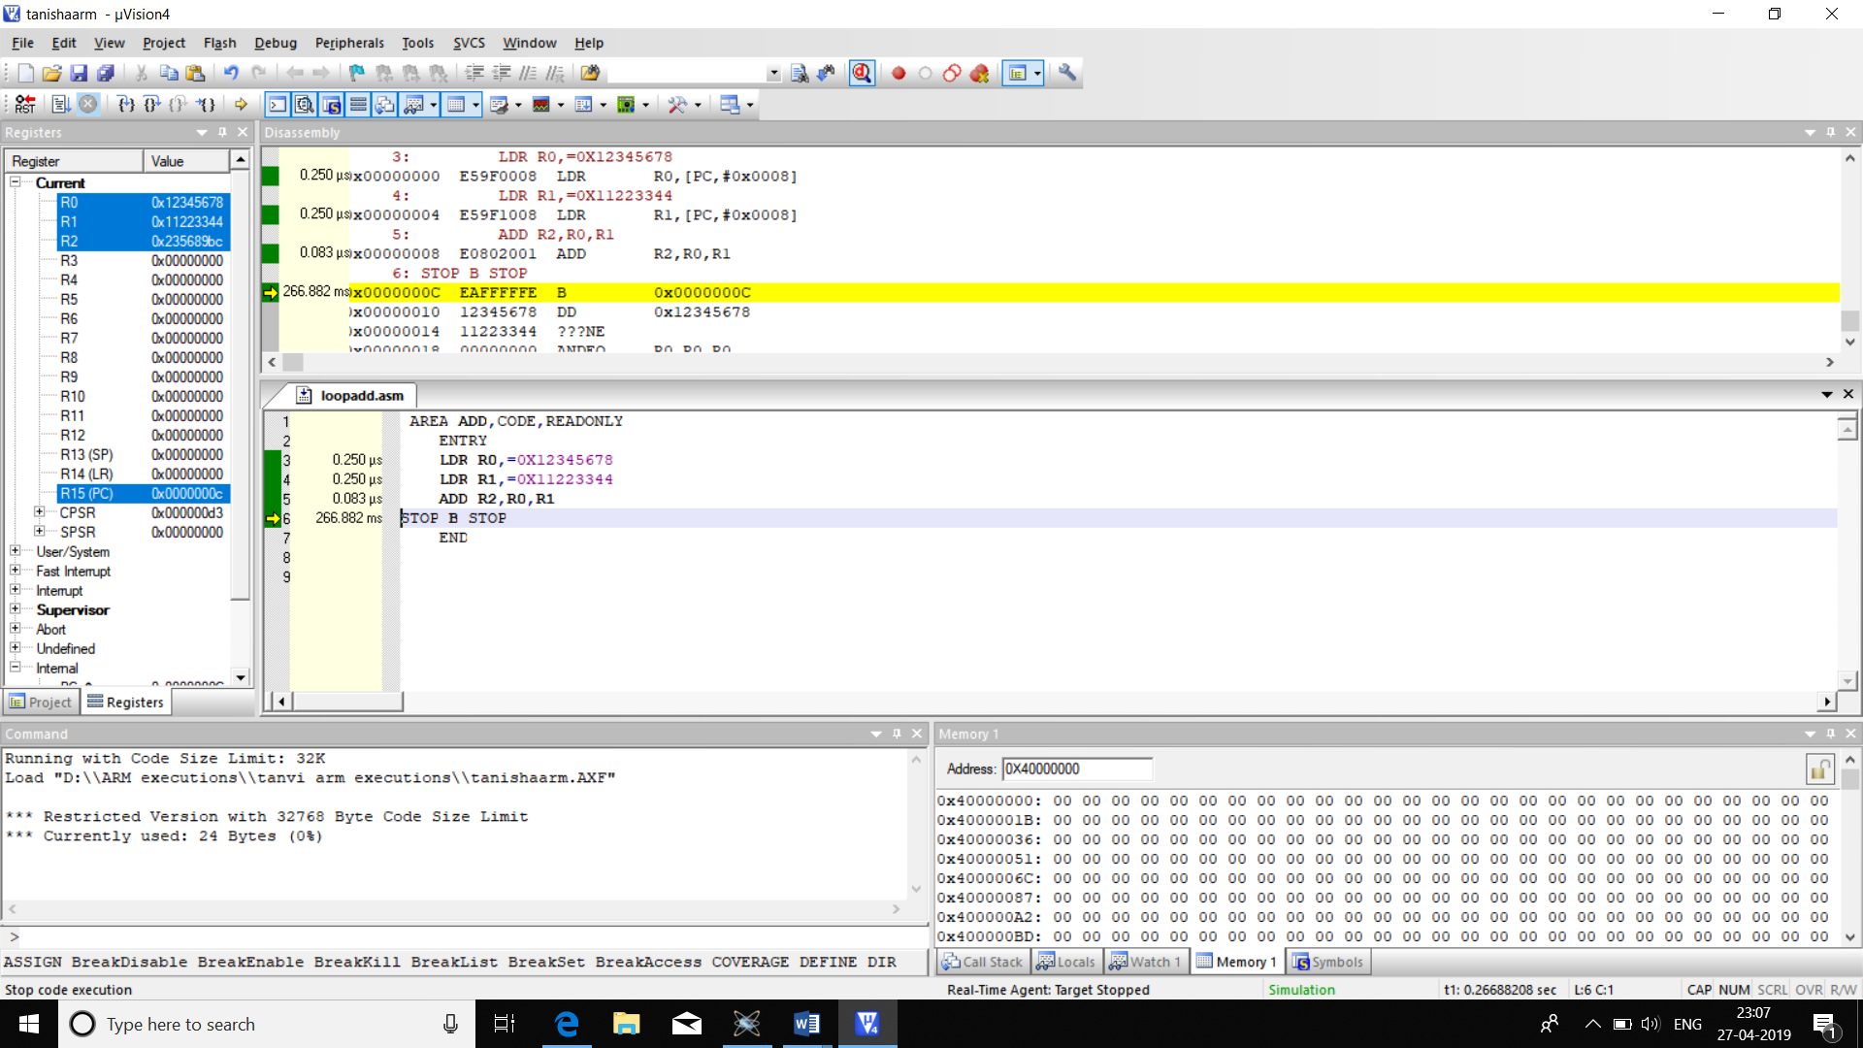

|  |  |  |
| --- | --- | --- |
|  | MEMORY | TIME |
| CODE | 24B | 0.583us |

**2.ARM CODE TO SUBTRACT TWO 32 BIT NUMBERS**

AREA ADD,CODE,READONLY

ENTRY

LDR R0,=0X12345678

LDR R1,=0X11223344

SUB R2,R0,R1

STOP B STOP

END

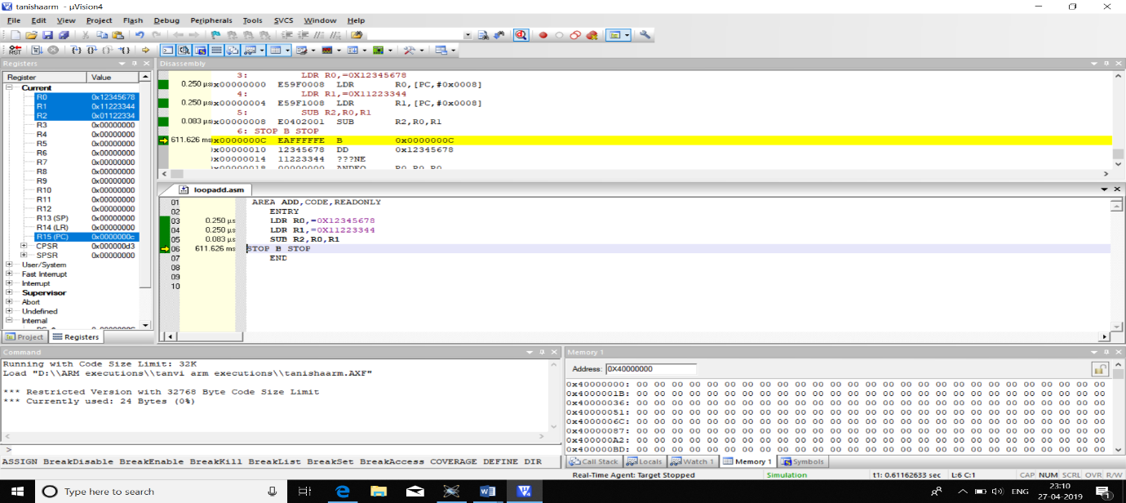

|  |  |  |
| --- | --- | --- |
|  | MEMORY | TIME |
| CODE | 24B | 0.583us |

**3. ARM CODE TO ADD TWO 64 BIT VALUES**

AREA ADD,CODE,READONLY

ENTRY

LDR R0,=0X12345678

LDR R1,=0X11223344

LDR R2,=0X11111111

LDR R3,=0X22222222

ADD R4,R0,R1

ADC R5,R2,R3

STOP B STOP

END

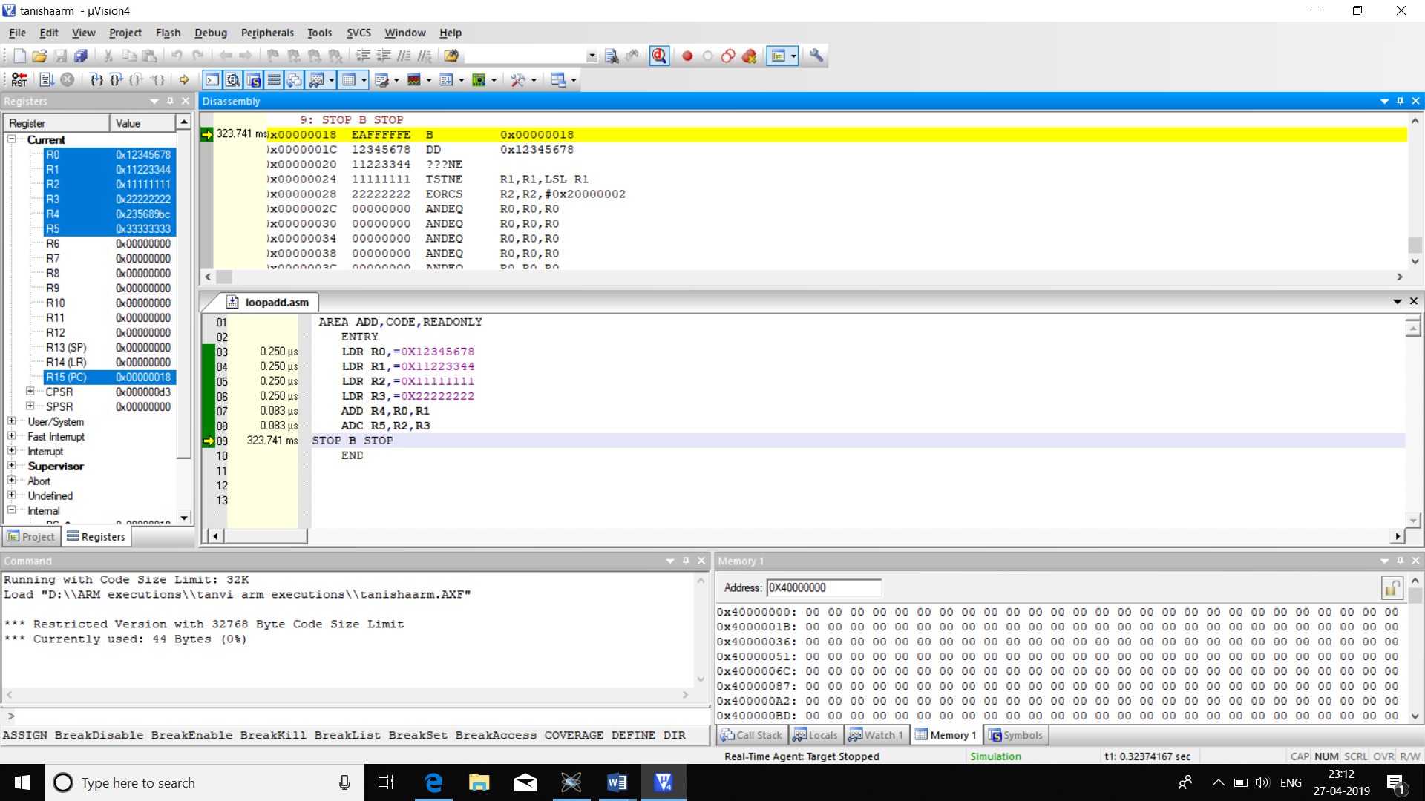

|  |  |  |
| --- | --- | --- |
|  | memory | time |
| code | 44b | 1.166us |

**4. ARM CODE TO SUBTRACT TWO 64 BIT NUMBERS**

AREA ADD,CODE,READONLY

ENTRY

LDR R0,=0X12345678

LDR R1,=0X11223344

LDR R2,=0X11111111

LDR R3,=0X22222222

SUB R4,R0,R1

SUB R5,R3,R2

STOP B STOP

END

|  |  |  |
| --- | --- | --- |
|  | memory | time |
| code | 44b | 1.166us |

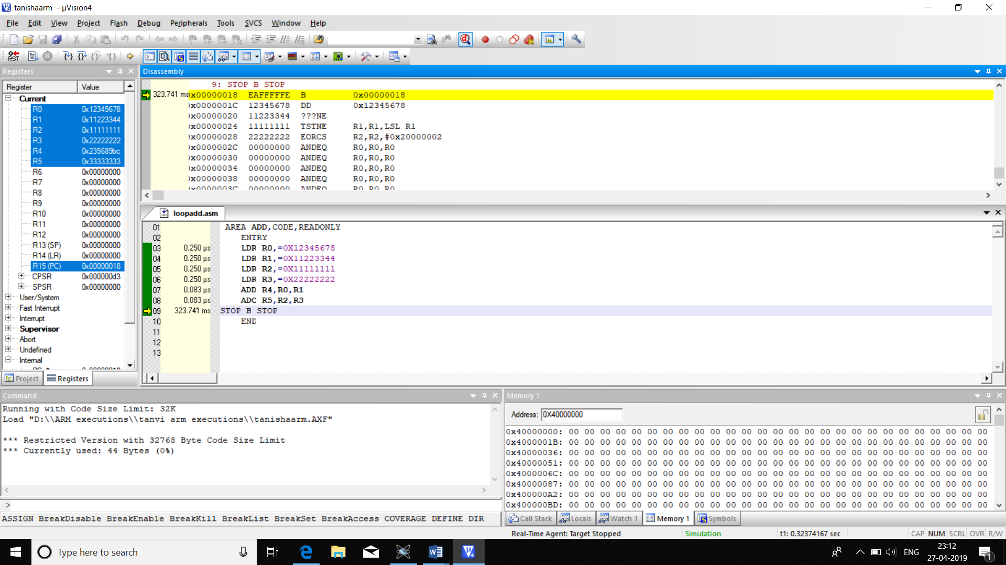

**5. ARM CODE TO CHECK IF A NUMBER IS POSITIVE OR NEGATIVE IF ITS POSITIVE SUBTRACT 1 AND IF ITS NEGATIVE ADD 1**

AREA POSNEG,CODE,READONLY

ENTRY

MOVS R0,R1

ADDMI R0,R0,#0X01

SUBPL R0,R0,#0X01

STOP B STOP

END

|  |  |  |
| --- | --- | --- |
|  | memory | time |
| code | 16b | 1.166us |

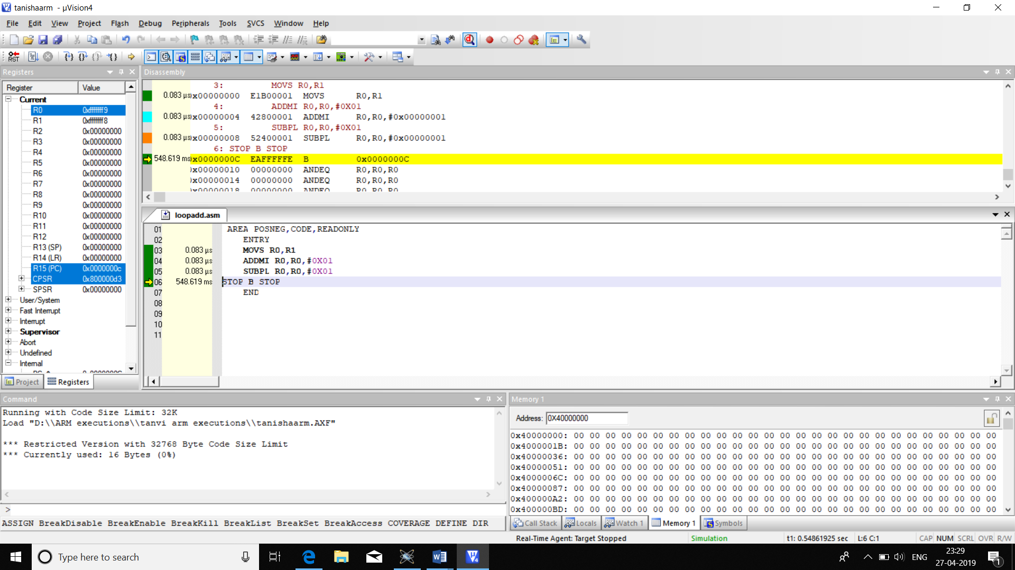

**6. ARM CODE TO CHECK IF A NUMBER IS EVEN OR ODD,IF ITS EVEN ADD 0 IF ITS ODD ADD 1**

AREA EVODD,CODE,READONLY

ENTRY

MOVS R0,R1,ROR #0X01

ADDCS R1,R1,#0X01

ADDCC R1,R1,#0X00

STOP B STOP

END

|  |  |  |
| --- | --- | --- |
|  | memory | time |
| code | 16b | 0.249us |

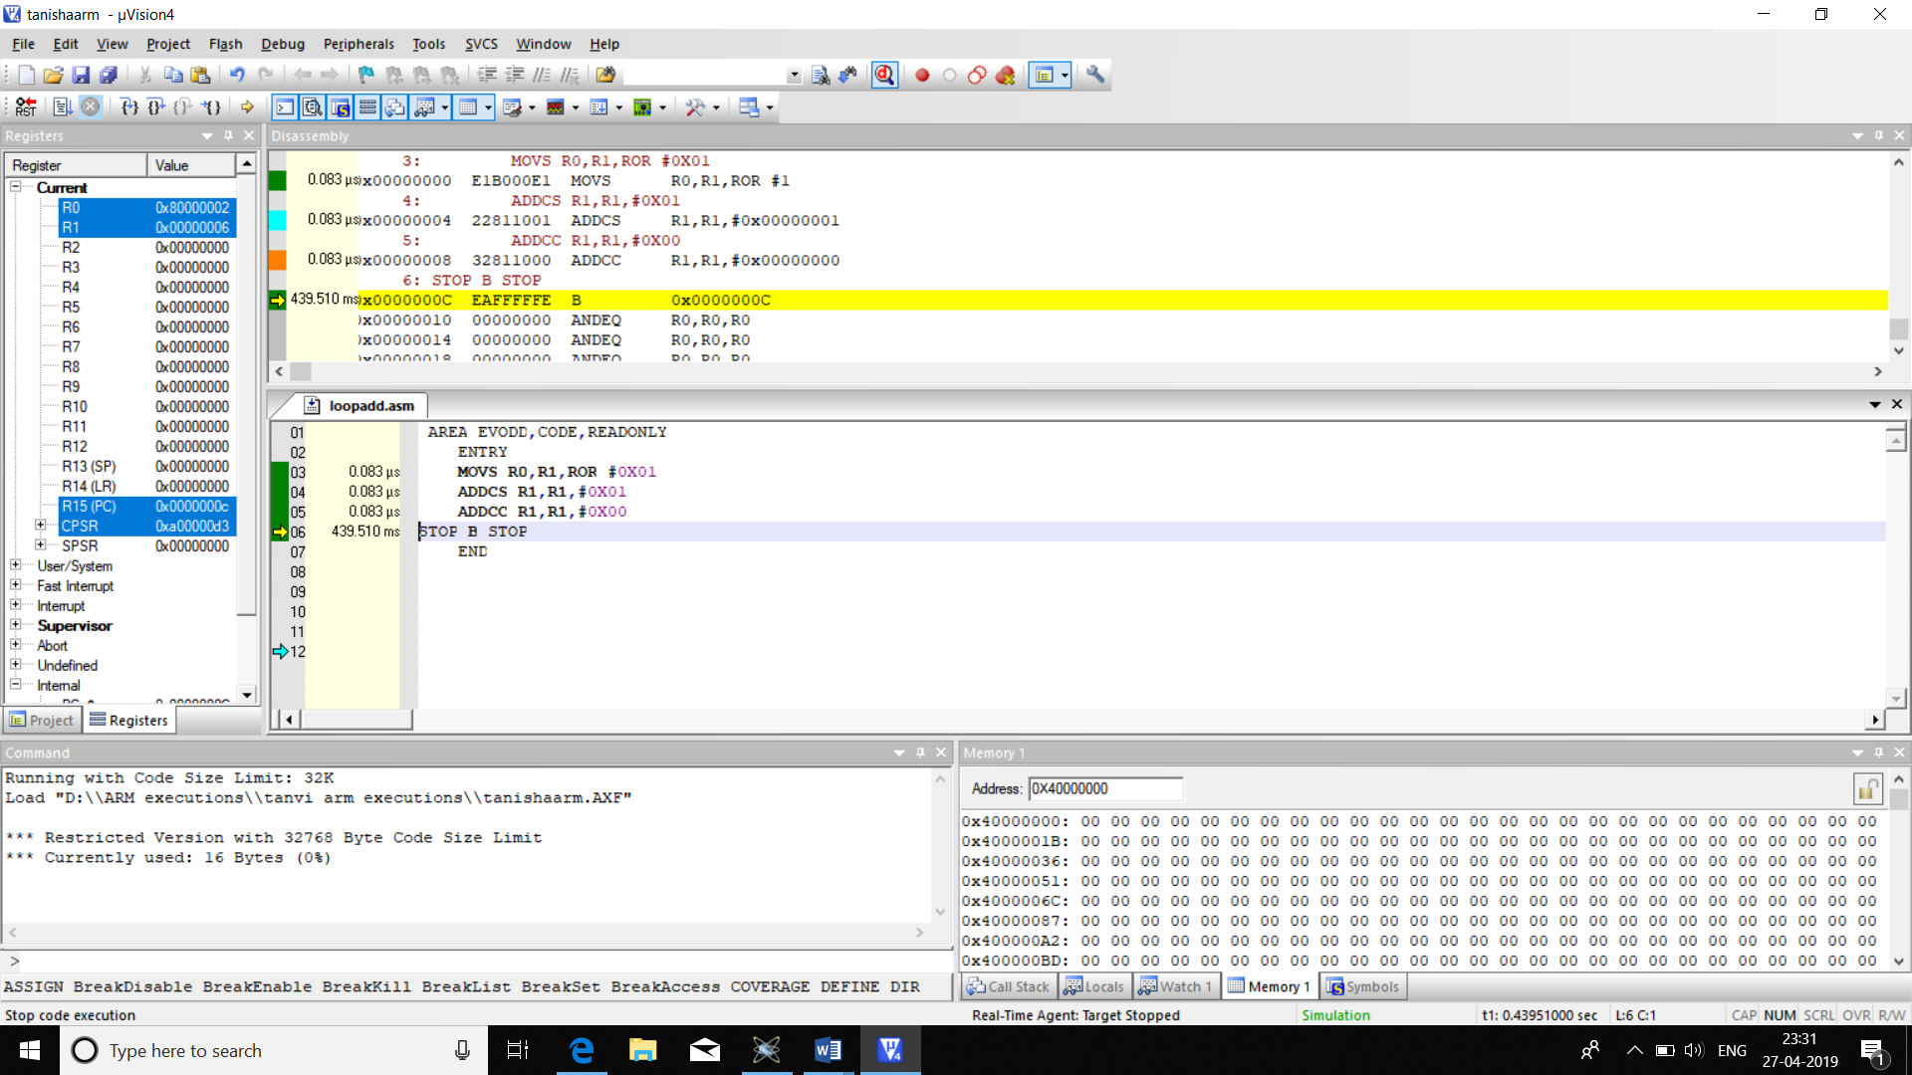

**7. ARM CODE TO ADD 5 32 BIT NUMBERS**

**CODE1:**

AREA ADD532,CODE,READONLY

ENTRY

LDR R0,=0X12345678

LDR R1,=0X11223344

LDR R2,=0X12341111

LDR R3,=0X11111111

LDR R4,=0X22222222

ADD R5,R0,R1

ADC R5,R5,R2

ADC R5,R5,R3

ADC R5,R5,R4

STOP B STOP

END

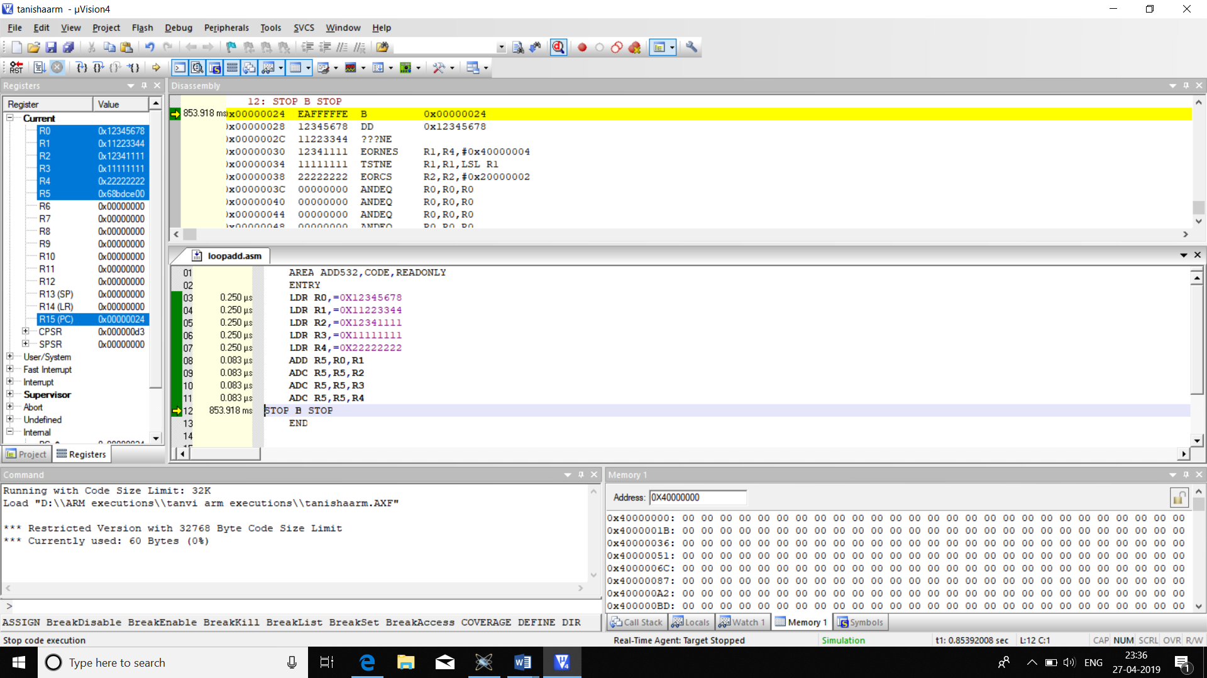

**CODE2:**

AREA ADD32,CODE,READONLY

ENTRY

LDR R0,=0X40000000

LDR R1,=0X40000000

MOV R2,#0X04

LDR R3,[R0],#4

LOP LDR R4,[R0],#4

ADD R3,R3,R4

SUBS R2,R2,#0X01

BNE LOP

STR R3,[R1]

STOP B STOP

END

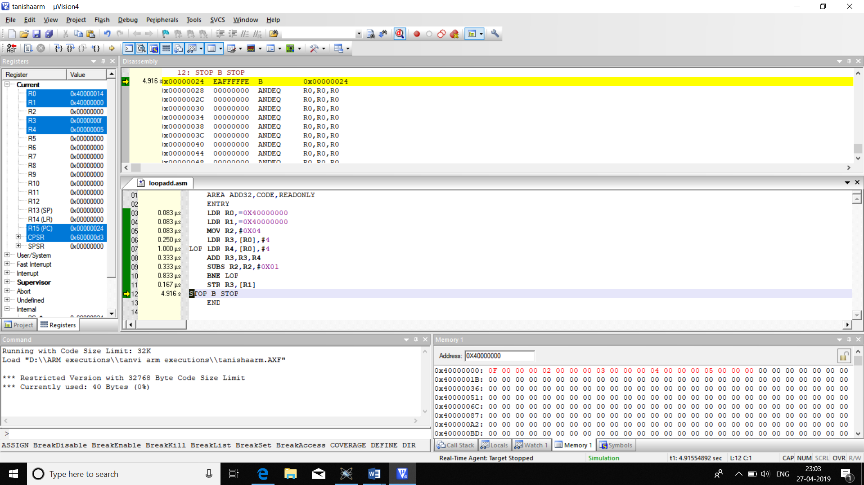

EXECUTION PROFILING :

|  |  |  |
| --- | --- | --- |
|  | MEMORY | TIME |
| CODE1 | 60b | 1.582us |
| CODE2 | 40b | 3.165us |

**8.ARM CODES TO SUBTRACT 5 32 BIT NUMBERS:**

**CODE1:**

AREA SUB532,CODE,READONLY

ENTRY

LDR R0,=0X22222222

LDR R1,=0X12345678

LDR R2,=0X12222222

LDR R3,=0X11112222

LDR R4,=0X11111111

SUB R5,R0,R1

SUB R5,R5,R2

SUB R5,R5,R3

SUB R5,R5,R4

STOP B STOP

END

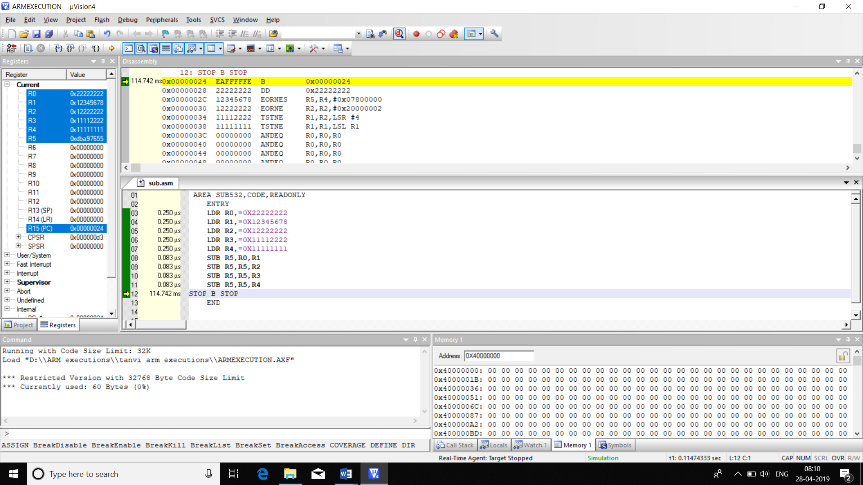

**CODE2:**

AREA ADD32,CODE,READONLY

ENTRY

LDR R0,=0X40000000

LDR R1,=0X40000000

MOV R2,#0X04

LDR R3,[R0],#4

LOP LDR R4,[R0],#4

SUB R3,R3,R4

SUBS R2,R2,#0X01

BNE LOP

STR R3,[R1]

STOP B STOP

END

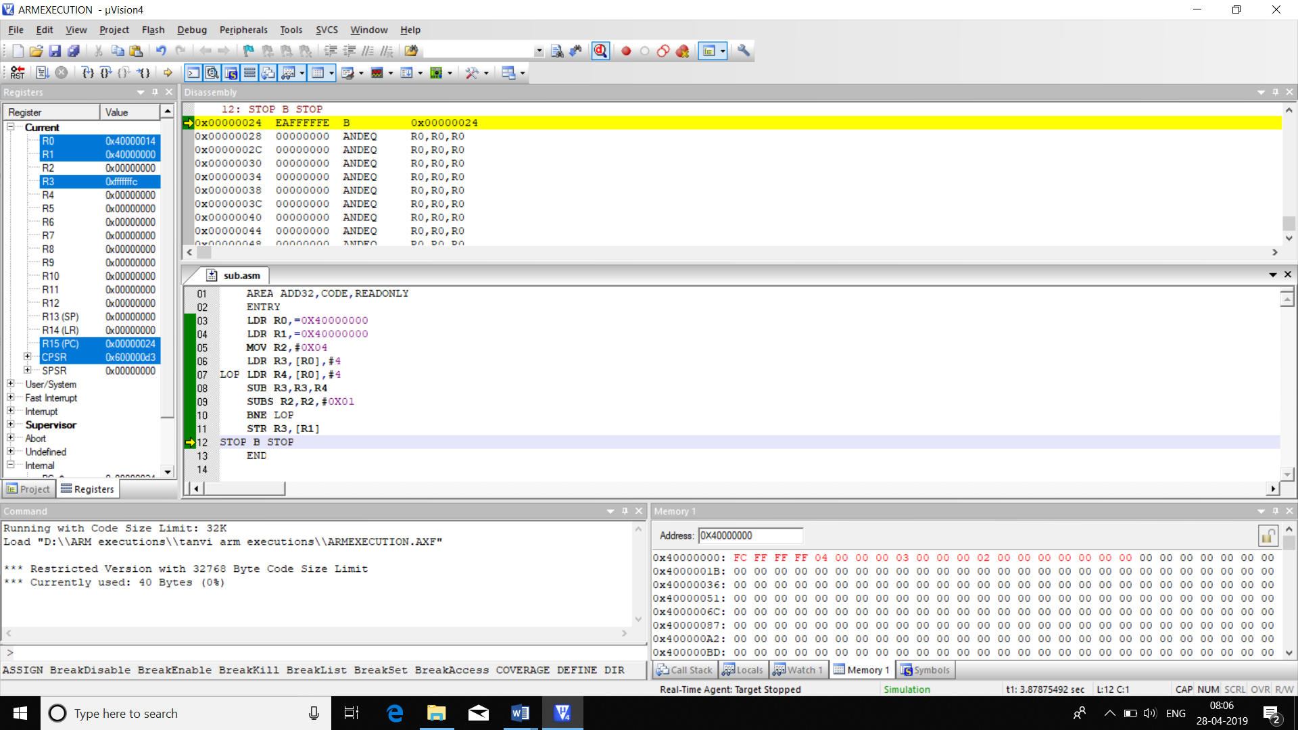

|  |  |  |
| --- | --- | --- |
|  | MEMORY | TIME |
| CODE1 | 60b | 1.582us |
| CODE2 | 40b | 3.165us |

**9.ARM CODE TO FIND LARGEST OF TWO NUMBERS**

**CODE1:**

AREA LAR,CODE,READONLY

ENTRY

CMP R0,R1

MOVCS R3,R0

MOVCC R3,R1

STOP B STOP

END

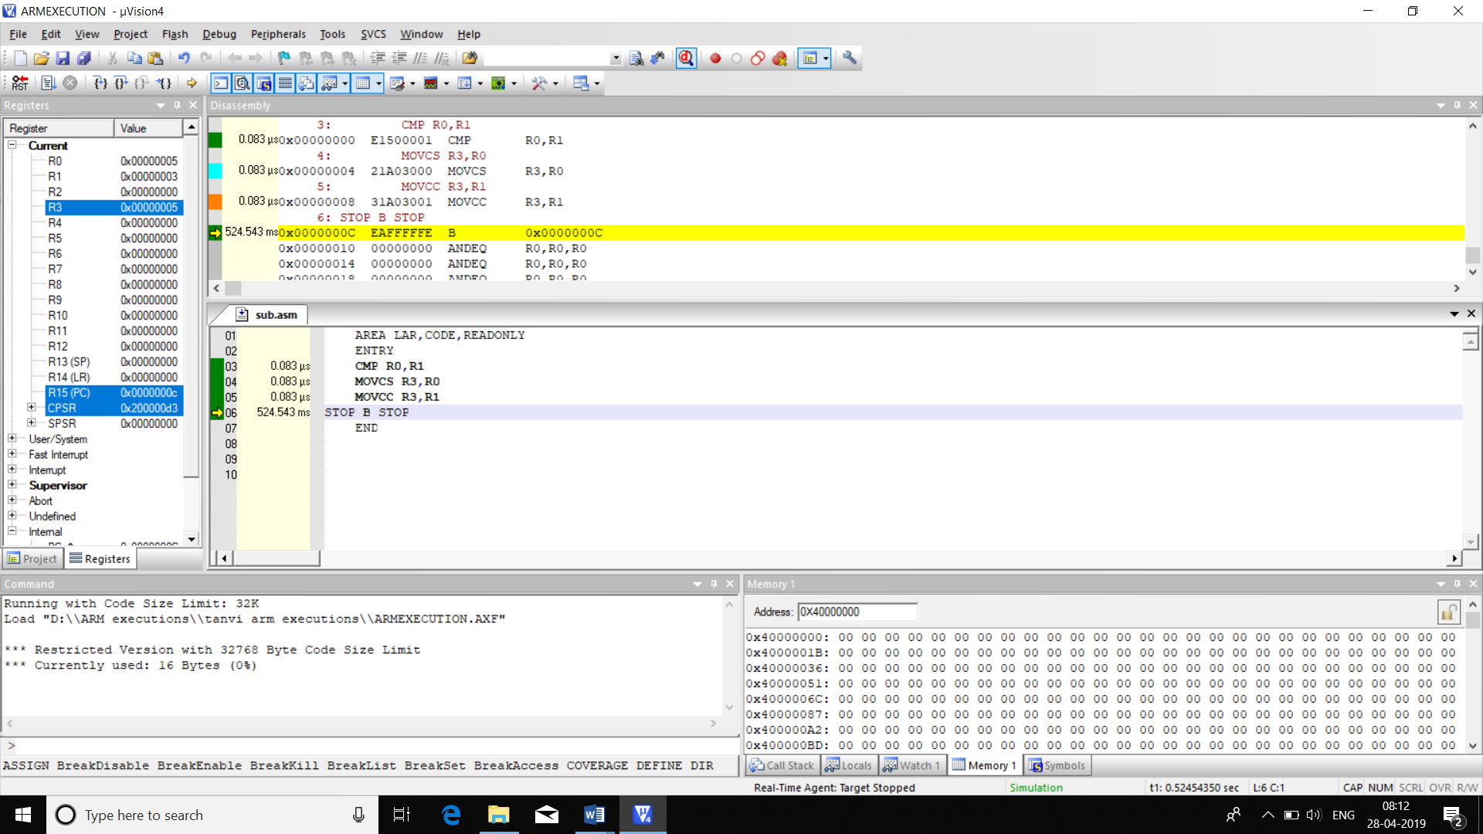

**CODE2:**

AREA LAR,CODE,READONLY

ENTRY

SUBS R5,R0,R1

MOVCS R3,R0

MOVCC R3,R1

STOP B STOP

END

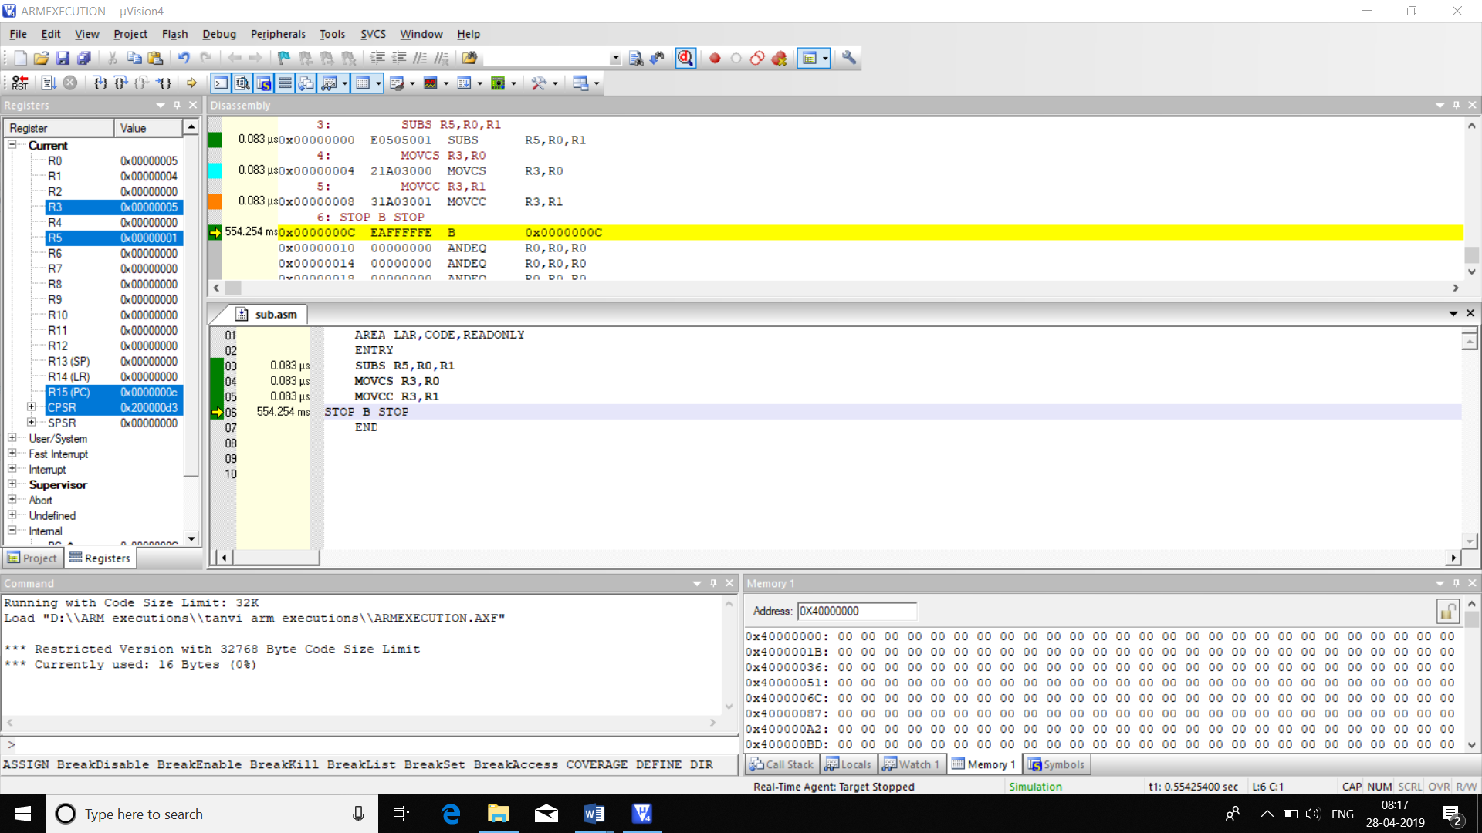

|  |  |  |
| --- | --- | --- |
|  | MEMORY | TIME |
| CODE1 | 16B | 0.249us |
| CODE2 | 16B | 0.249us |

**10. ARM CODE TO FIND THE SMALLEST**

**CODE1:**

AREA LAR,CODE,READONLY

ENTRY

CMP R0,R1

MOVCS R3,R1

MOVCC R3,R0

STOP B STOP

END

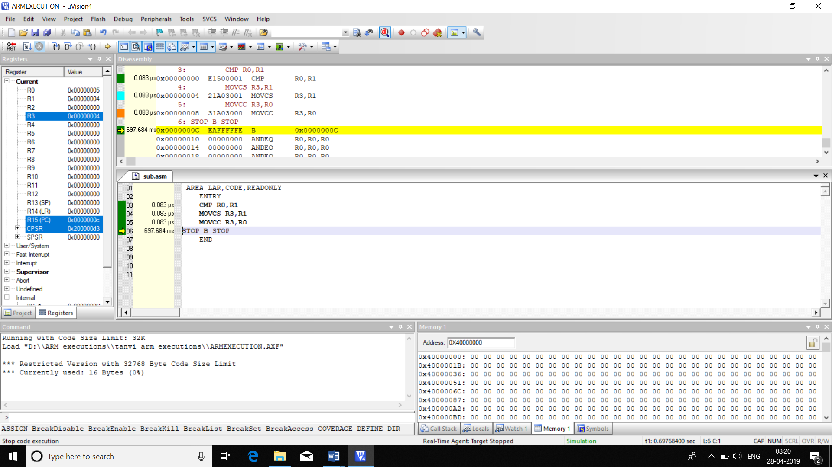

**CODE2:**

AREA LAR,CODE,READONLY

ENTRY

SUB R5,R0,R1

MOVCS R3,R1

MOVCC R3,R0

STOP B STOP

END

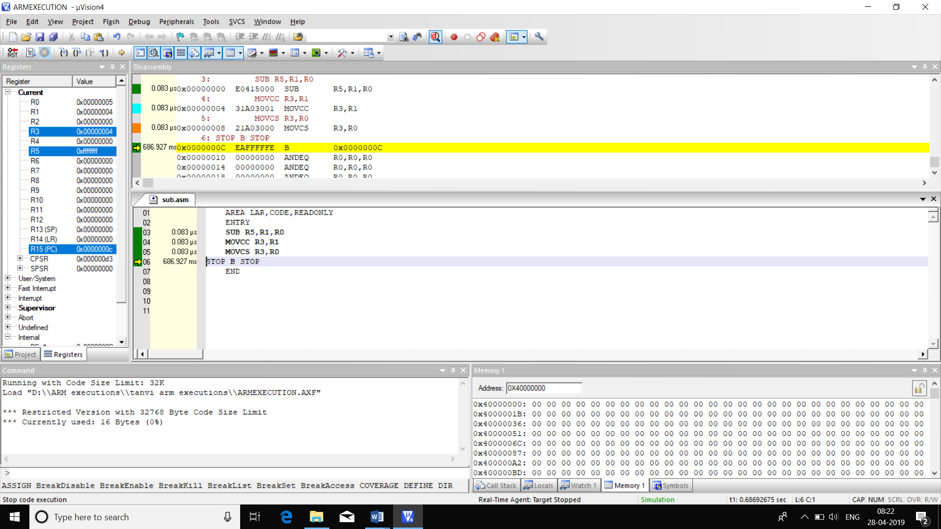

|  |  |  |
| --- | --- | --- |
|  | MEMORY | TIME |
| CODE1 | 16B | 0.249us |
| CODE2 | 16B | 0.249us |

**11. ARM CODE TO DIVIDE A NUMBER BY 4 USING SUBTRACTION LOGIC**

AREA SUBDIV,CODE,READONLY

ENTRY

LOOP CMP R0,#0X00

SUBPL R0,#0X04

ADDPL R1,R1,#0X01

CMP R0,#0X04

BPL LOOP

STOP B STOP

END

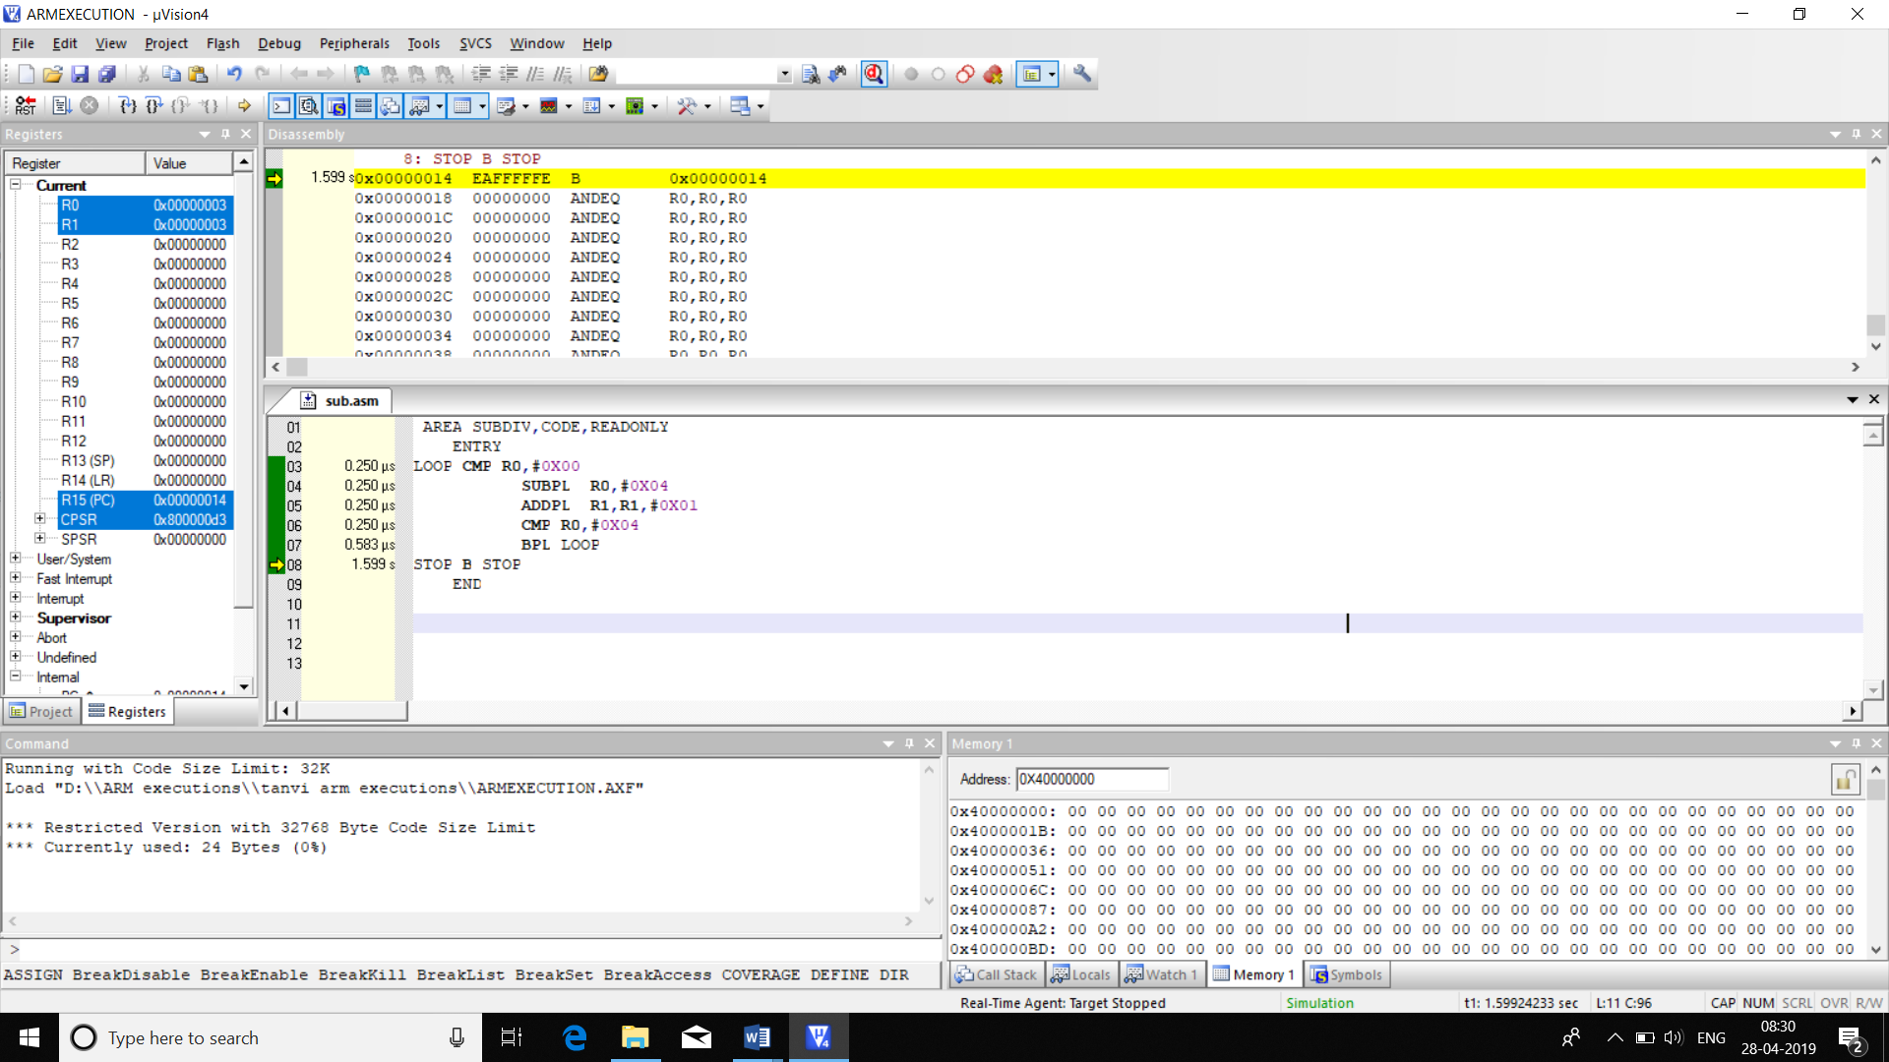

|  |  |  |
| --- | --- | --- |
|  | MEMORY | TIME |
| CODE | 24B | 1.583us |

**12.ARM CODE FOR MULTIPLYING A NUMBER BY 5 USING ADDITION LOGIC**

**CODE1.**

AREA MULADD,CODE,READONLY

ENTRY

MOV R0,#0X05

LOOP CMP R0,#0X00

ADDNE R2,R2,R1

SUBNE R0,R0,#0X01

B LOOP

STOP B STOP

END

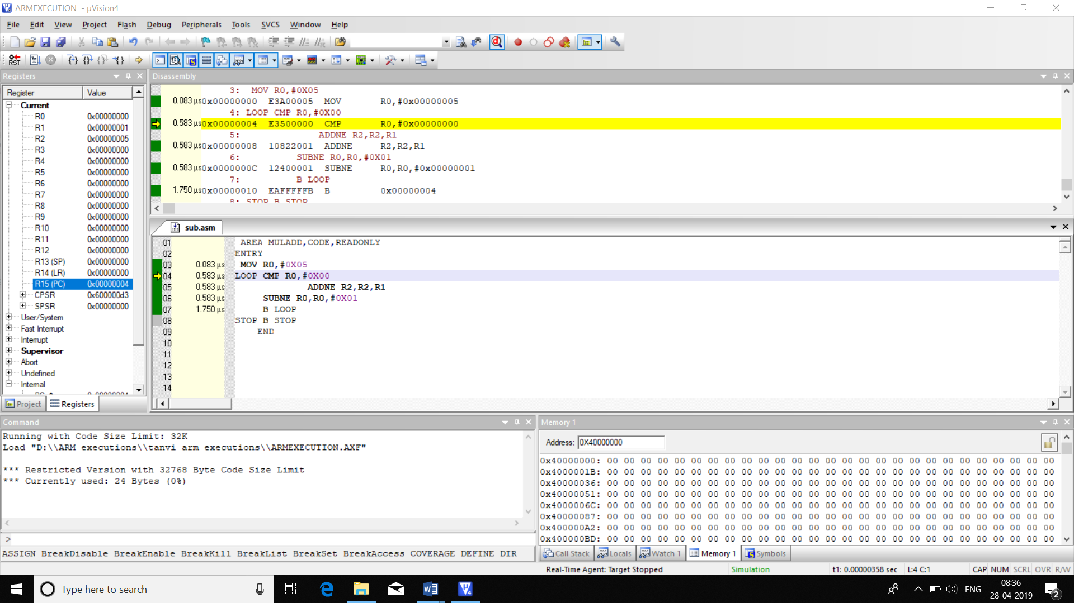

**CODE2.**

AREA MULADD2,CODE,READONLY

ENTRY

MOV R0,#0X02

ADD R2,R0,R0,LSL #0X02

STOP B STOP

END

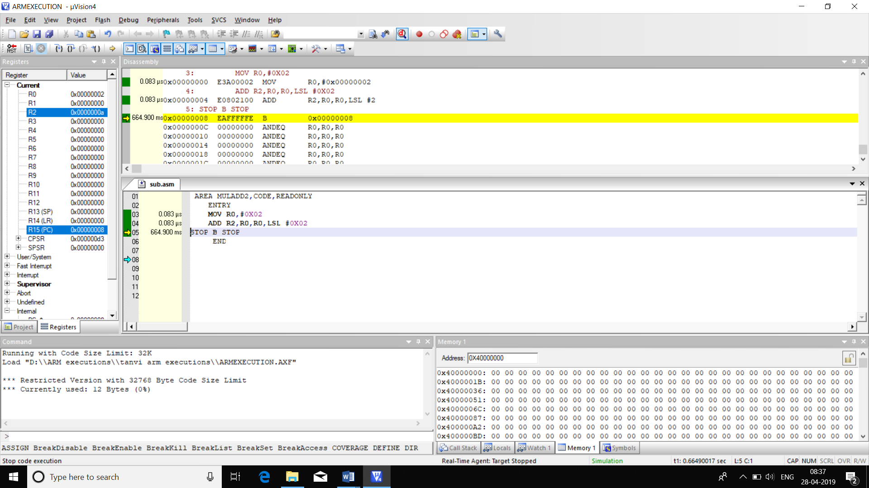

|  |  |  |
| --- | --- | --- |
|  | MEMORY | TIME |
| CODE1 | 24B | 1.832us |
| C0DE2 | 12B | 0.166us |

**13. ARM CODE TO FIND THE LARGEST IN AN ARRAY OF 5 32 BIT NUMBERS**

AREA MAXC2,CODE,READONLY

ENTRY

MOV R0,#0X04

LDR R1,=ARRAY

LDR R2,[R1],#4

LDR R5,=0X40000000

LOOP LDR R3,[R1],#4

CMP R2,R3

MOVCS R2,R2

MOVCC R2,R3

SUBS R0,R0,#0X01

BNE LOOP

STOP B STOP

ARRAY DCD 0X55554411,0X44567890,0X12341111,0X11111111,0X22222222

END

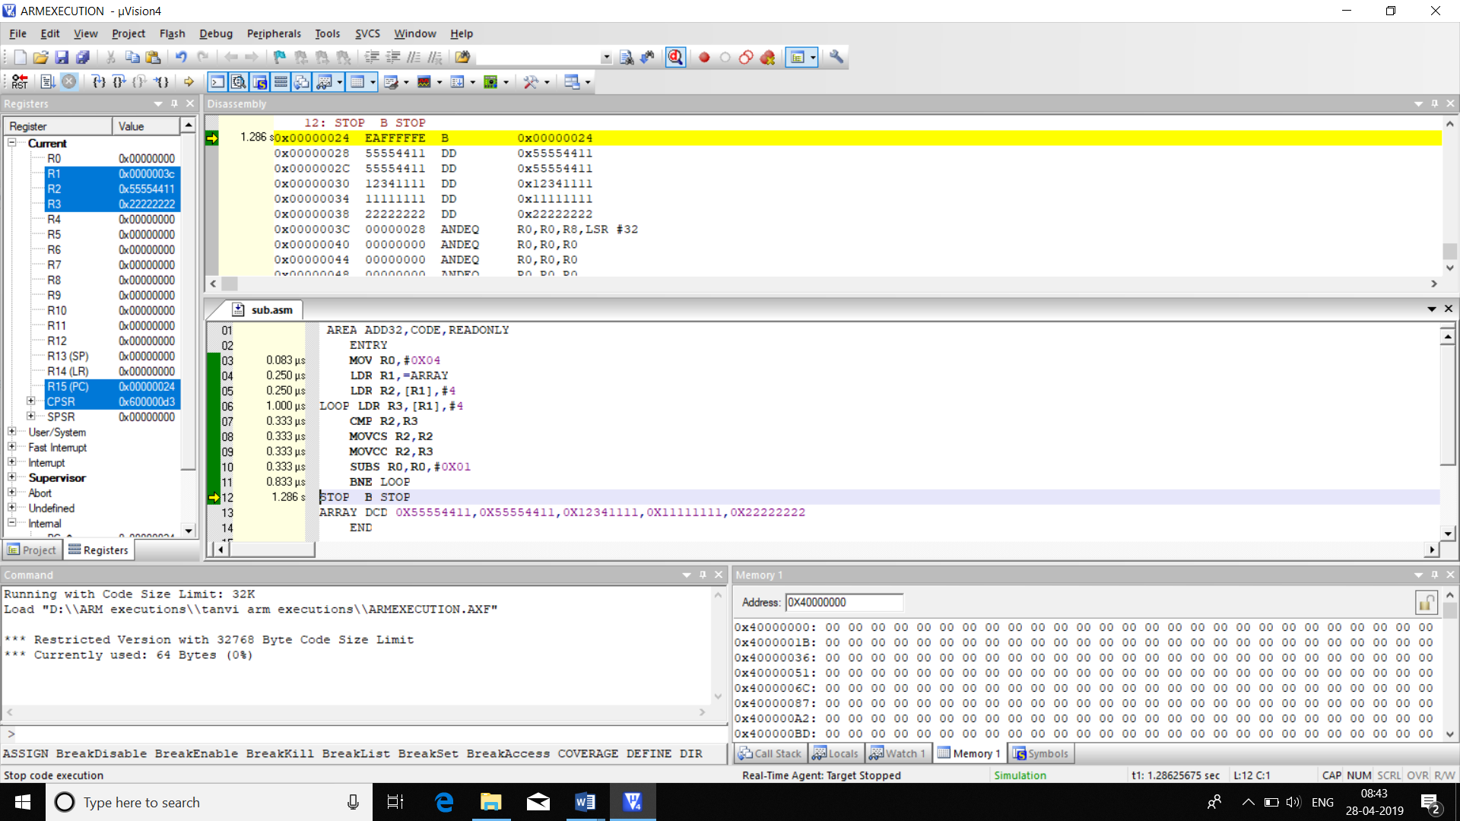

CODE2:

AREA LARGEST,CODE

ENTRY

MOV R5,0X05;

LDR R1,=0X40000000;

LDR R2,[R1],#04;

LOOP LDR R4,[R1],#04

CMP R2,R4

BCC LOOP1

MOV R2,R4

LOOP1 SUBS R5,R5,#1

BNE LOOP

STOP B STOP

END

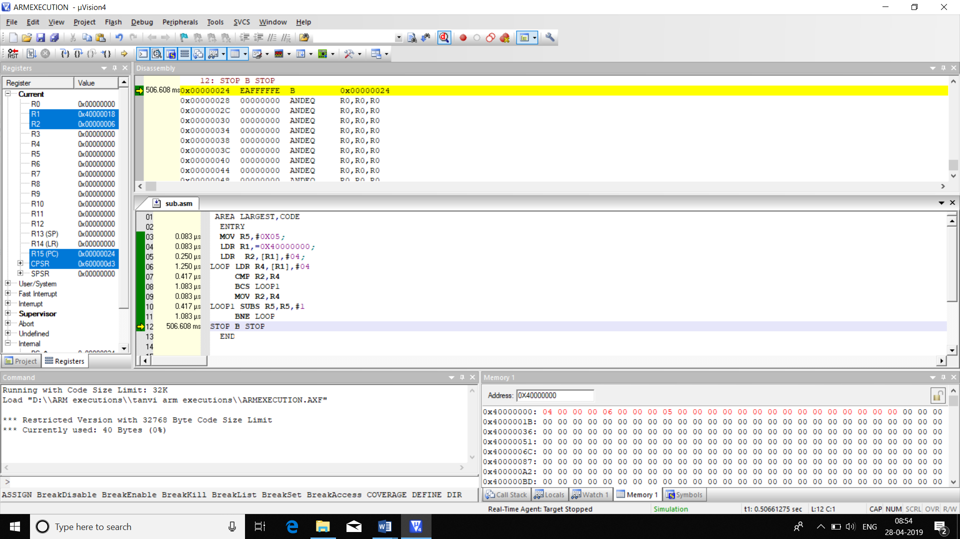

|  |  |  |
| --- | --- | --- |
|  | MEMORY | TIME |
| CODE1 | 64B | 25ms |
| CODE2 | 40B | 4.75us |

**14. ARM CODE TO FIND THE SMALLEST IN AN ARRAY OF 5 32 BIT NUMBERS**

AREA MAXC2,CODE,READONLY

ENTRY

MOV R0,#0X04

LDR R1,=ARRAY

LDR R2,[R1],#4

LDR R5,=0X40000000

LOOP LDR R3,[R1],#4

CMP R2,R3

MOVCC R2,R2

MOVCS R2,R3

SUBS R0,R0,#0X01

BNE LOOP

STOP B STOP

ARRAY DCD 0X55554411,0X44567890,0X12341111,0X11111111,0X22222222

END

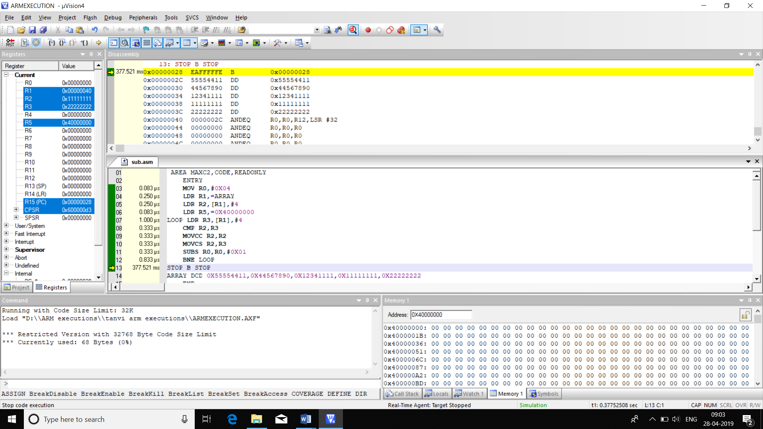

**CODE2:**

AREA LARGEST,CODE

ENTRY

MOV R5,0X05;

LDR R1,=0X40000000;

LDR R2,[R1],#04;

LOOP LDR R4,[R1],#04

CMP R2,R4

BCC LOOP1

MOV R2,R4

LOOP1 SUBS R5,R5,#1

BNE LOOP

STOP B STOP

END

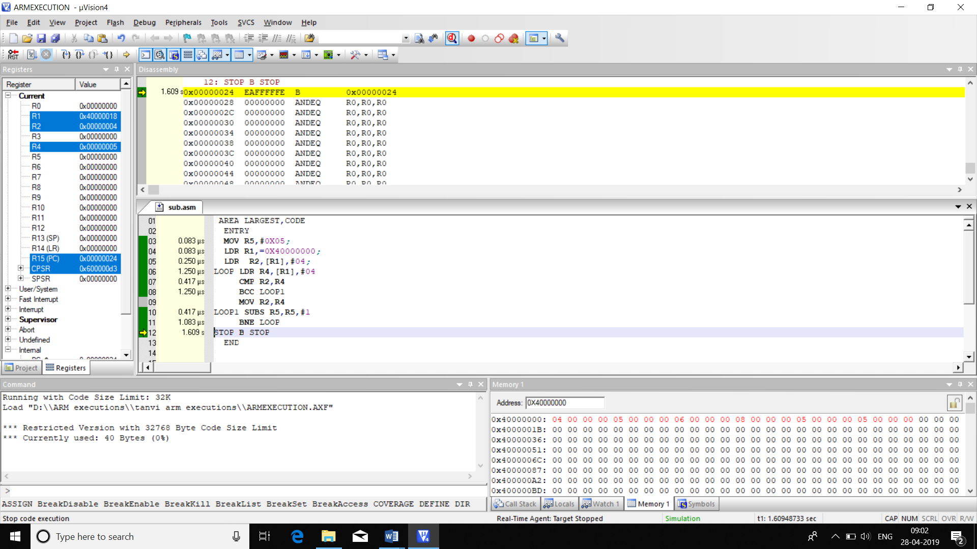

|  |  |  |
| --- | --- | --- |
|  | MEMORY | **TIME** |
| **CODE1** | 68B | 4.08us |
| **CODE2** | 40B | 48ms |

**15.ARM CODE TO FIND NUMBER OF ZEROES AND ONES IN 8 BIT DATA**

AREA ZO,CODE,READONLY

ENTRY

MOVS R0,R0,LSR #0X01

ADDCS R1,R1,#0X01

ADDCC R2,R2,#0X01

MOVS R0,R0,LSR #0X01

ADDCS R1,R1,#0X01

ADDCC R2,R2,#0X01

MOVS R0,R0,LSR #0X01

ADDCS R1,R1,#0X01

ADDCC R2,R2,#0X01

MOVS R0,R0,LSR #0X01

ADDCS R1,R1,#0X01

ADDCC R2,R2,#0X01

STOP B STOP

END

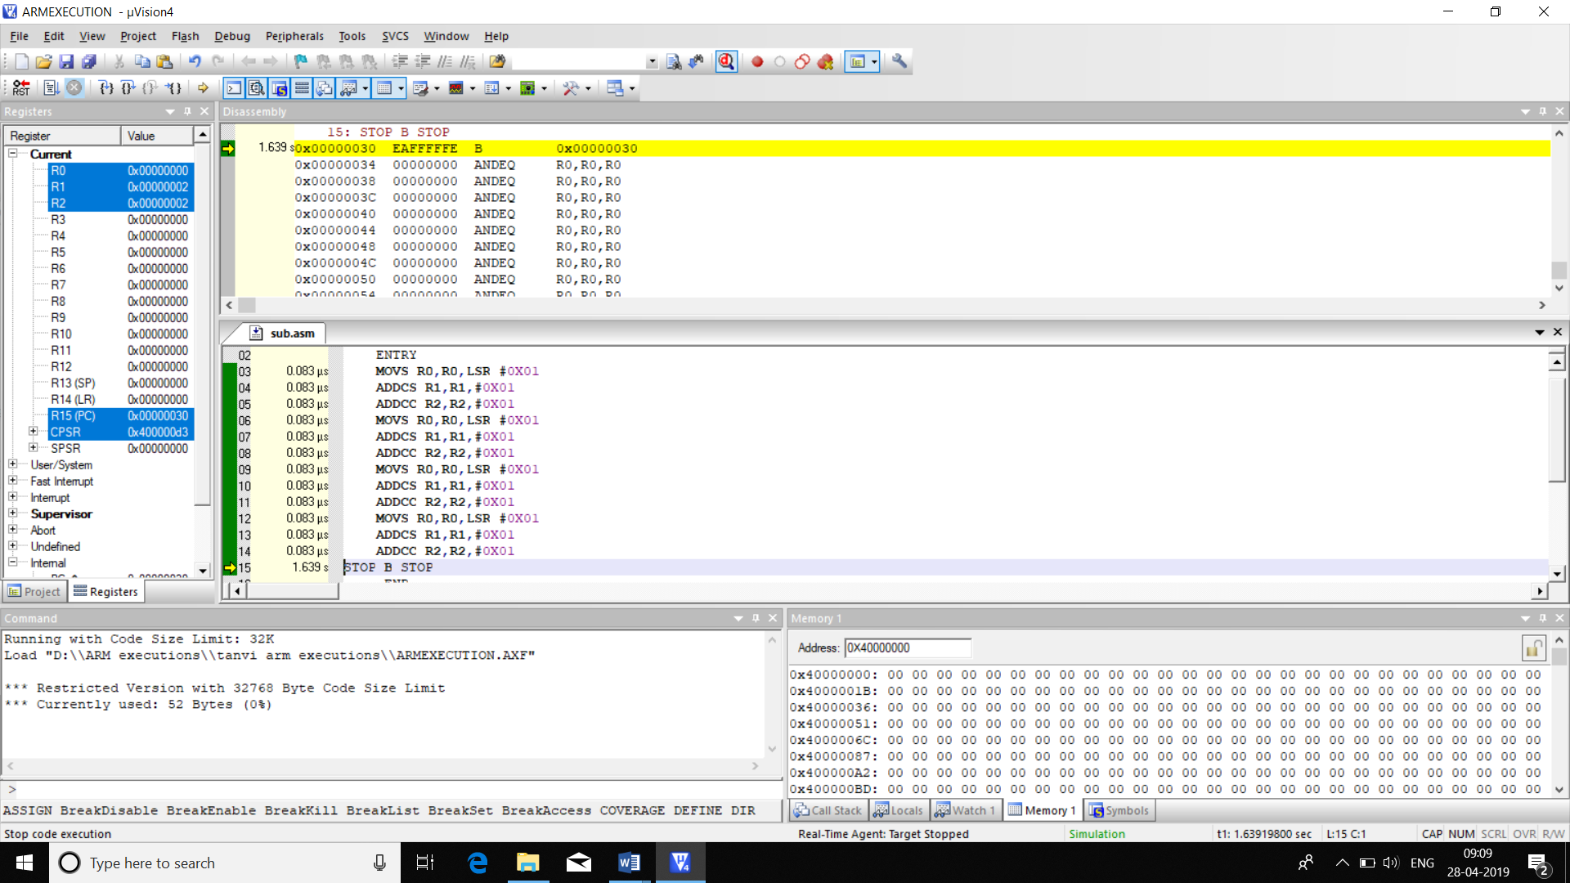

CODE2:

AREA ZO,CODE,READONLY

ENTRY

LDR R0,=0X40000000

LDR R1,[R0]

MOV R2,#0X08

LOP MOVS R1,R1,LSR #0X01

ADDCC R4,R4,#0X01

ADDCS R5,R5,#0X01

SUBS R2,R2,#0X01

BNE LOP

STOP B STOP

END

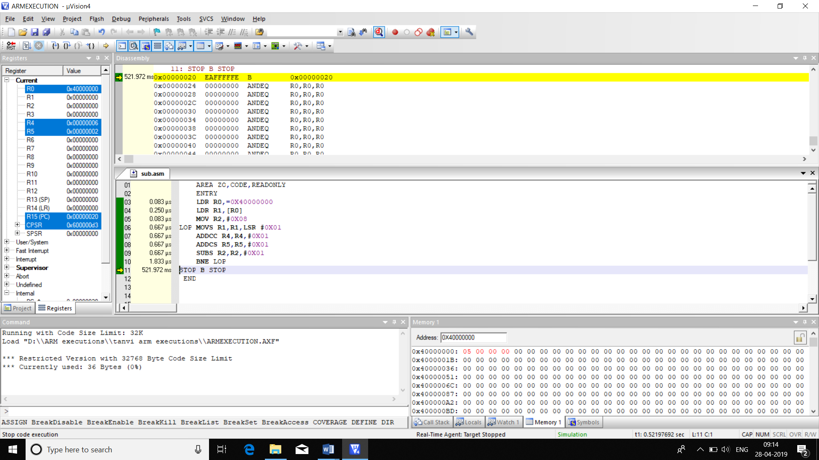

|  |  |  |
| --- | --- | --- |
|  | MEMORY | TIME |
| CODE1 | 52B | 0.913us |
| CODE2 | 36B | 4.92us |

**16.ARM CODE TO FIND THE NUMBER OF EVEN NUMBERS IN AN ARRAY OF 5 32 BIT NUMBERS**

AREA EV32,CODE,READONLY

ENTRY

MOV R0,#0X05

LDR R1,=ARRAY

LOOP LDR R2,[R1],#4

MOVS R3,R2,ROR #0X01

ADDCC R4,R4,#0X01

SUBS R0,R0,#0X01

BNE LOOP

STOP B STOP

ARRAY DCD 0X11111111,0X12345678,0X12341120,0X1234781,0X12121234

END

|  |  |  |
| --- | --- | --- |
|  | MEMORY | TIME |
| CODE | 56B | 3.917us |

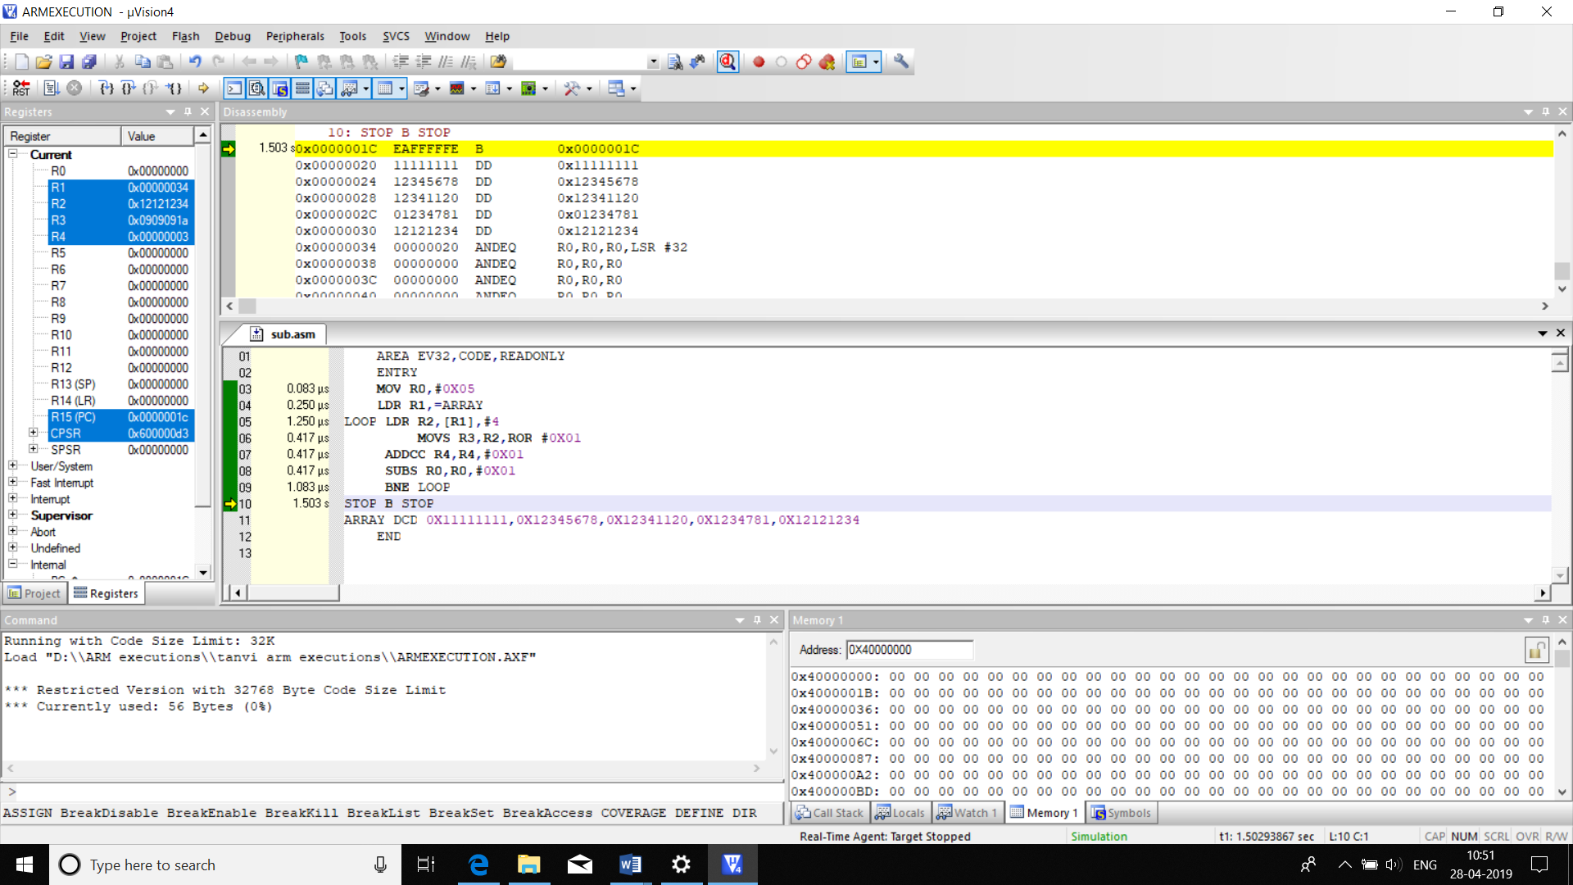

**17. ARM CODE TO FIND THE NUMBER OF ODD NUMBERS IN AN ARRAY OF 5 32 BIT NUMBERS**

AREA EV32,CODE,READONLY

ENTRY

MOV R0,#0X05

LDR R1,=ARRAY

LOOP LDR R2,[R1],#4

MOVS R3,R2,ROR #0X01

ADDCS R4,R4,#0X01

SUBS R0,R0,#0X01

BNE LOOP

STOP B STOP

ARRAY DCD 0X11111111,0X12345678,0X12341120,0X1234781,0X12121234

END

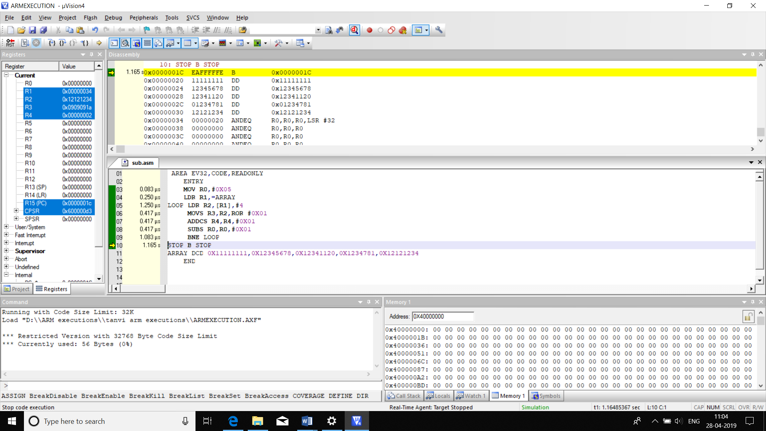

|  |  |  |
| --- | --- | --- |
|  | MEMORY | TIME |
| CODE | 56B | 3.917us |

**18.ARM CODE TO FIND THE NUMBER OF POSITIVE NUMBERS IN AN ARRAY OF 5 32 BIT NUMBERS**

AREA POS32,CODE,READONLY

ENTRY

MOV R0,#0X05

LDR R1,=ARRAY

LOOP LDR R2,[R1],#4

CMP R2,#0X00

ADDPL R3,R3,#0X01

SUBS R0,R0,#0X01

BNE LOOP

STOP B STOP

ARRAY DCD 0X12345678,0XFFFFFFFC,0X12341120,0X12347815,0X12121234

END

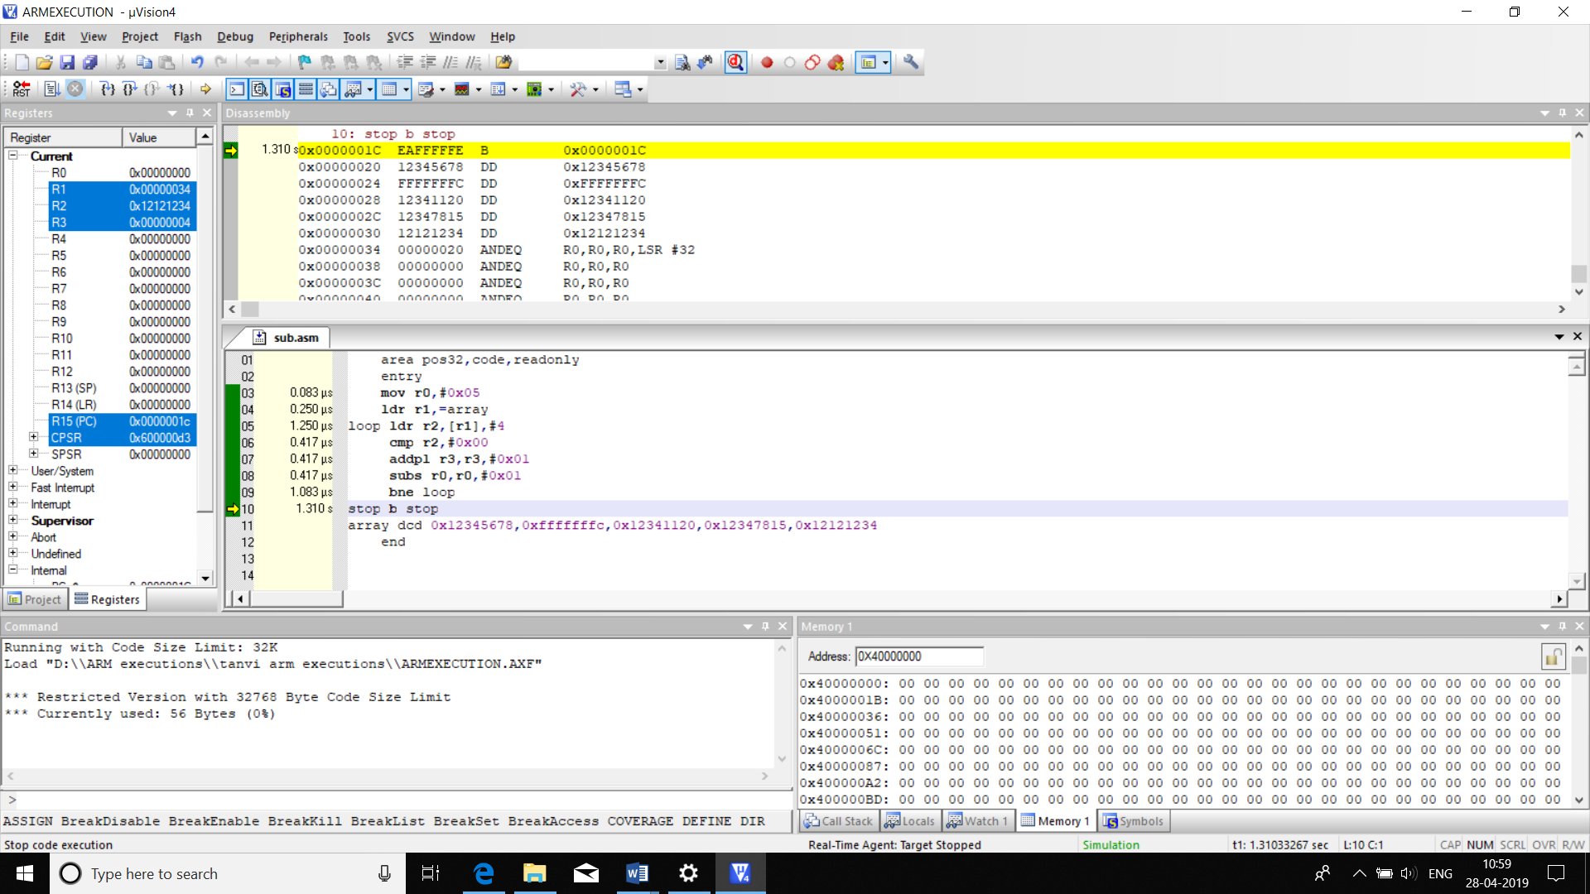

|  |  |  |
| --- | --- | --- |
|  | memory | Time |
| code | 56b | 3.917us |

**19.ARM CODE TO FIND NUMBER OF NEGATIVE NUMBERS IN AN ARRAY OF 5 32 BIT NUMBERS**

AREA POS32,CODE,READONLY

ENTRY

MOV R0,#0X05

LDR R1,=ARRAY

LOOP LDR R2,[R1],#4

CMP R2,#0X00

ADDMI R3,R3,#0X01

SUBS R0,R0,#0X01

BNE LOOP

STOP B STOP

ARRAY DCD 0X12345678,0XFFFFFFFC,0X12341120,0X12347815,0X12121234

END

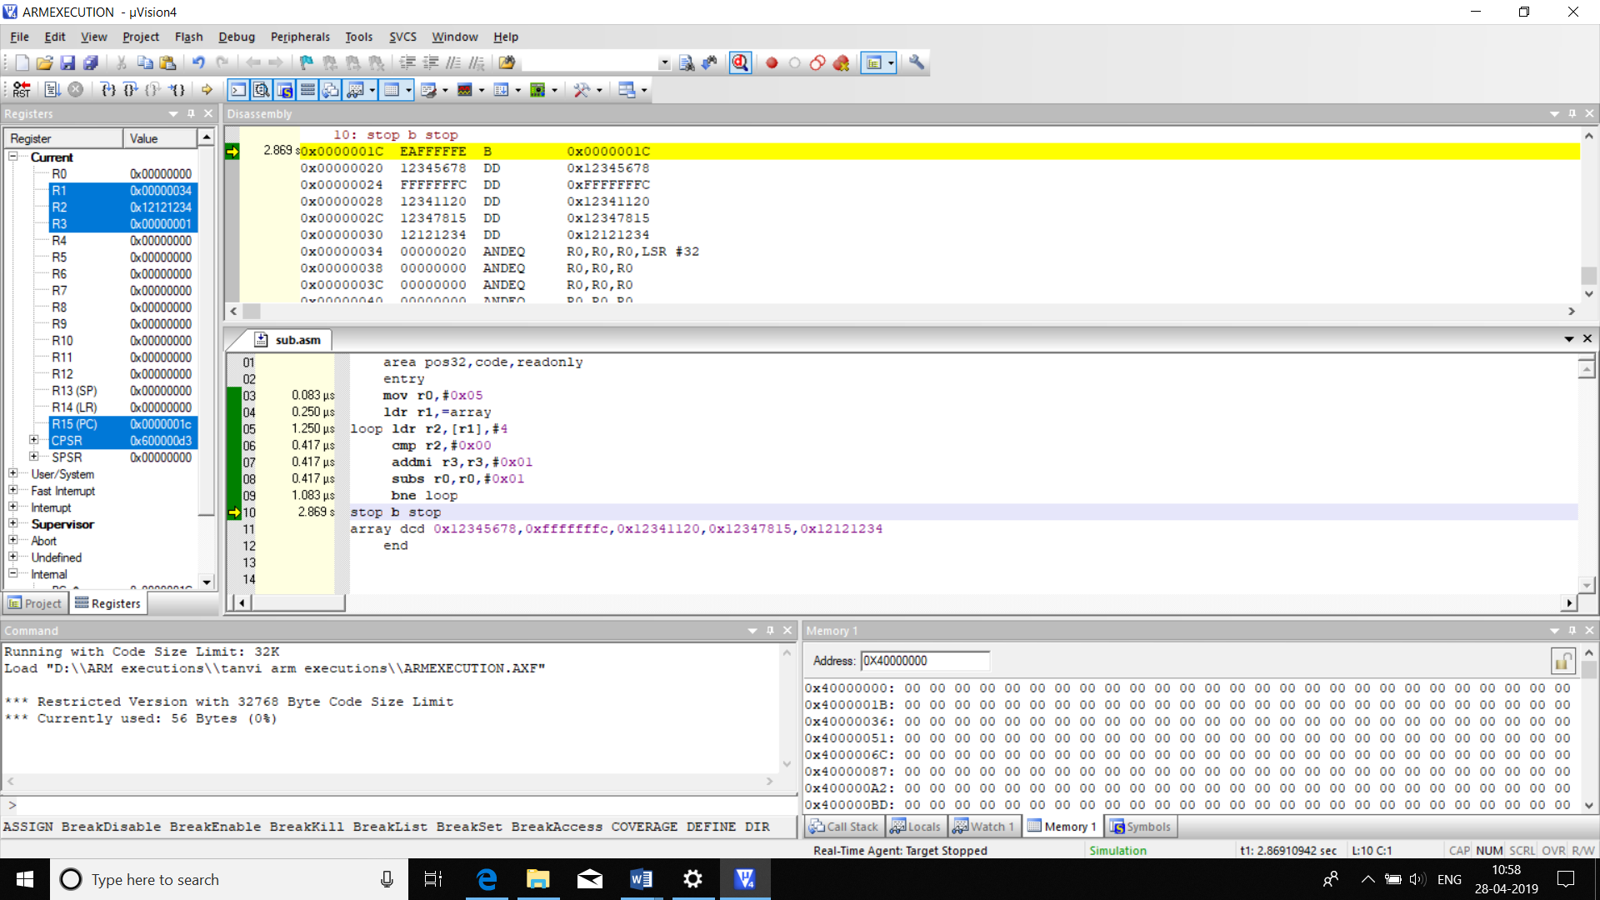

|  |  |  |
| --- | --- | --- |
|  | memory | Time |
| code | 56b | 3.917us |

**20.** ***.ALP TO ADD TWO ARRAY ELEMENTS AND SAVE THE ANSWER IN THIRD ARRAY***

AREA ARRAYSUM,CODE,READONLY

ENTRY

LDR R3,=0X40000000

LDR R2,=ARRAY1

LDR R4,=ARRAY2

MOV R5,#0X05

ADD LDR R0,[R2],#4

LDR R6,[R4],#4

ADD R7,R0,R6

STR R7,[R3],#4

SUBS R5,R5,#1

BNE ADD

STOP B STOP

ARRAY1 DCD 0X01,0X02,0X03,0X04,0X05

ARRAY2 DCD 0X05,0X04,0X03,0X02,0X01

END

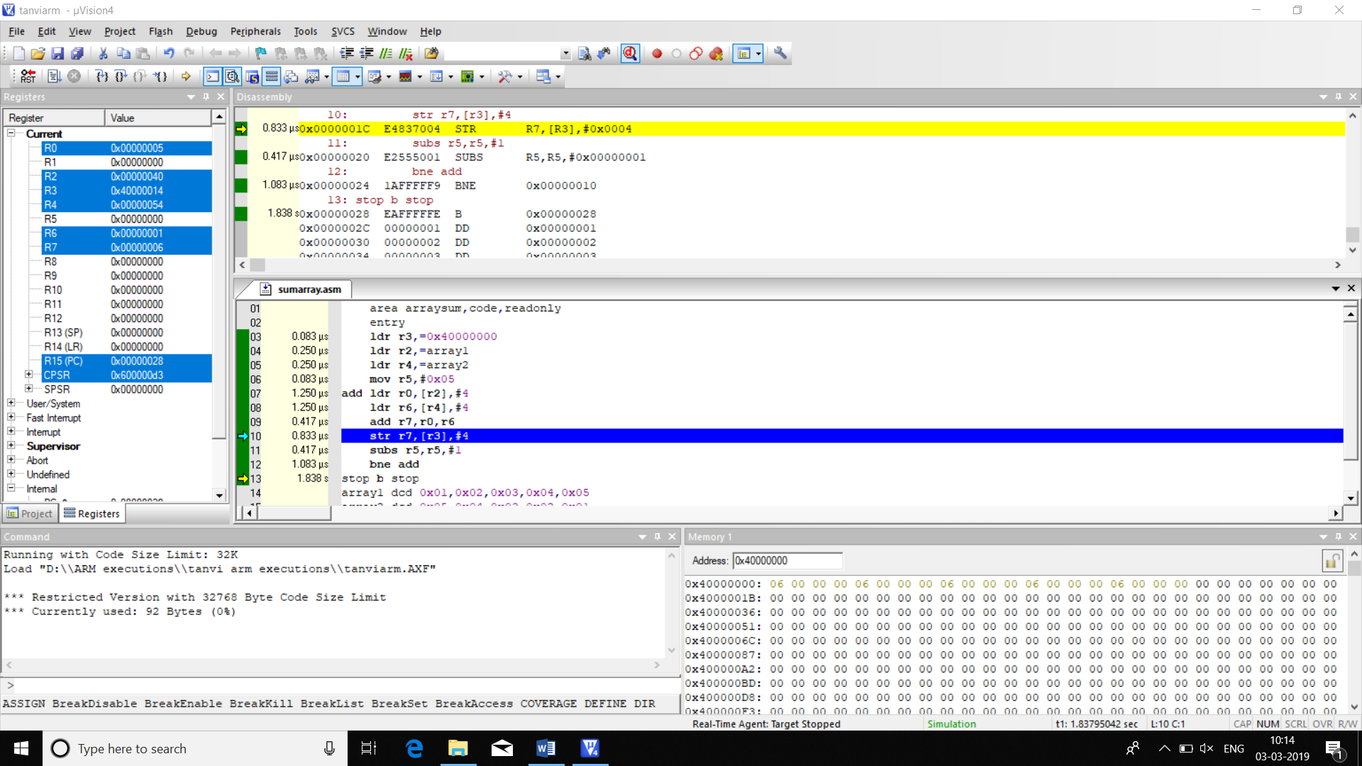

|  |  |  |
| --- | --- | --- |
|  | MEMORY | TIMETAKEN |
| CODE1 | 92B | 7.754us |

**21****.ALP TO FIND THE SUM OF ALL EVEN NUMBERS IN AN ARRAY**

AREA EVSUM,CODE,READONLY

ENTRY

MOV R3,#0

MOV R5,#0X05

LDR R0,=0X40000000

LOOP LDR R2,[R0],#4

MOVS R6,R2,ROR #1

ADDCC R3,R3,R2

SUBS R5,R5,#0X01

BNE LOOP

STOP B STOP

END

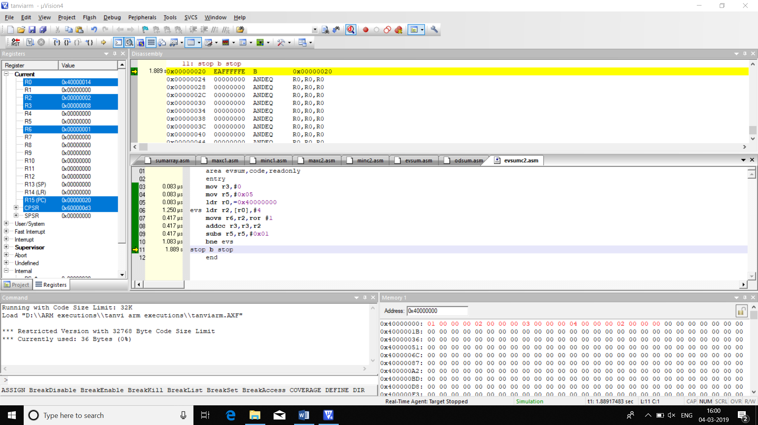

|  |  |  |
| --- | --- | --- |
|  | MEMORY | TIME TAKEN |
| CODE | 36bytes | 3.833us |

**22. ALP TO FIND THE SUM OF ALL ODD NUMBERS IN AN ARRAY**

AREA ODSUM,CODE,READONLY

ENTRY

MOV R3,#0

MOV R5,#0X05

LDR R0,=0X40000000

LOOP LDR R2,[R0],#4

MOVS R6,R2,ROR #1

ADDCC R3,R3,R2

SUBS R5,R5,#0X01

BNE LOOP

STOP B STOP

END

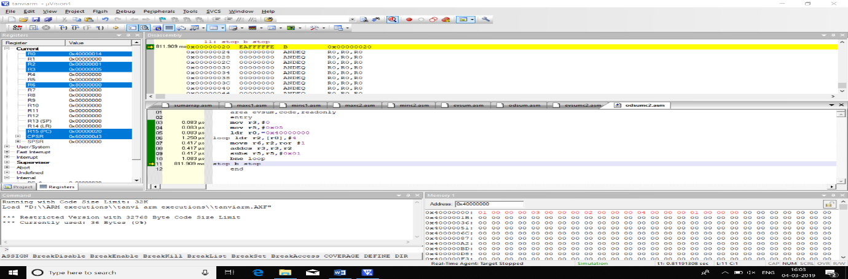

|  |  |  |
| --- | --- | --- |
|  | MEMORY | TIME TAKEN |
| CODE | 36bytes | 3.833us |

**23. ALP TO FIND THE SUM OF ALL THE NEGATIVE NUMBERS IN AN ARRAY**

AREA NEG,CODE,READONLY

ENTRY

MOV R3,#0

MOV R0,#0X05

LDR R1,=0X40000000

LOOP LDR R2,[R1],#4

CMP R2,#0X00

ADDMI R3,R3,R2

SUBS R0,R0,#0X01

BNE LOOP

STOP B STOP

END

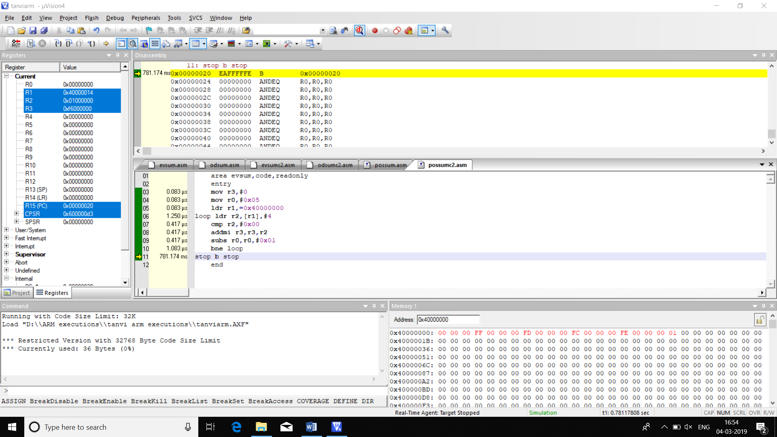

|  |  |  |
| --- | --- | --- |
|  | MEMORY | TIME TAKEN |
| CODE | 36bytes | 3.833us |

**24***.***ALP TO FIND THE SUM OF ALL THE POSITIVE NUMBERS IN AN ARRAY**

AREA EVSUM,CODE,READONLY

ENTRY

MOV R3,#0

MOV R0,#0X05

LDR R1,=0X40000000

LOOP LDR R2,[R1],#4

CMP R2,#0X00

ADDPL R3,R3,R2

SUBS R0,R0,#0X01

BNE LOOP

STOP B STOP

END

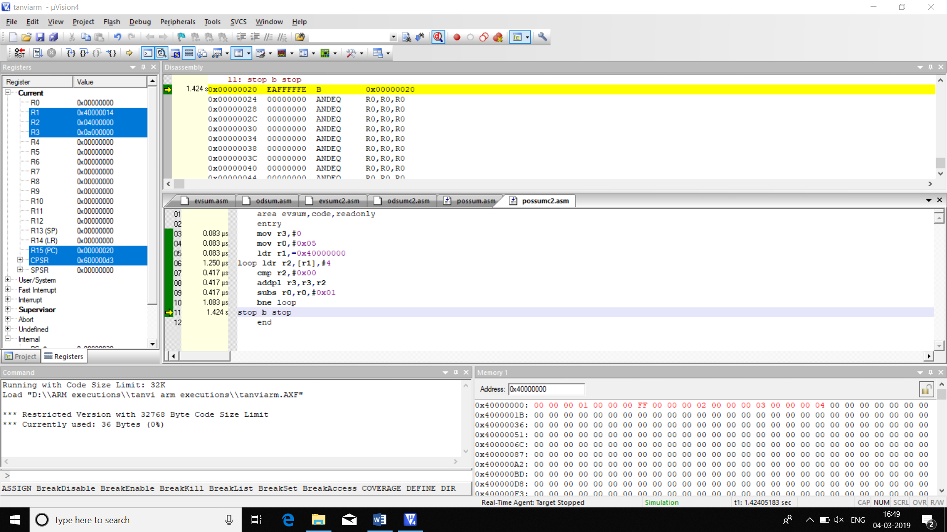

|  |  |  |
| --- | --- | --- |
|  | MEMORY | TIME TAKEN |
| CODE | 36bytes | 3.833us |

**25. ALP TO SORT ARRAY IN ASCENDING ORDER**

AREA ASC,CODE,READONLY

ENTRY

MOV R0,#0X05

LOOP LDR R5,=0X40000000

ADD R6,R5,#4

MOV R3,#0X04

IN LDR R1,[R5]

LDR R2,[R6]

CMP R1,R2

BCC LOP

MOV R4,R2

MOV R2,R1

MOV R1,R4

LOP STR R1,[R5]

STR R2,[R6]

ADD R5,R5,#4

ADD R6,R6,#4

SUBS R3,R3,#0X01

BNE IN

SUBS R0,R0,#0X01

BNE LOOP

STOP B STOP

END

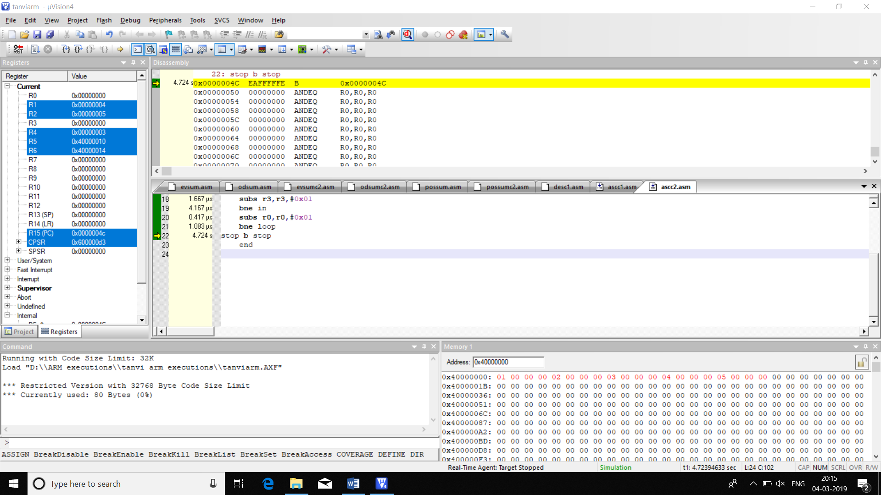

|  |  |  |
| --- | --- | --- |
|  | MEMORY | TIME TAKEN |
| CODE | 80bytes | 35.585us |

**26**.**ALP TO SORT ARRAY IN DESCENDING ORDER**

AREA ASC,CODE,READONLY

ENTRY

MOV R0,#0X05

LOOP LDR R5,=0X40000000

ADD R6,R5,#4

MOV R3,#0X04

IN LDR R1,[R5]

LDR R2,[R6]

CMP R1,R2

BCS LOP

MOV R4,R2

MOV R2,R1

MOV R1,R4

LOP STR R1,[R5]

STR R2,[R6]

ADD R5,R5,#4

ADD R6,R6,#4

SUBS R3,R3,#0X01

BNE IN

SUBS R0,R0,#0X01

BNE LOOP

STOP B STOP

END

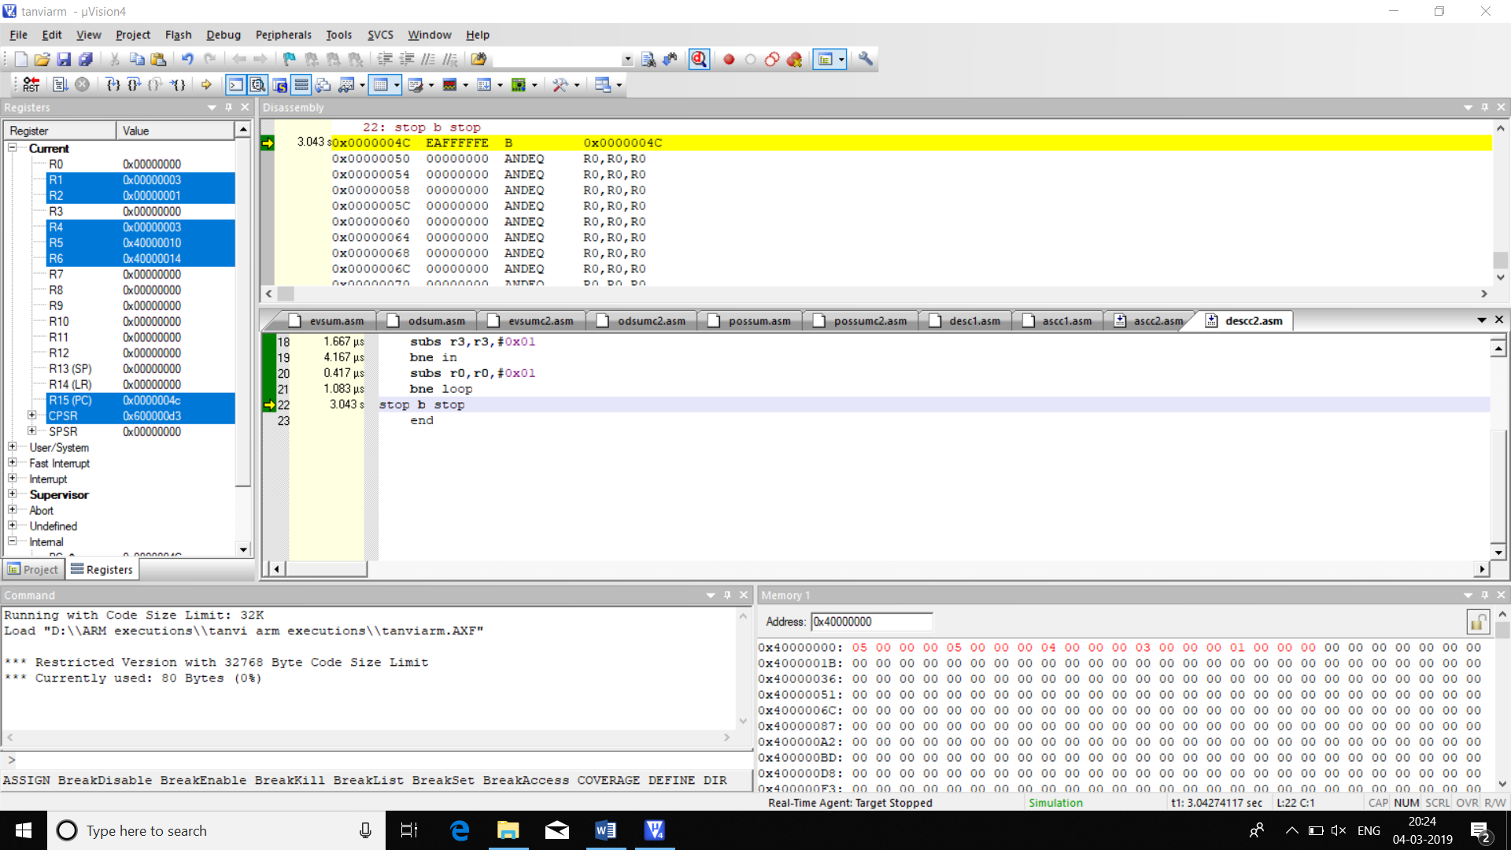

|  |  |  |
| --- | --- | --- |
|  | MEMORY | TIME TAKEN |
| CODE | 80bytes | 35.997us |

**27.SORT ARRAY IN HALF ASCENDING HALF DESCENDING ORDER**

AREA ASC,CODE,READONLY

ENTRY

MOV R0,#0X03

LOOP1 LDR R5,=0X40000000

ADD R6,R5,#4

MOV R3,#0X02

IN1 LDR R1,[R5]

LDR R2,[R6]

CMP R1,R2

BCC LOP1

MOV R4,R2

MOV R2,R1

MOV R1,R4

LOP1 STR R1,[R5]

STR R2,[R6]

ADD R5,R5,#4

ADD R6,R6,#4

SUBS R3,R3,#0X01

BNE IN1

SUBS R0,R0,#0X01

BNE LOOP1

MOV R0,#0X02

LOOP LDR R5,=0X4000000c

ADD R6,R5,#4

MOV R3,#0X01

IN LDR R1,[R5]

LDR R2,[R6]

CMP R1,R2

BCS LOP

MOV R4,R2

MOV R2,R1

MOV R1,R4

LOP STR R1,[R5]

STR R2,[R6]

ADD R5,R5,#4

ADD R6,R6,#4

SUBS R3,R3,#0X01

BNE IN

SUBS R0,R0,#0X01

BNE LOOP

STOP B STOP

END

|  |  |  |
| --- | --- | --- |
|  | MEMORY | TIME |
| CODE | 156 | 15.2us |

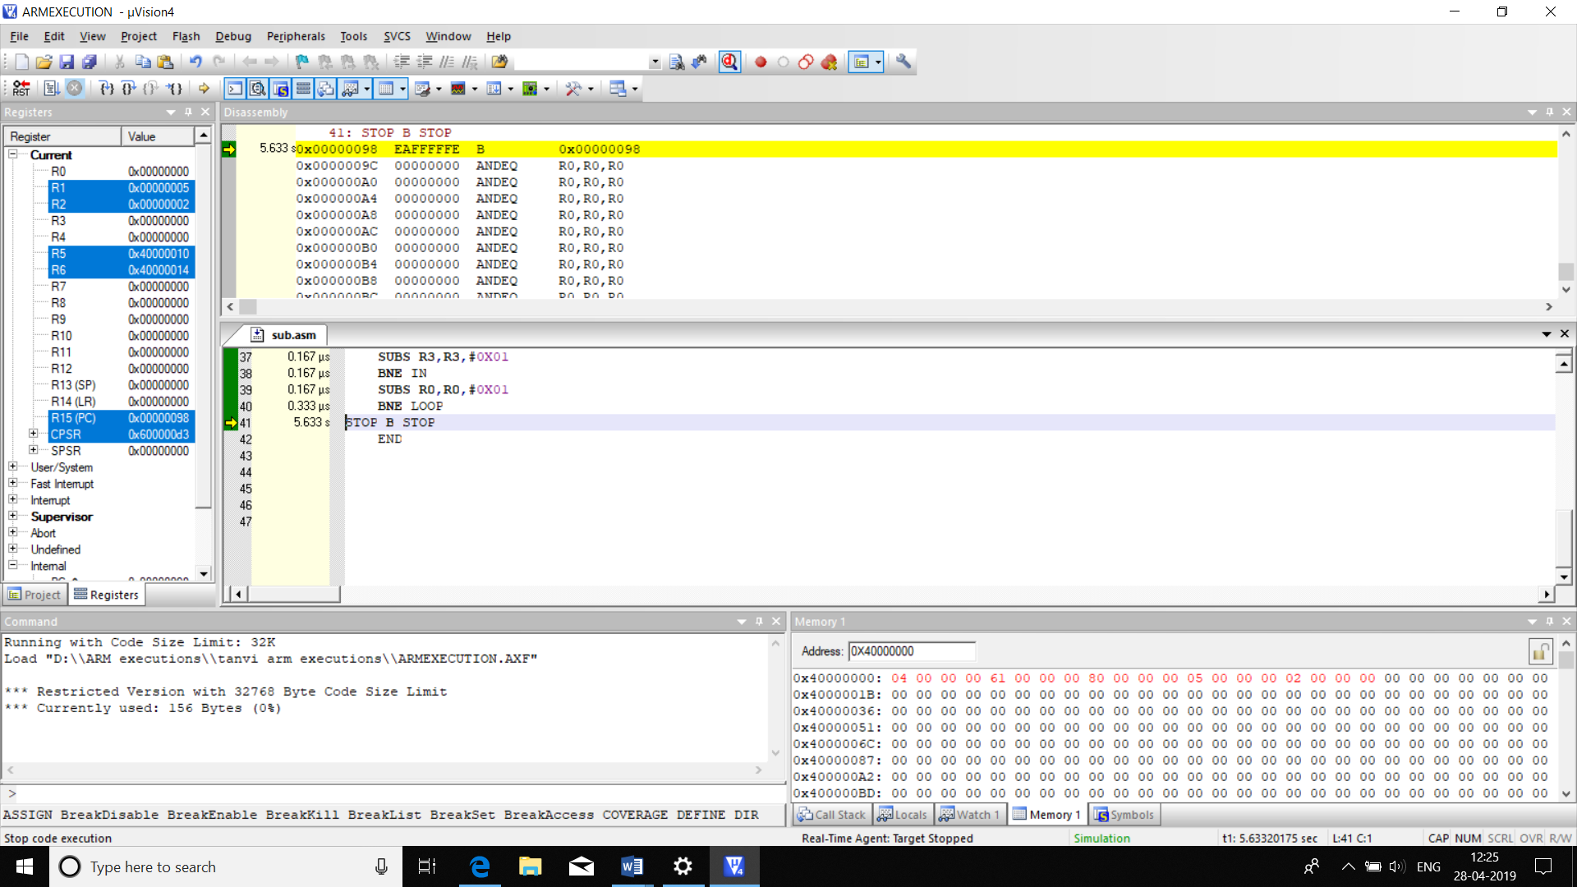

**28.(25)DEVELOP A ARM CODE FOR:**

**a)** AREA CCODE,CODE,READONLY

ENTRY

MOV R0,#00; (a)

CMP R0,#00

BEQ LOOP

SUB R1,R0,#1

B STOP

LOOP ADD R2,R0,#1

STOP B STOP

END

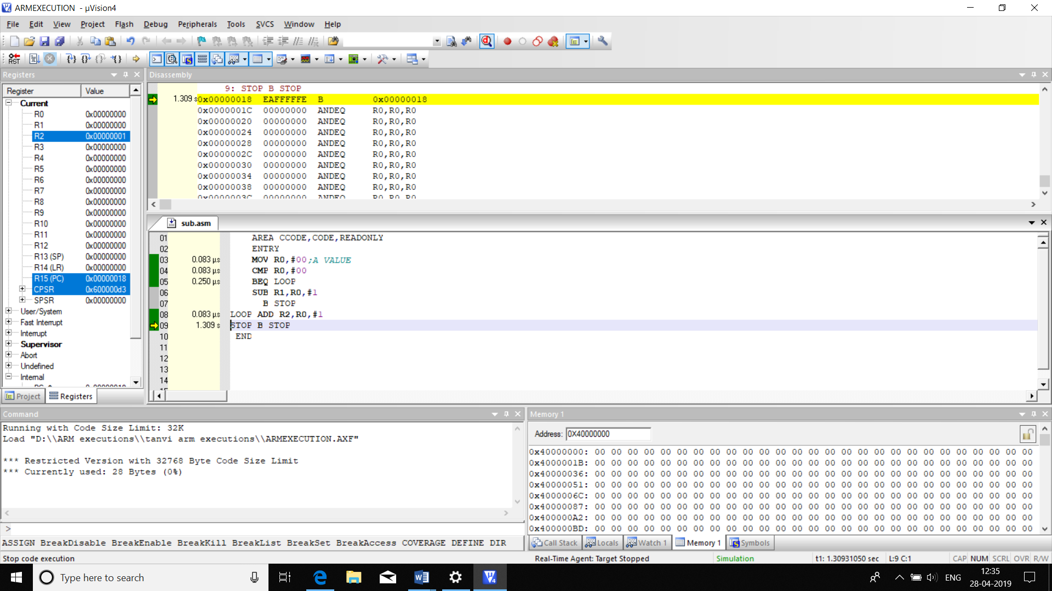

|  |  |  |
| --- | --- | --- |
|  | MEMORY | TIME |
|  | 28B | 0.416us |

**b)** AREA CCODE,CODE,READONLY

ENTRY

MOV R0,#06;(a)

CMP R0,#5

BPL LOOP1

SUB R1,R0,#1

B STOP

LOOP1 ADD R2,R0,#1

STOP B STOP

END

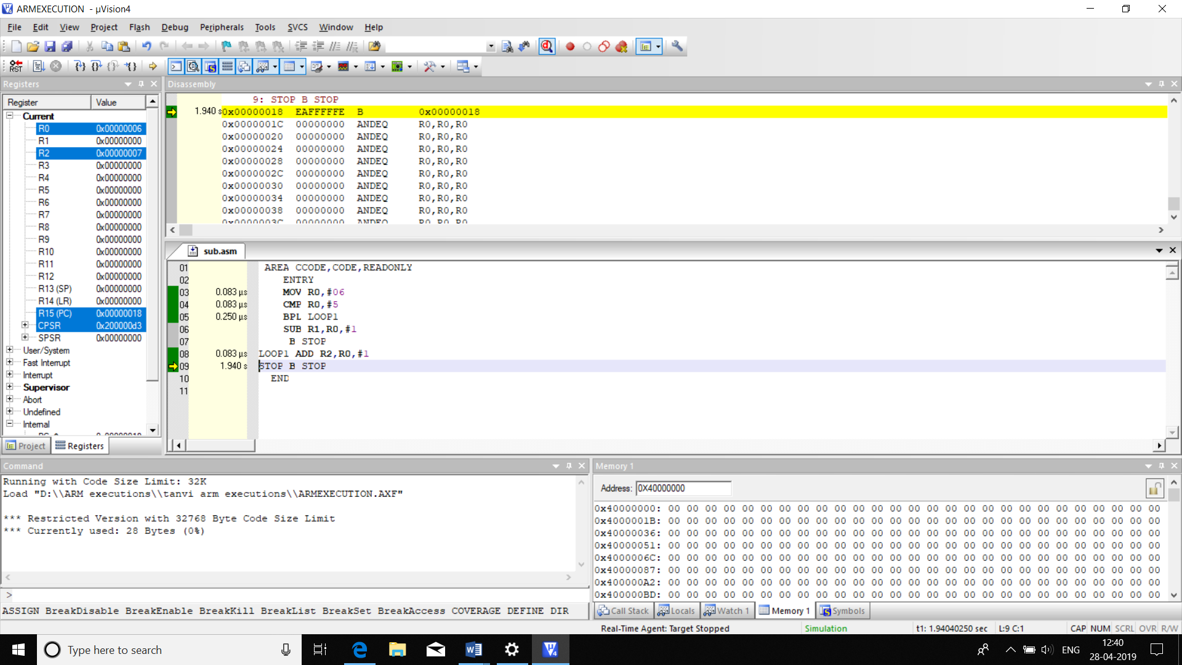

|  |  |  |
| --- | --- | --- |
|  | MEMORY | TIME |
| CODE | 28B | 0.416us |

**29.GENERATE 10 FIBONACCI SERIES**

AREA FIBBO,CODE

ENTRY

MOV R0,#00

SUB R0,R0,#01

MOV R1,#01

MOV R4,#10

LDR R2,=0X40000000

BACK ADD R0,R0,R1

STR R0,[R2],#4

MOV R3,R0

MOV R0,R1

MOV R1,R3

SUBS R4,R4,#01

BNE BACK

STOP B STOP

END

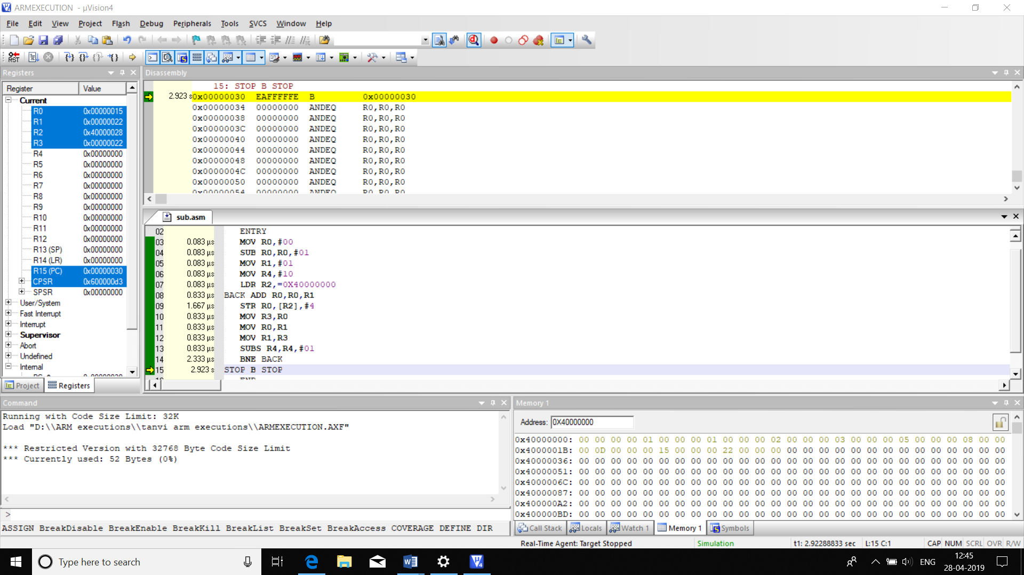

|  |  |  |
| --- | --- | --- |
|  | MEMORY | TIME |
| CODE | 52B | 8.58us |

**30.GENERATE FIST 10 EVEN NUMBERS**

AREA GENE_EVEN,CODE,READONLY

ENTRY

MOV R0,#2

LDR R1,=0X40000000

MOV R2,#10

LOOP STRB R0,[R1],#1

ADD R0,R0,#2

SUBS R2,R2,#1

BNE LOOP

STOP B STOP

END

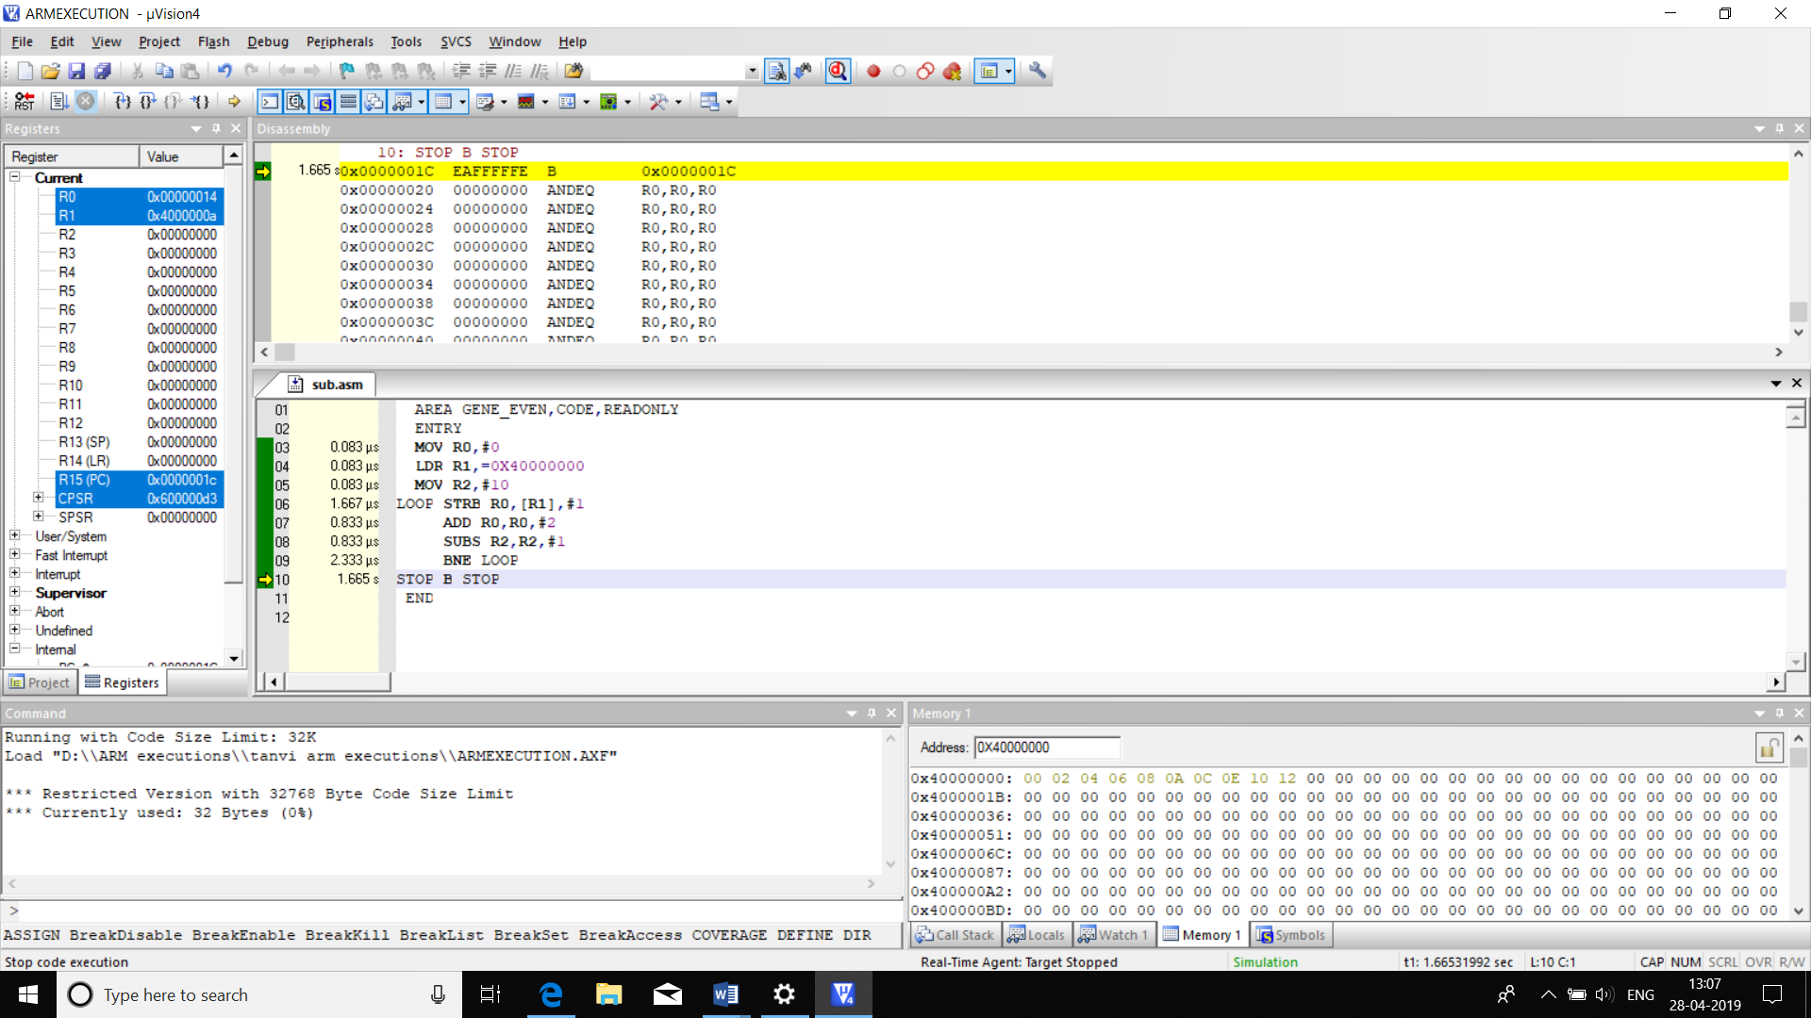

|  |  |  |
| --- | --- | --- |
|  | MEMORY | TIME |
| CODE | 32B | 5.915us |

**31.GENERATE FIRST 10 ODD NUMBERS**

AREA ODD,CODE,READONLY

ENTRY

MOV R0,#1

LDR R1,=0X40000000

MOV R2,#10

LOOP STRB R0,[R1],#1

ADD R0,R0,#2

SUBS R2,R2,#1

BNE LOOP

STOP B STOP

END

|  |  |  |
| --- | --- | --- |
|  | MEMORY | TIME |
| CODE | 32B | 5.915us |

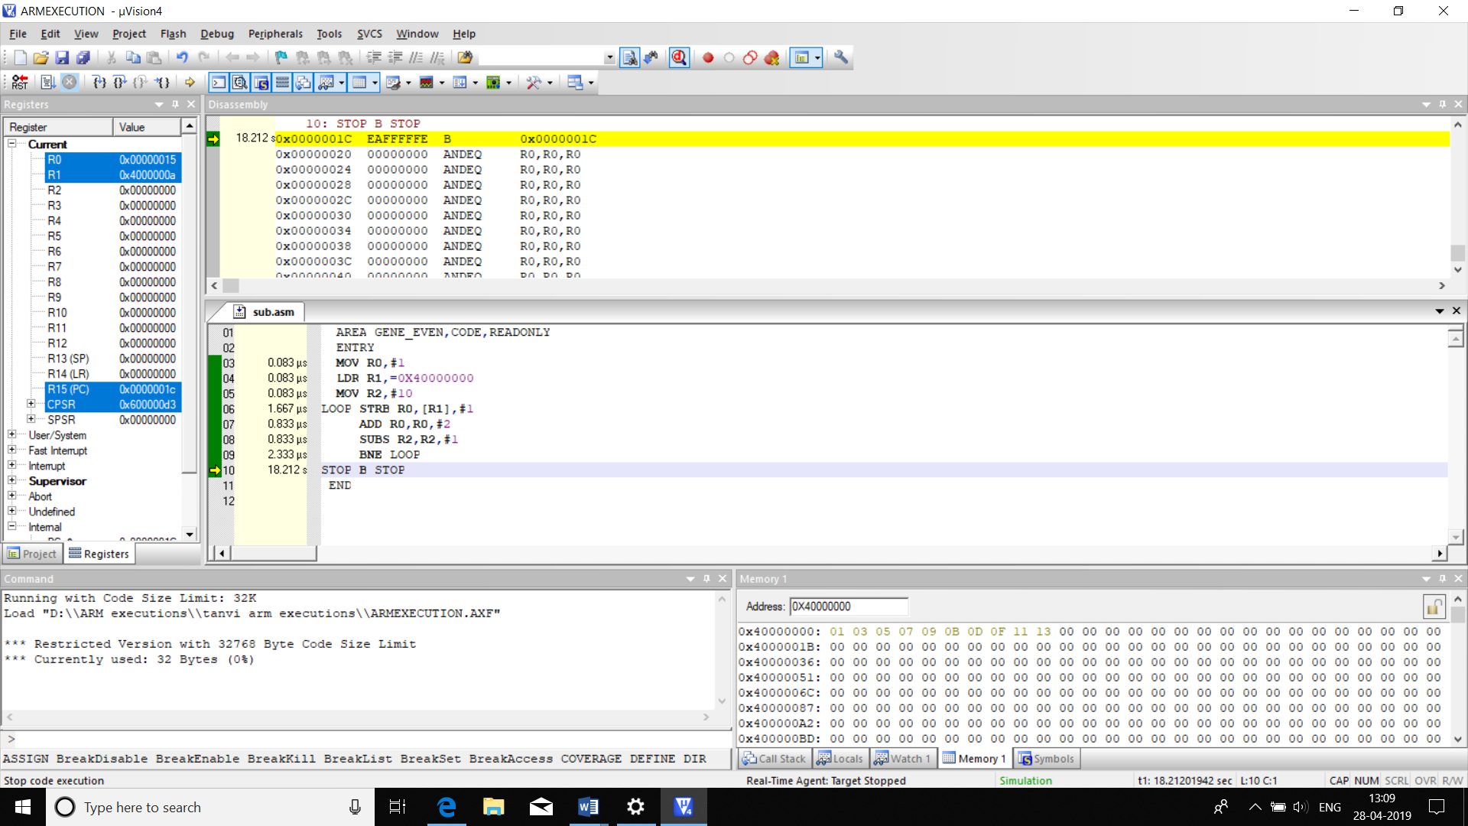

**32.FINDING SQUARE OF A NUMBER WITHOUT USING MULTIPLICATION**

AREA SQUARE_MUL,CODE,READONLY

ENTRY

MOV R0,#3

MOV R1,#00

MOV R2,R0

LOOP ADD R1,R1,R0

SUBS R2,R2,#1

BNE LOOP

STOP B STOP

END

|  |  |  |
| --- | --- | --- |
|  | MEMORY | TIME |
| CODE | 28B | 1.332us |

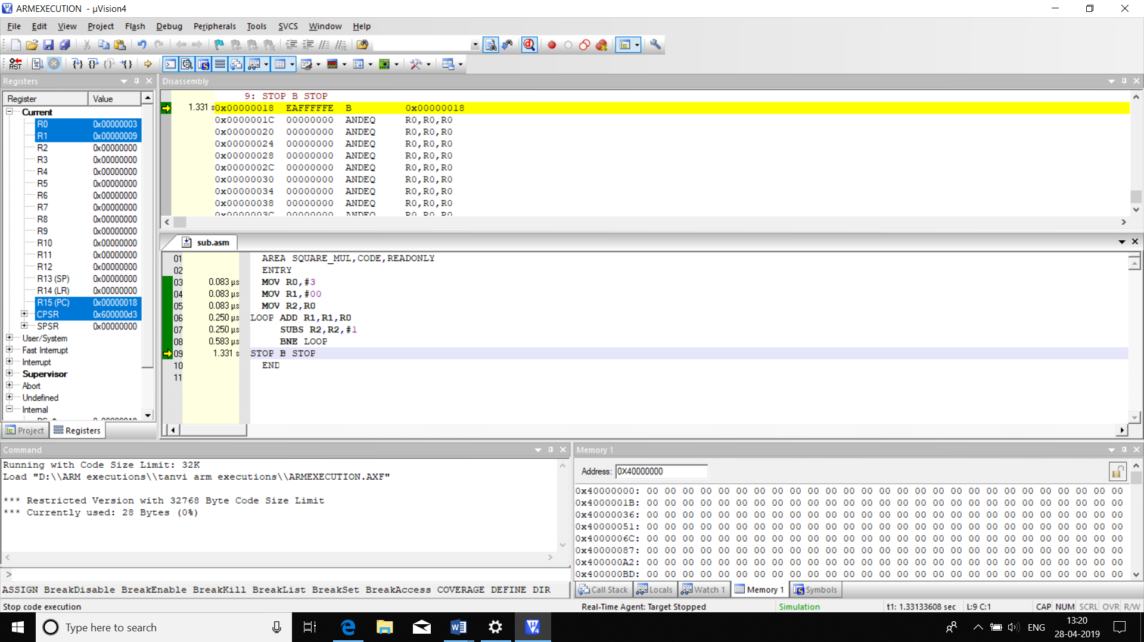

**33.MULTIPLY A NUMBER BY 23 USING SHIFT LOGIC**

AREA SHIFT23,CODE,READONLY

ENTRY

MOV R0,#3

MOV R1,R0

MOV R2,R0

MOVS R1,R1,LSL#4

MOVS R2,R2,LSL #3

ADD R2,R1,R2

SUBS R3,R2,R0

STOP B STOP

END

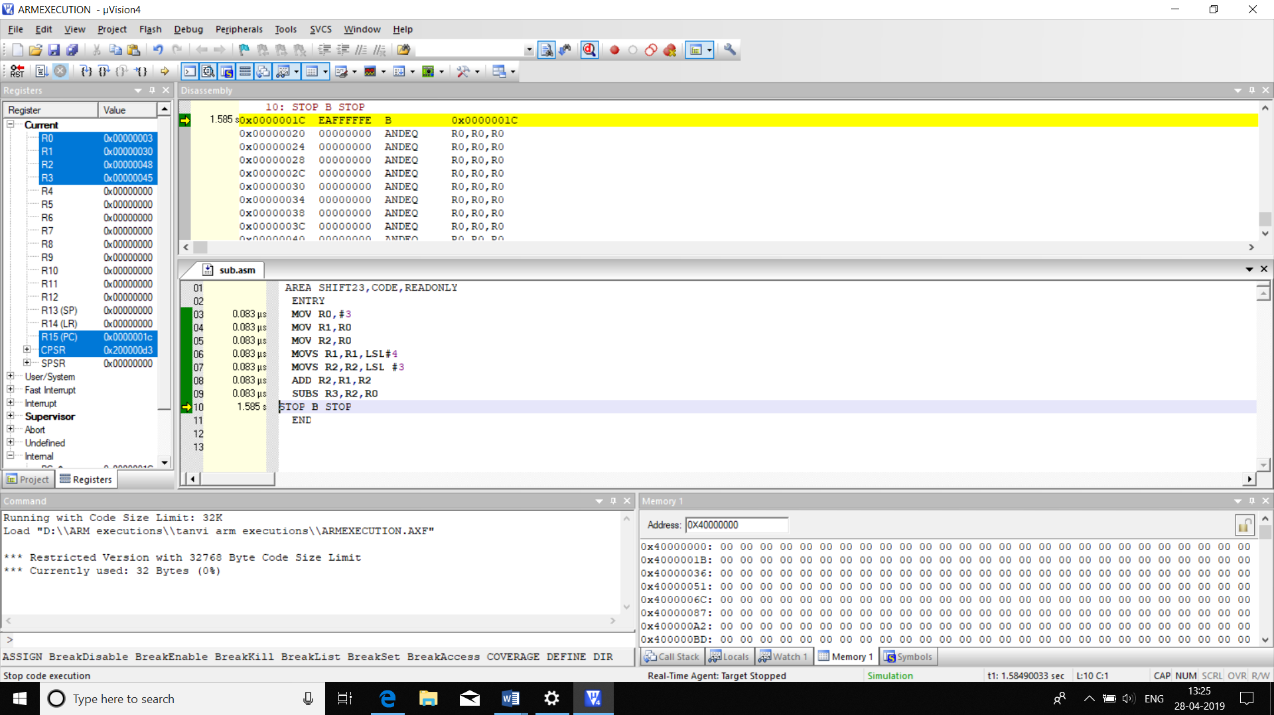

|  |  |  |
| --- | --- | --- |
|  | MEMORY | TIME |
| CODE | 32B | 0.581us |

**34.DEVELOP ARM CODE FOR THE FOLLOWING C PROGRAM CODES**

**a)**

AREA C1,CODE,READONLY

ENTRY

MOV R1,#0X02

MOV R2,#0X05

MUL R0,R1,R2

S B S

END

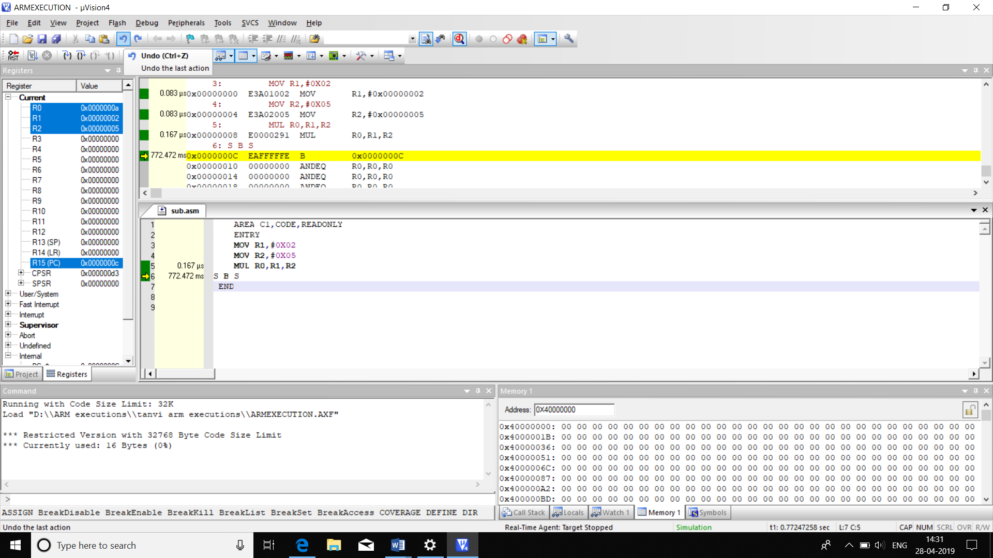

|  |  |  |
| --- | --- | --- |
|  | MEMORY | TIME |
| CODE | 16B | 0.167us |

**b)**

AREA C1,CODE,READONLY

ENTRY

MOV R4,#0X02

MOV R2,#0X0A

MUL R3,R4,R2

S B S

END

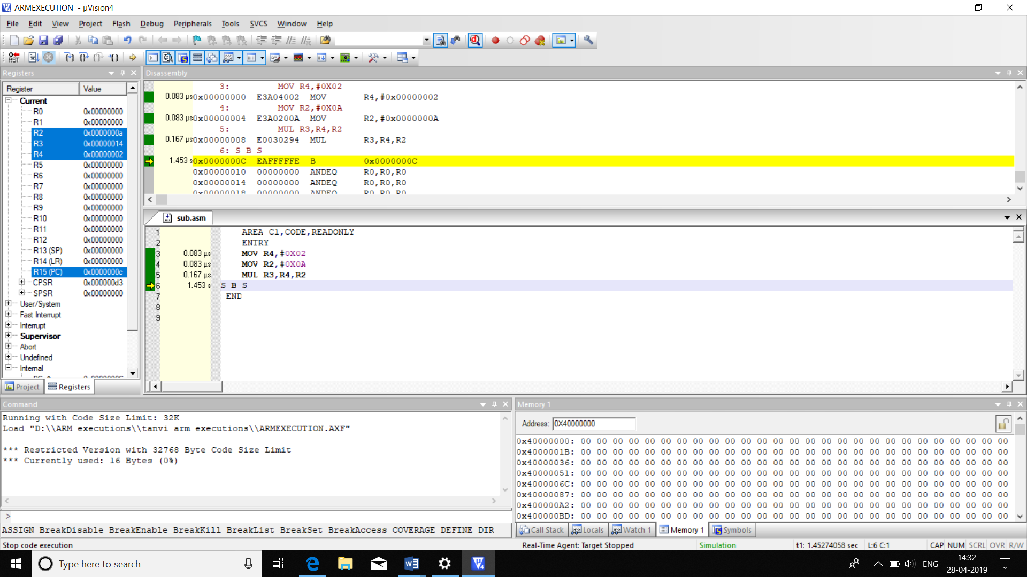

|  |  |  |
| --- | --- | --- |
|  | MEMORY | TIME |
| CODE | **16B** | **0.333** |

**c)**

AREA C1,CODE,READONLY

ENTRY

MOV R3,#0X02

MOV R2,#0X0F

MUL R7,R3,R2

S B S

END

|  |  |  |
| --- | --- | --- |
|  | MEMORY | TIME |
| CODE | **16B** | **0.333** |

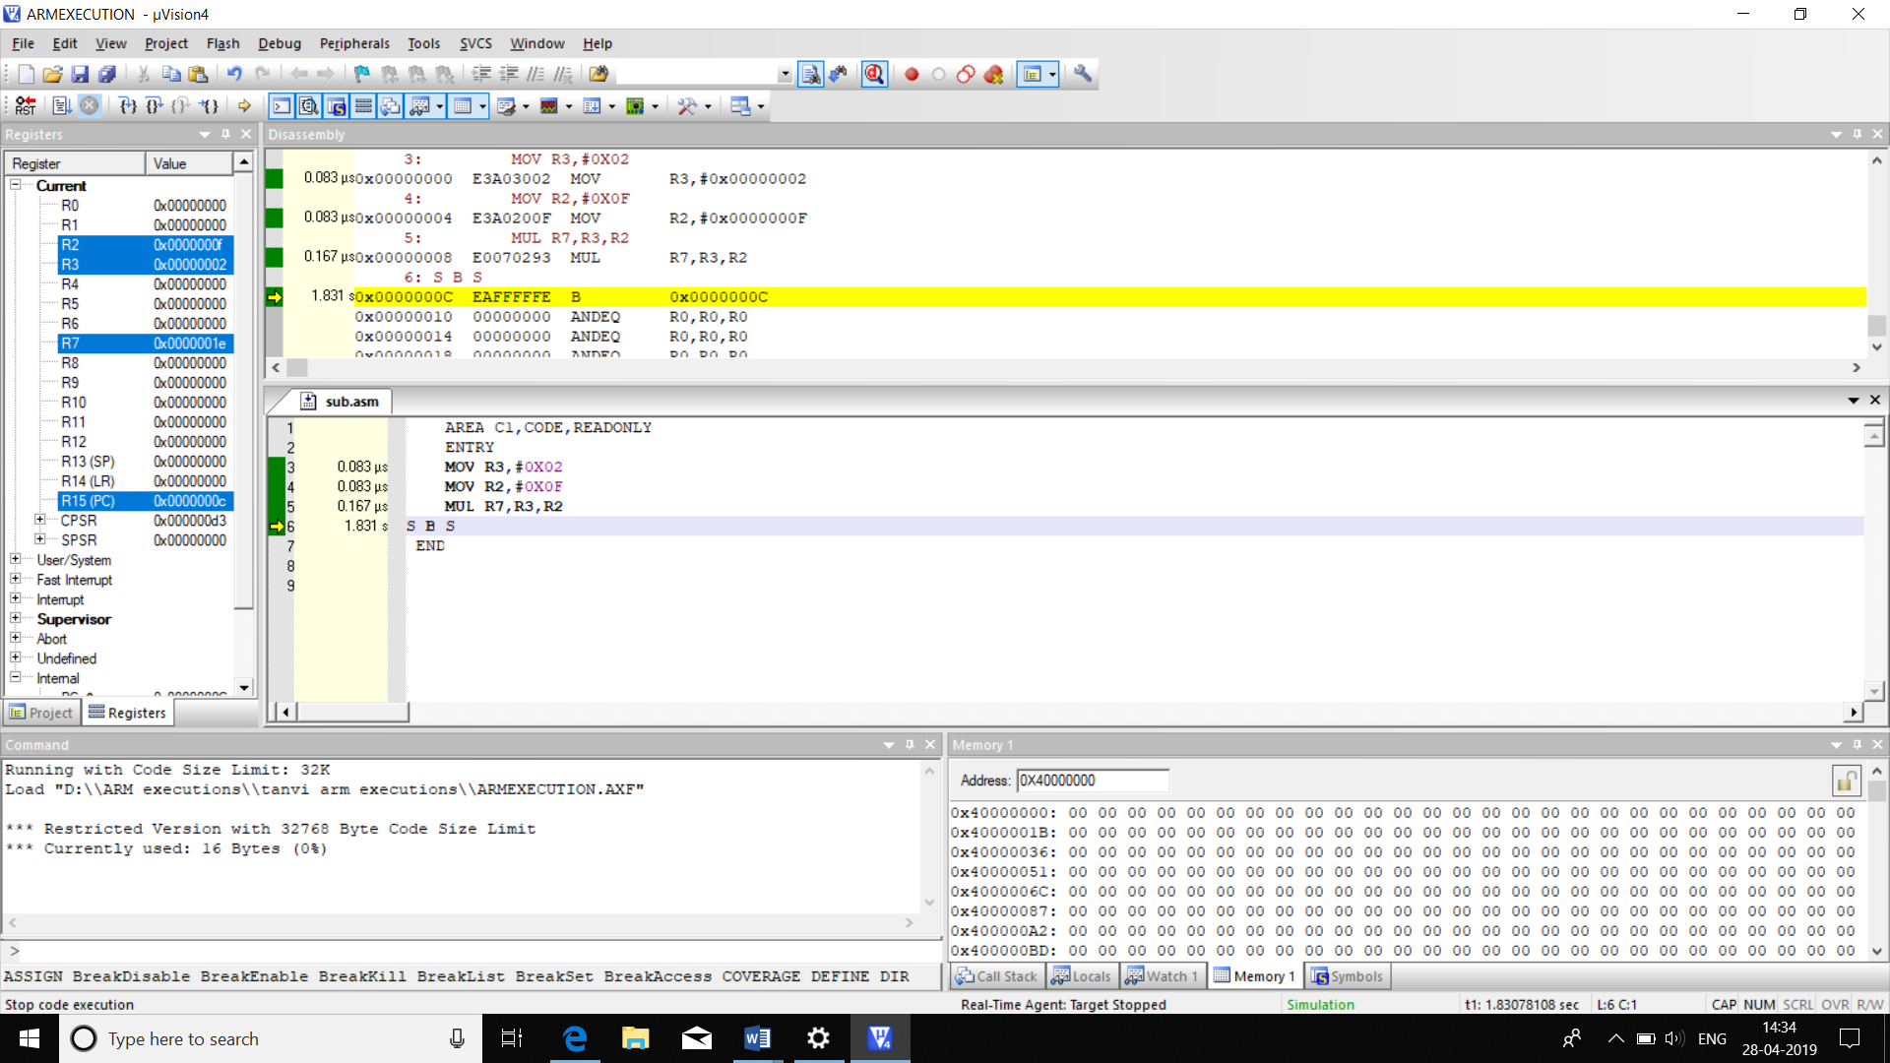

**d)**

AREA C1,CODE,READONLY

ENTRY

MOV R0,#5

MOV R1,#2

CMP R0,R1

BPL LOOP1

MOV R3,#7

MUL R4,R3,R1

ADD R2,R0,R4

B STOP

LOOP1 MOV R5,#4

MUL R6,R5,R1

ADD R2,R0,R6

STOP B STOP

END

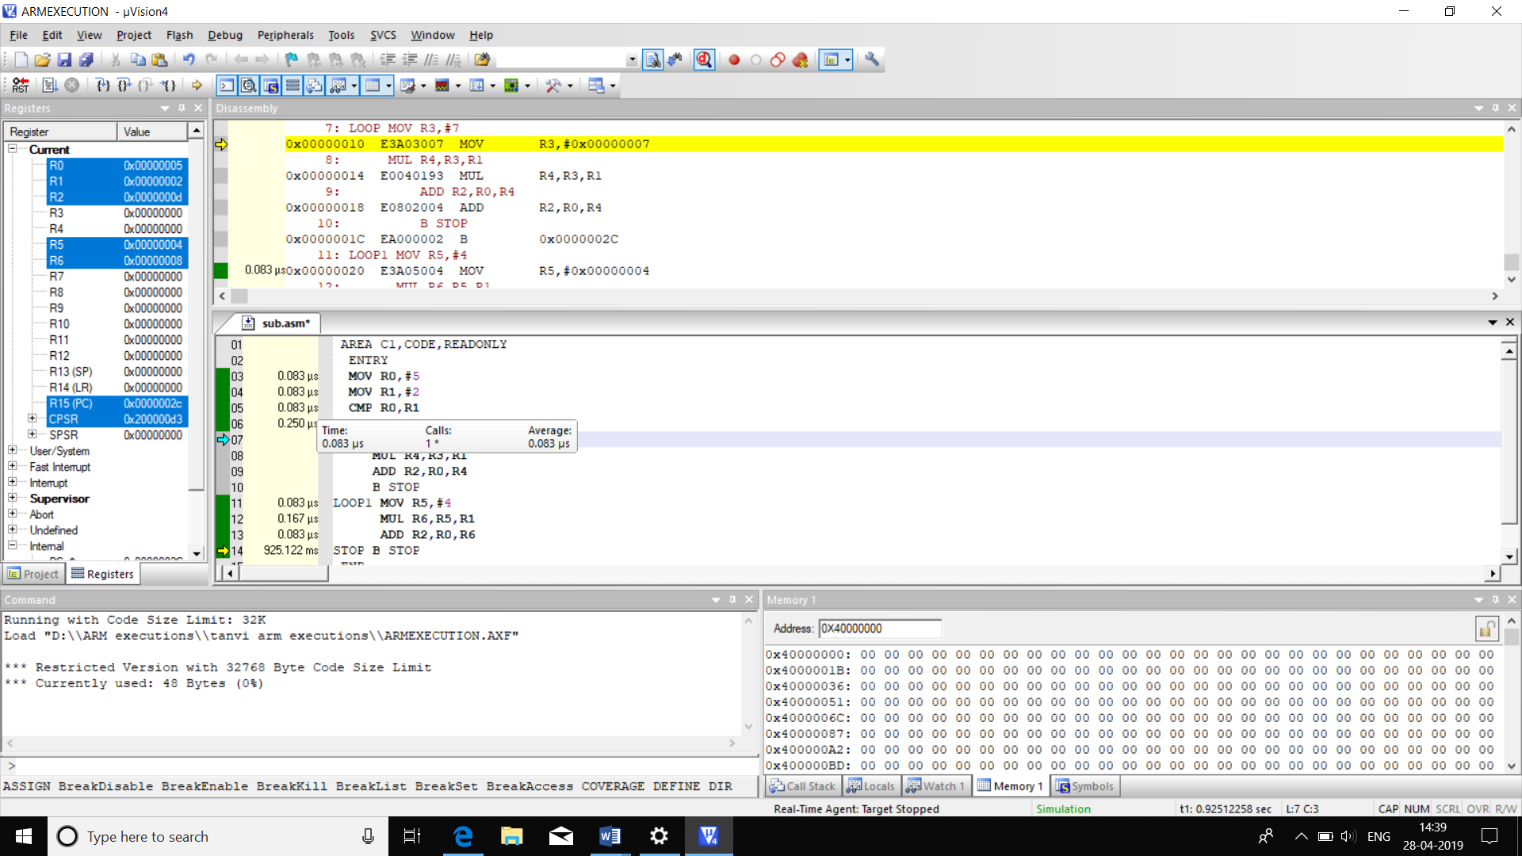

|  |  |  |
| --- | --- | --- |
|  | MEMORY | TIME |
| CODE | 48B | 0.832us |

**e)**

AREA CCODE,CODE,READONLY

MOV R5,#2

MOV R6,#5

MOV R0,#1;A

MOV R1,#1;B

MOV R2,#1;C

CMN R5,R6

BEQ LOOP1

LOOP MUL R3,R0,R1

MUL R4,R1,R2

MUL R7,R0,R2

ADD R8,R3,R4

ADD R9,R8,R7

LOOP1

EOR R3,R0,R1

EOR R3,R3,R2

STOP B STOP

END

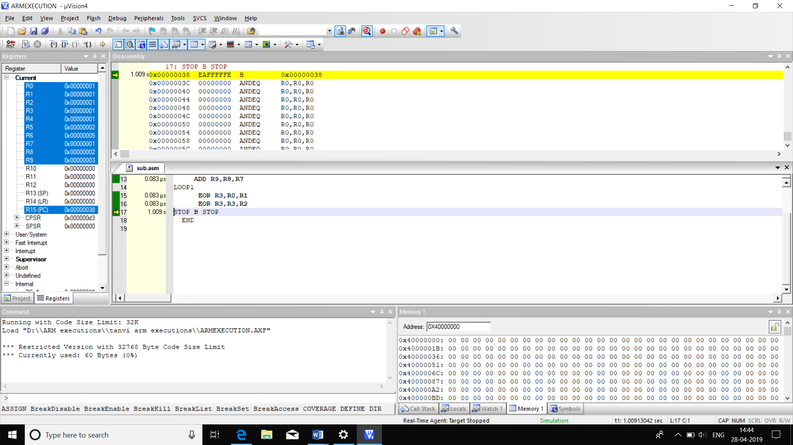

|  |  |  |
| --- | --- | --- |
|  | MEMORY | TIME |
| CODE | 60B | 1.414us |

**35.SEARCH A GIVEN CHARACTER IN A STRING**

AREA SEARCHSTRING,CODE,READONLY

ENTRY

LDR R0,=STRING

LOOP LDRB R2,[R0],#1

CMP R2,#'B'

ADDEQ R3,R3,#1

CMP R2,#0

BNE LOOP

STOP B STOP

STRING DCB "BVB",0

END

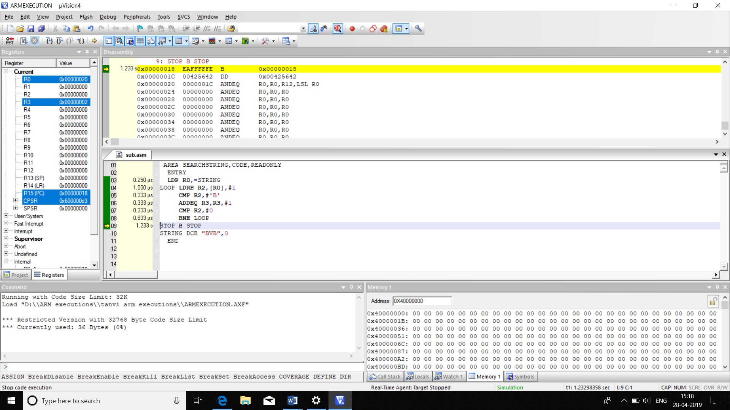

|  |  |  |
| --- | --- | --- |
|  | MEMORY | TIME |
| CODE | 36B | 2.582us |

**36.FIND THE NUMBER OF BLANK SPACES IN STRING**

AREA COUNT,CODE,READONLY

ENTRY

SPACE EQU ' '

LDR R0,=STRING

LOOP LDRB R2,[R0],#1

CMP R2,#SPACE

ADDEQ R3,R3,#1

CMP R2,#0

BNE LOOP

STOP B STOP

STRING DCB "BVB CET ",0

END

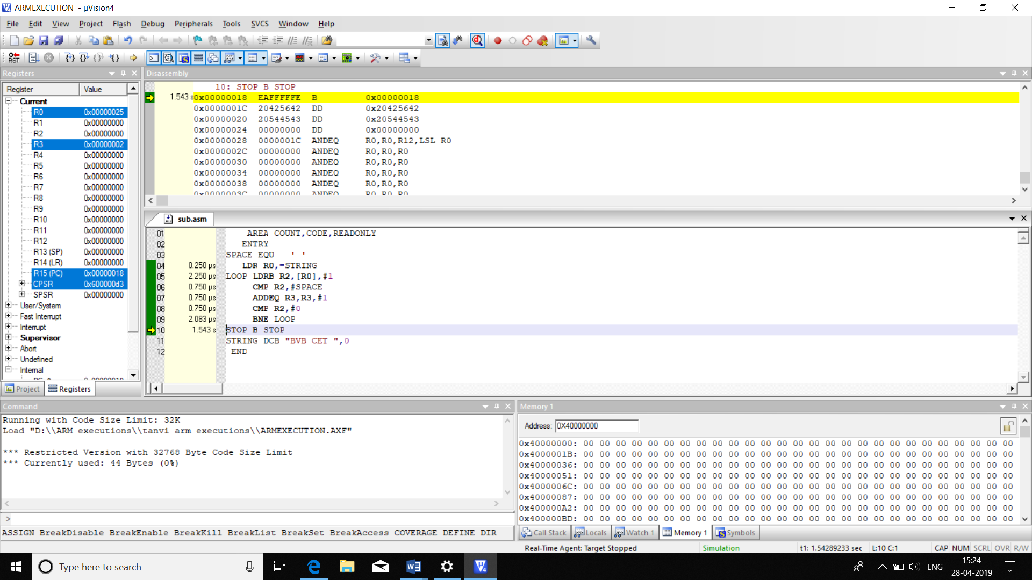

|  |  |  |
| --- | --- | --- |
|  | MEMORY | TIME |
| CODE | 44B | 4.833us |

**37.COMPARE TWO STRINGS FOR LENGTH AND CONTENT**

AREA CMP_STR,CODE,READONLY

ENTRY

LDR R0,=STRING1

LDR R1,=STRING2

MOV R9,R0

MOV R10,R1

MOV R8,#0

LOOP LDRB R2,[R0],#1

CMP R2,#0

ADD R3,R3,#1

BNE LOOP

LOOP1 LDRB R4,[R1],#1

CMP R4,#0

ADD R5,R5,#1

BNE LOOP1

CMP R3,R5

BNE STOP

LOOP2 LDRB R6,[R9],#1

LDRB R7,[R10],#1

CMP R6,R7

ADDEQ R8,R8,#1

CMP R6,#0

BNE LOOP2

CMP R8,R3

ADDEQ R11,R11,#1

STOP B STOP

STRING1 DCB "BVBCET",0

STRING2 DCB "BVB",0

END

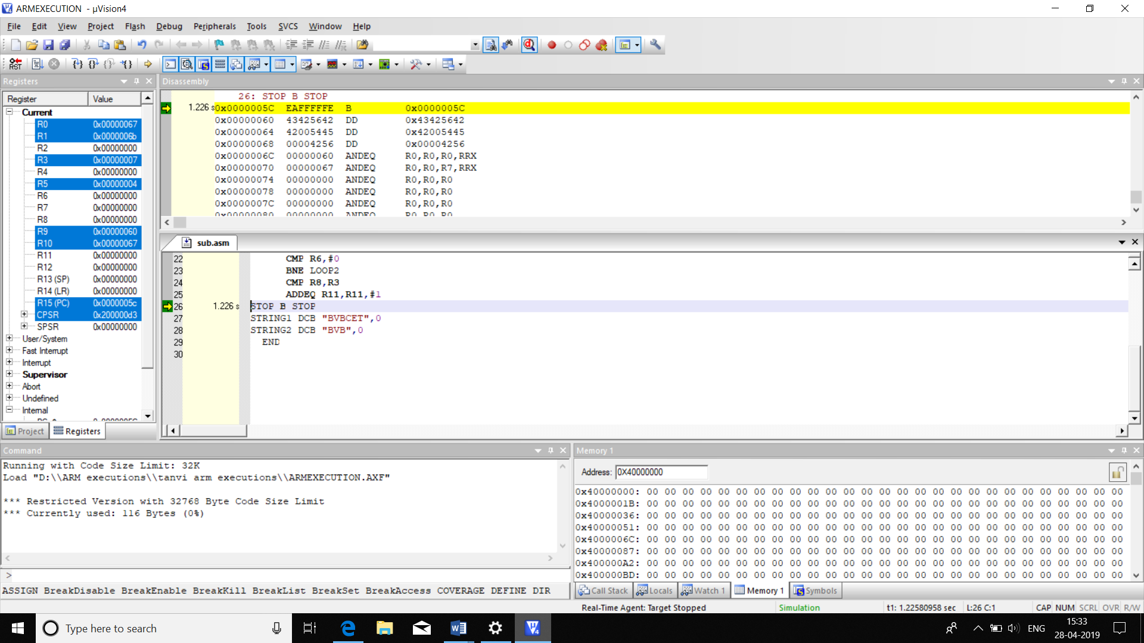

|  |  |  |
| --- | --- | --- |
|  | MEMORY | TIME |
| CODE | 116B | 8.08us |

**38.REVERSE THE STRING**

AREA REV,CODE

ENTRY

LDR R0,=STRING

LDR R10,=0X40000000

MOV R2,#00

LOOP LDRB R1,[R0],#1

CMP R1,#0

ADDNE R3,R3,#1

BNE LOOP

SUBS R0,R0,#2

LOOP1 LDRB R1,[R0],#-1

STRB R1,[R10],#1

SUBS R3,R3,#1

BNE LOOP1

STOP B STOP

STRING DCB "KLETECH",0

END

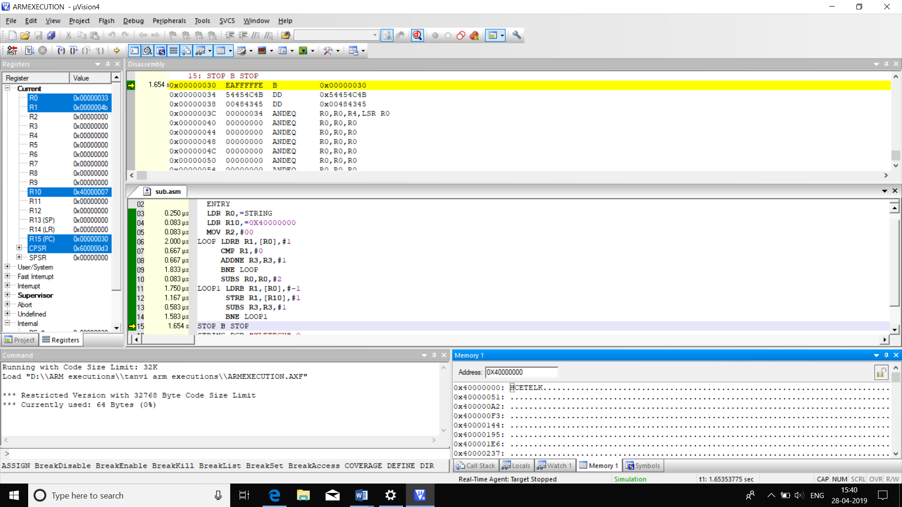

|  |  |  |
| --- | --- | --- |
|  | MEMORY | TIME |
| CODE | 64B | 10.749us |

**39.LENGTH OF CARRIAGE RETURN STRING**

AREA STRING,CODE

ENTRY

LDR R0,=STRIN

MOV R1,#00

LOOP LDRB R2,[R0],#1

CMP R2,#0X0D ;ASCILL OF CARRIAGE RETURN IS 13=0X0D

BEQ STOP

ADD R1,#1

B LOOP

STOP B STOP

STRIN DCB "ABCBD",'\r'

END

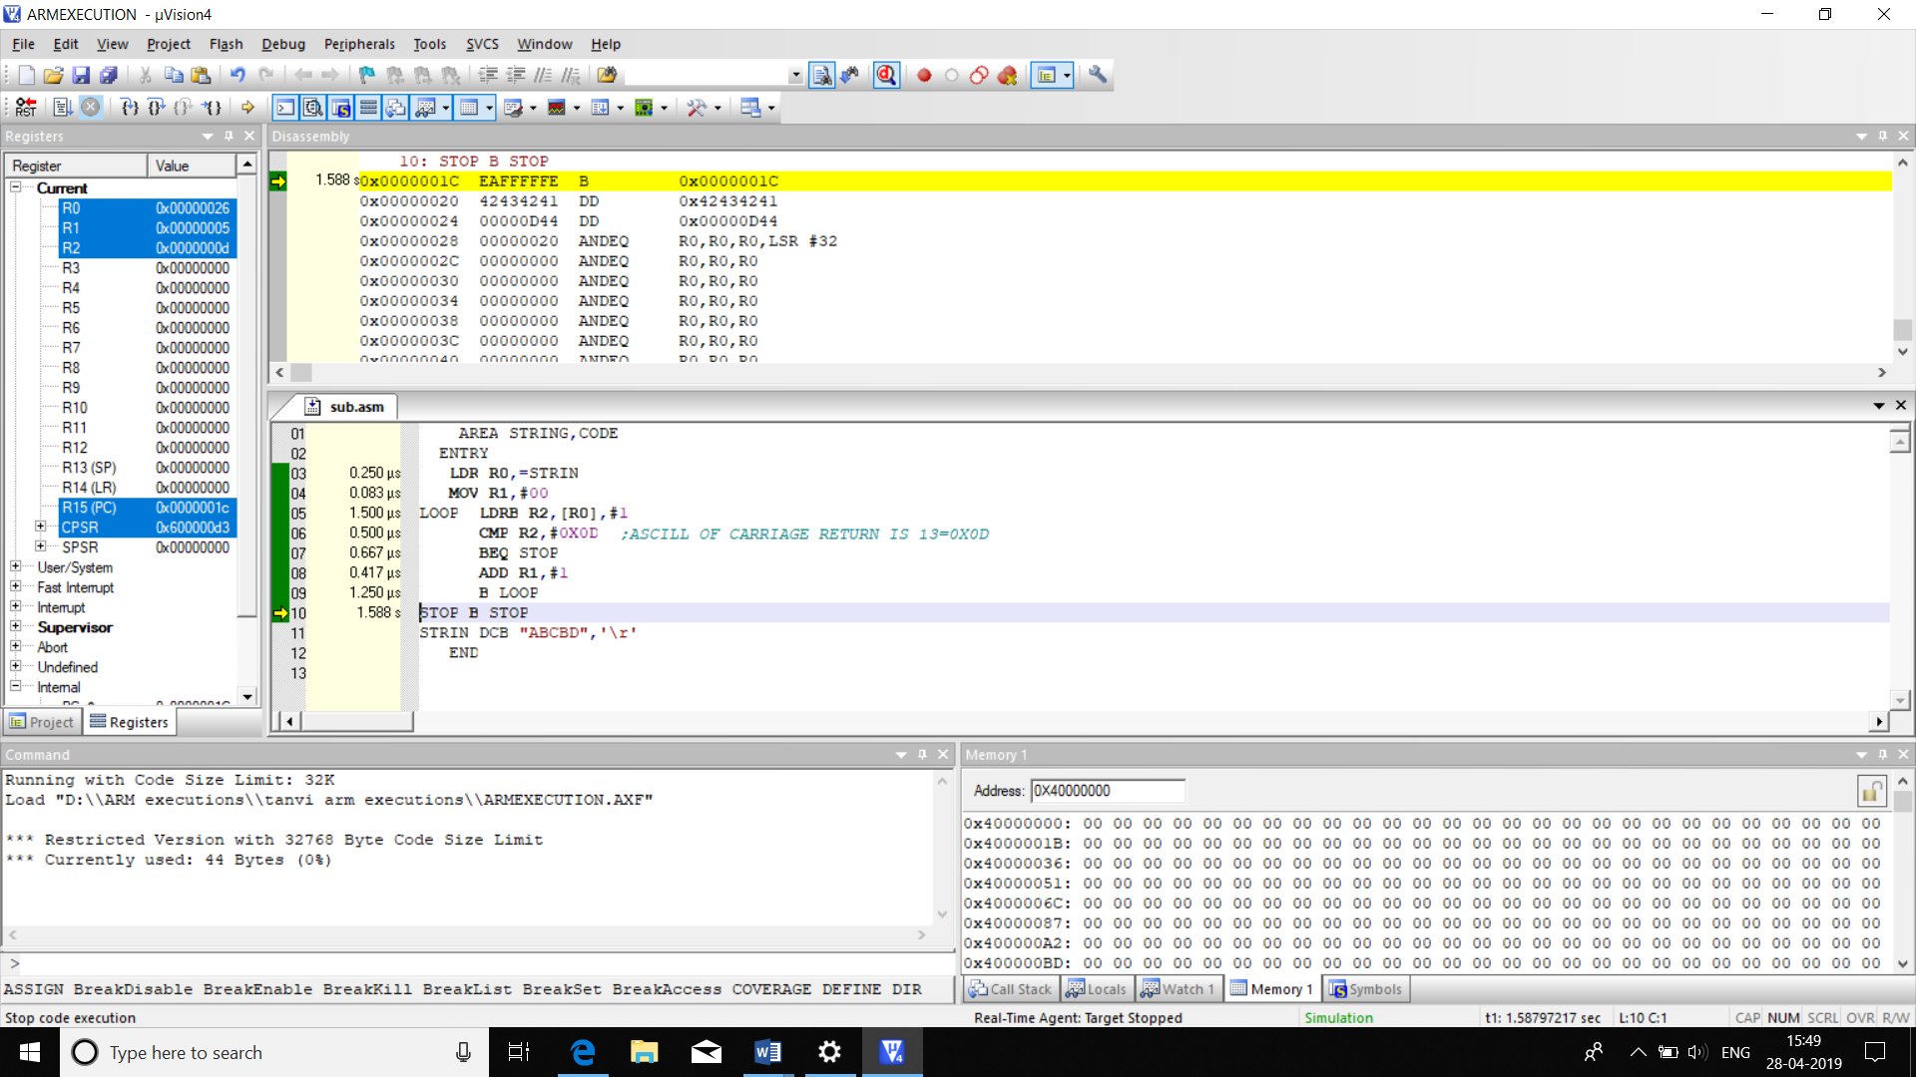

|  |  |  |
| --- | --- | --- |
|  | MEMORY | TIME |
| CODE | **44B** | **4.667us** |

**40.T0 CHECK IF STRING IS PALINDROME OR NOT**

AREA PALIN,CODE,READONLY

ENTRY

LDR R0,=0X40000000

LDR R1,=ARRAY

MOV R10,R1

LEN LDRB R2,[R1],#1

CMP R2,#00

ADDNE R3,R3,#1;STRING LENGTH

BNE LEN

MOV R4,R3

MOV R1,R10

SEC LDRB R2,[R1],#1

STRB R2,[R0],#1

SUBS R3,R3,#1

BNE SEC

MOV R1,R10

SUB R0,R0,#1

CCMP LDRB R5,[R0],#-1

LDRB R6,[R1],#1

CMP R5,R6

ADDNE R7,R7,#1;NOT A PALINDROME IF R7=0

SUBS R4,R4,#1

BNE CCMP

ARRAY DCB "MARK",0

END

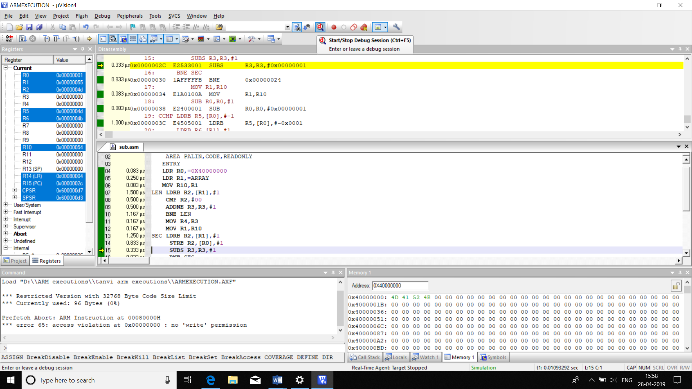

|  |  |  |
| --- | --- | --- |
|  | MEMORY | TIME |
| CODE | 96B | 13.746us |

**41.BLOCK EXCHANGE**

**a) DATA TO STACK**

1.**WITH LDM/STM DATA TO STACK**

AREA BT,CODE,READONLY

ENTRY

LDR R13,=0X40000020

LDR R7,=0X40000000

LDMFD R13,{R1-R3}

MOV R6,R1

SWP R1,R6,[R7]

ADD R7,#4

MOV R6,R2

SWP R2,R6,[R7]

ADD R7,#4

MOV R6,R3

SWP R3,R6,[R7]

STMIA R13,{R1-R3}

S B S

END

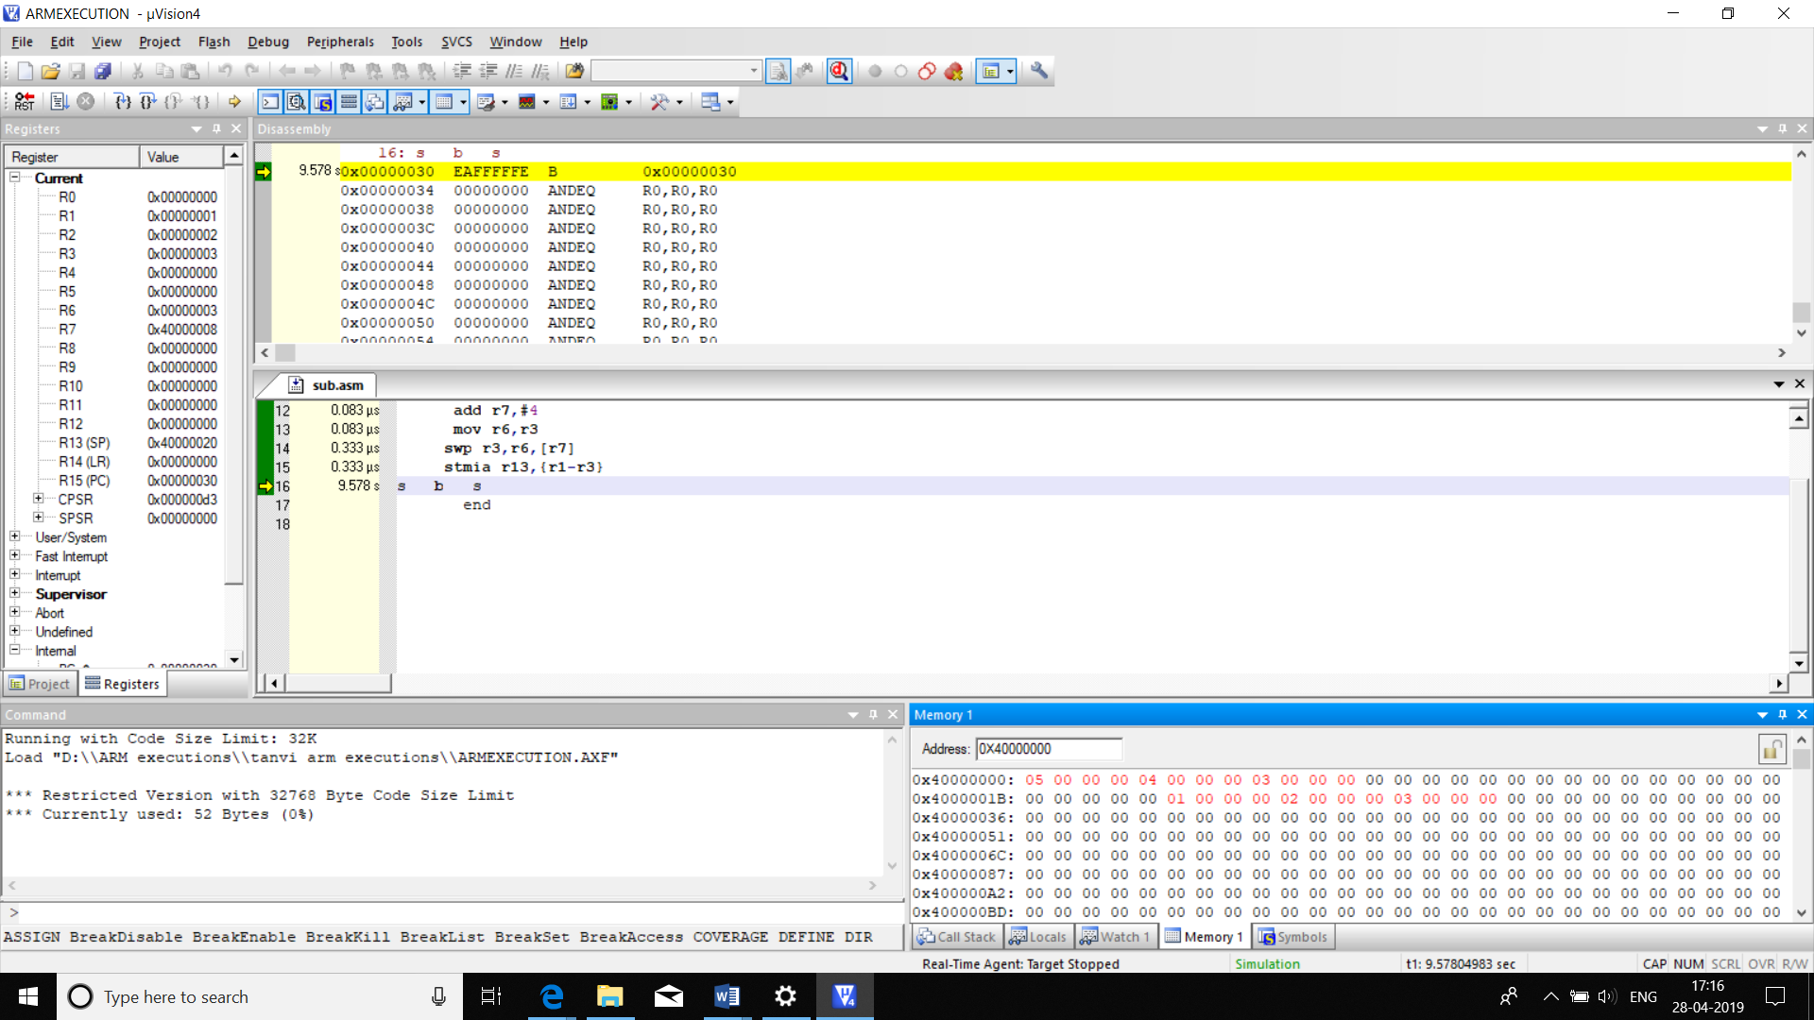

|  |  |  |
| --- | --- | --- |
|  | MEMORY | TIME |
| CODE | 52B | 2.33usG |

2**. WITHOUT USING LDM/STM**

AREA BT,CODE,READONLY

ENTRY

MOV R3,#3

LDR R5,=0X40000020

LDR R7,=0X40000000

LOP LDR R1,[R5]

MOV R6,R1

SWP R1,R6,[R7]

STR R1,[R5]

ADD R5,#4

ADD R7,#4

SUBS R3,#1

BNE LOP

S B S

END

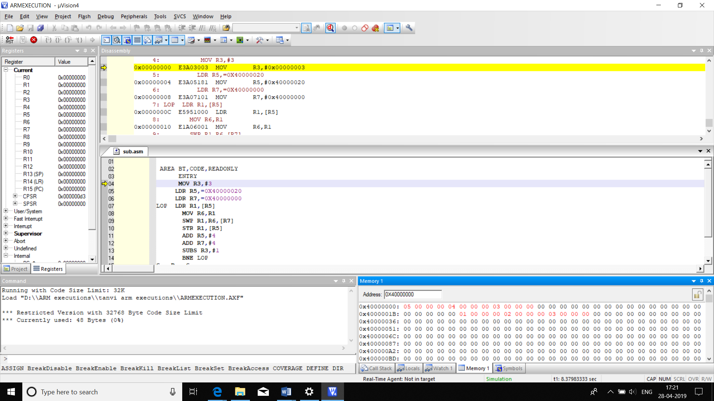

|  |  |  |
| --- | --- | --- |
|  | MEMORY | TIME |
| CODE | 48B | 4.082us |

**b)DATA TO DATA**

**1. WITHOUT USING LDM/STM**

AREA BT,CODE,READONLY

ENTRY

MOV R3,#3

LDR R5,=0X40000020

LDR R7,=0X40000000

LOP LDR R1,[R5]

MOV R6,R1

SWP R1,R6,[R7]

STR R1,[R5]

ADD R5,#4

ADD R7,#4

SUBS R3,#1

BNE LOP

S B S

END

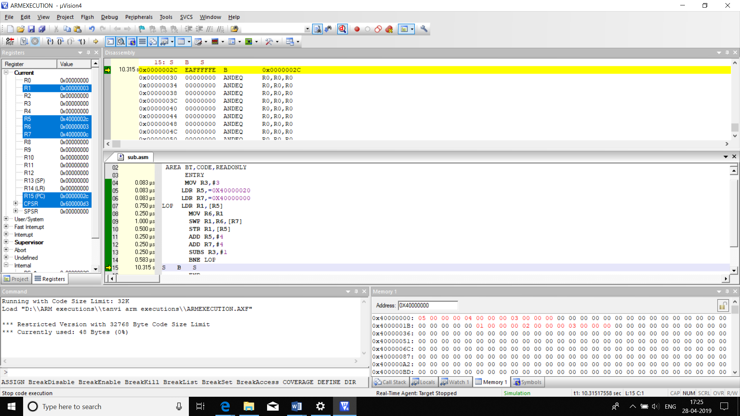

|  |  |  |
| --- | --- | --- |
|  | MEMORY | TIME |
| CODE | 48B | 4.082us |

2. **USING LDM/STM**

AREA BT,CODE,READONLY

ENTRY

LDR R5,=0X40000020

LDR R7,=0X40000000

LDM R5,{R1-R3}

MOV R6,R1

SWP R1,R6,[R7]

ADD R7,#4

MOV R6,R2

SWP R2,R6,[R7]

ADD R7,#4

MOV R6,R3

SWP R3,R6,[R7]

STM R5,{R1-R3}

S B S

END

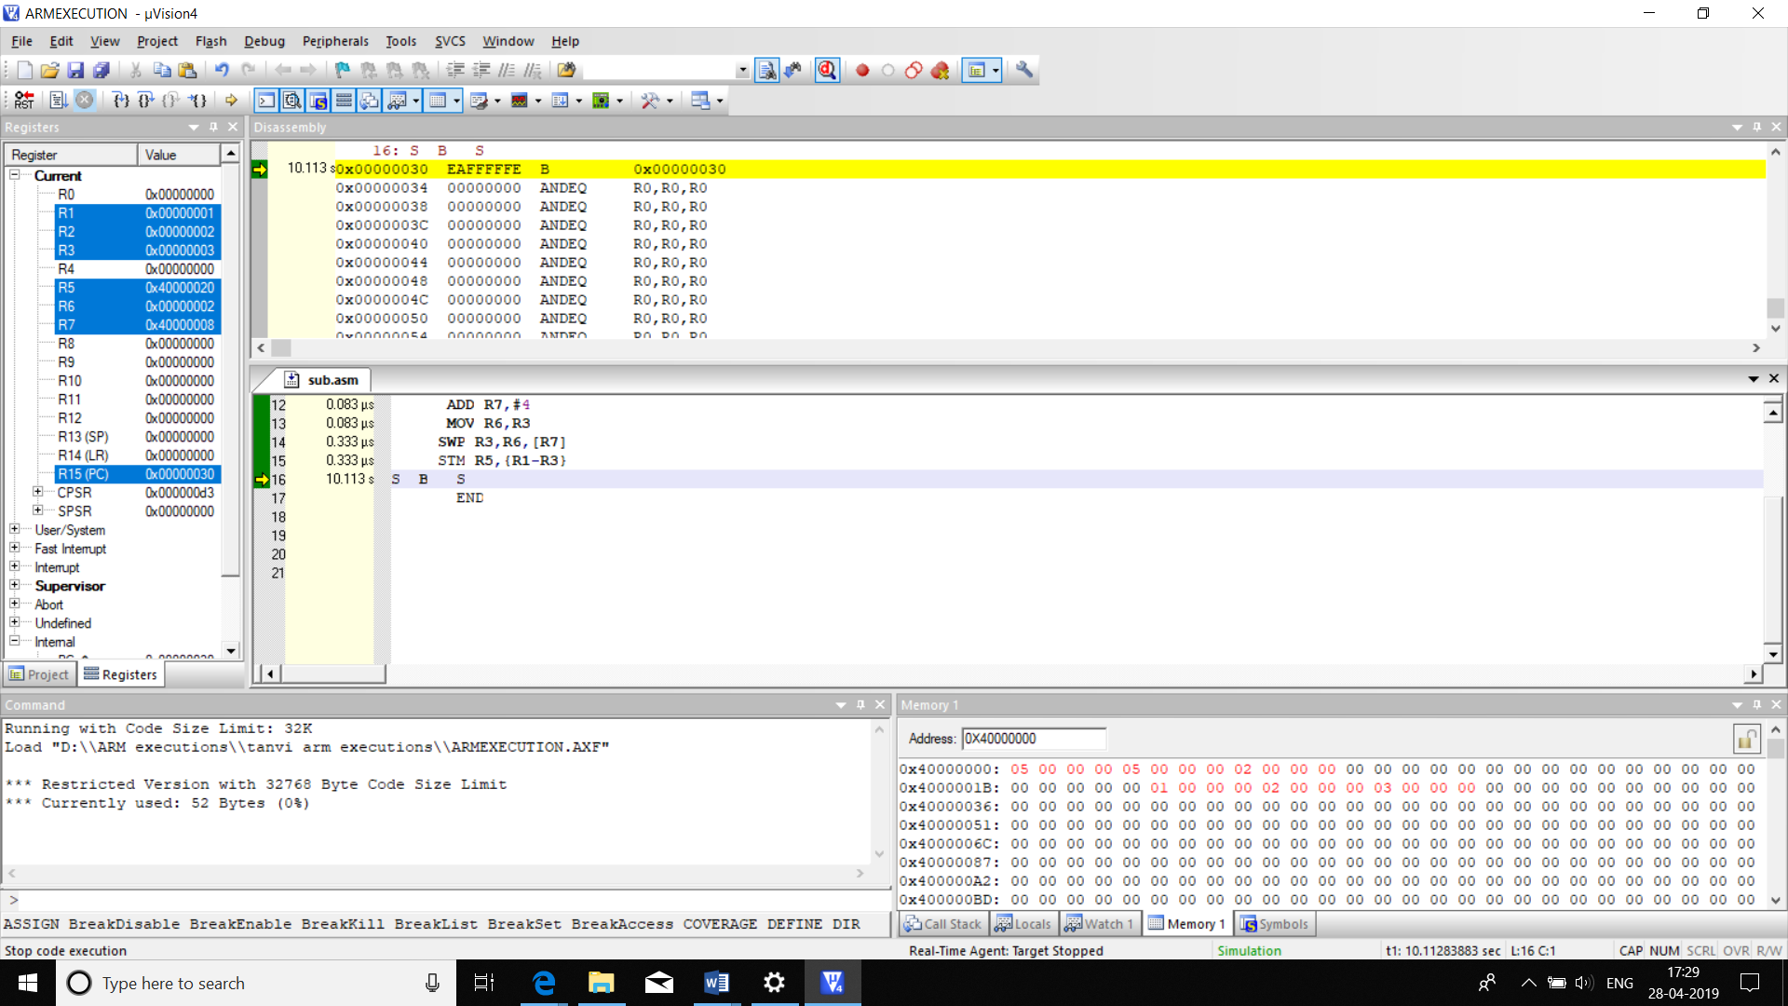

|  |  |  |
| --- | --- | --- |
|  | MEMORY | TIME |
| C0DE | 52B | 2.33us |

**42.BLOCK TRANSFER**

**a)DATA TO DATA MEMORY**

**1.USING LDM/STM**

AREA BT,CODE,READONLY

ENTRY

LDR R5,=0X40000020

LDR R7,=0X40000000

LDMIA R7,{R2-R4}

STMIA R5,{R2-R4}

S B S

END

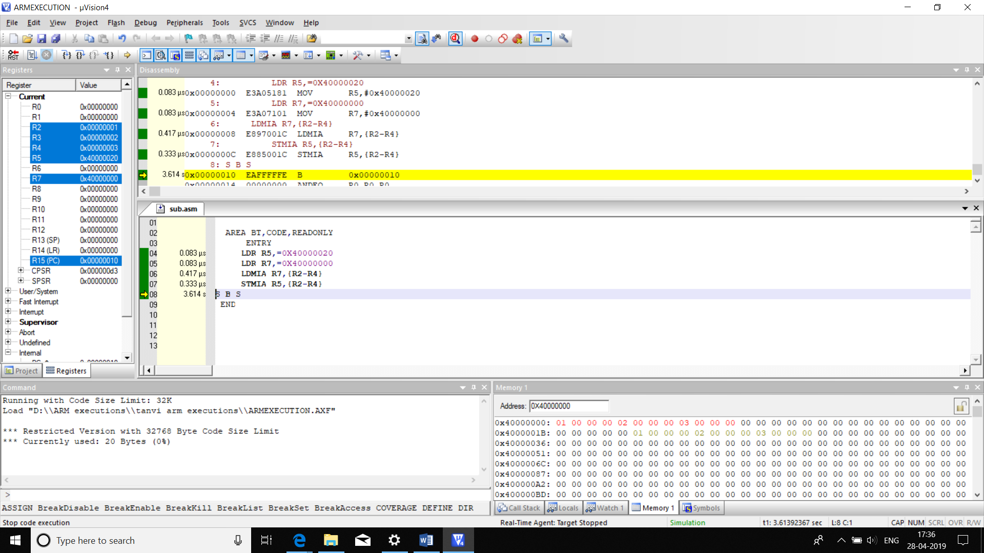

|  |  |  |
| --- | --- | --- |
|  | MEMORY | TIME |
| CODE | 20B | 0.916us |

2.**WITHOUT USING LDM/STM**

AREA BT,CODE,READONLY

ENTRY

LDR R1,=0X40000020

LDR R0,=0X40000000

MOV R5,#0X03

LOOP LDR R2,[R0],#4

STR R2,[R1],#4

SUBS R5,#0X01

BNE LOOP

S B S

END

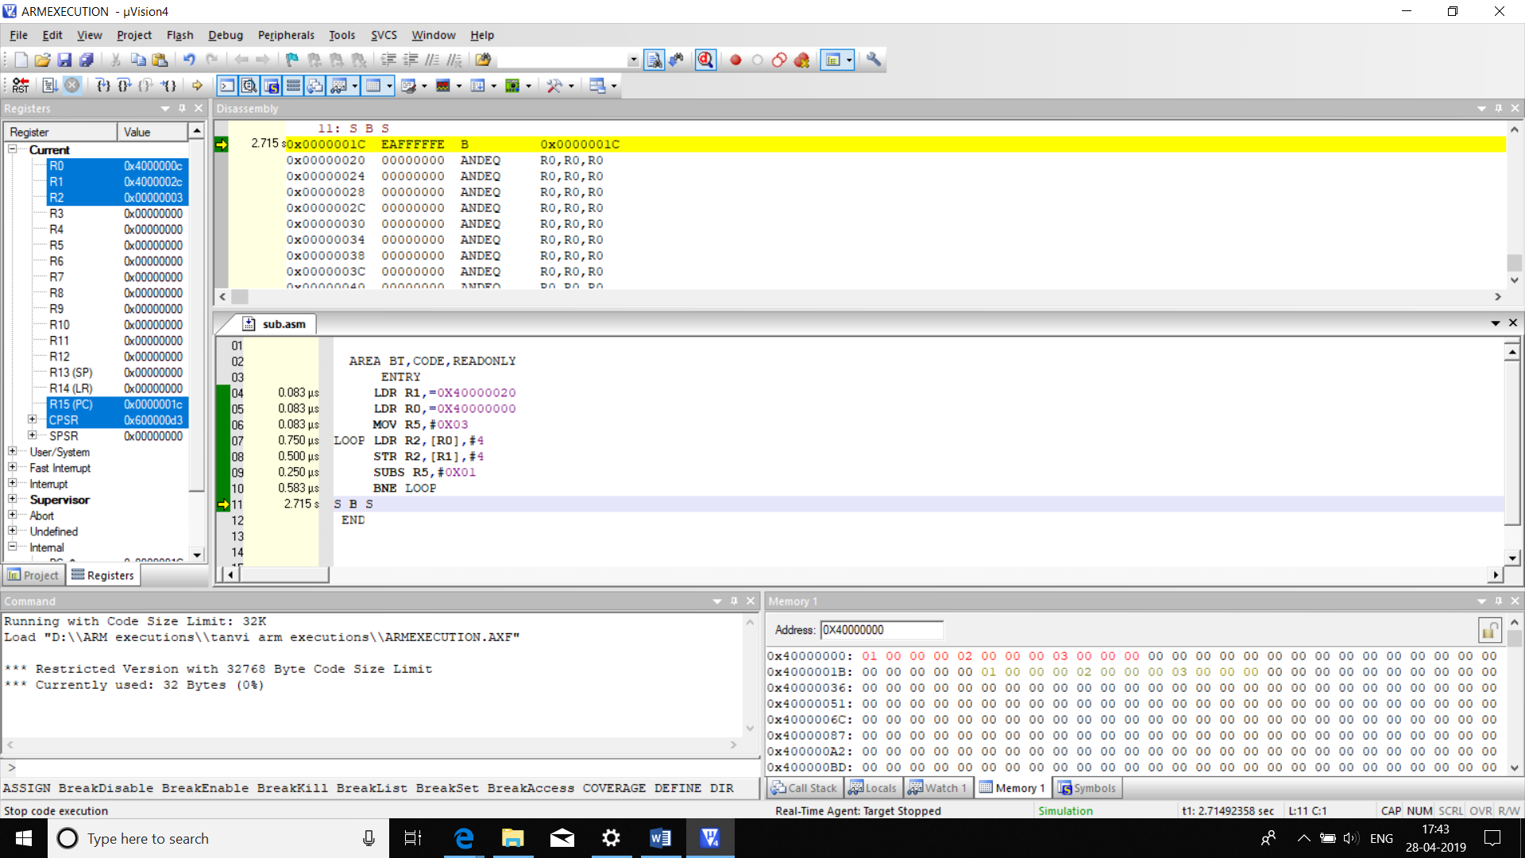

|  |  |  |
| --- | --- | --- |
|  | MEMORY | TIME |
| CODE | 32B | 2.332us |

**b)CODE TO DATA**

**1.WITHOUT LDM/STM**

AREA BT,CODE,READONLY

ENTRY

LDR R1,=ARRAY

LDR R0,=0X40000000

MOV R5,#0X03

LOOP LDR R2,[R1],#4

STR R2,[R0],#4

SUBS R5,#0X01

BNE LOOP

S B S

ARRAY DCD 0X01,0X02,0X03

END

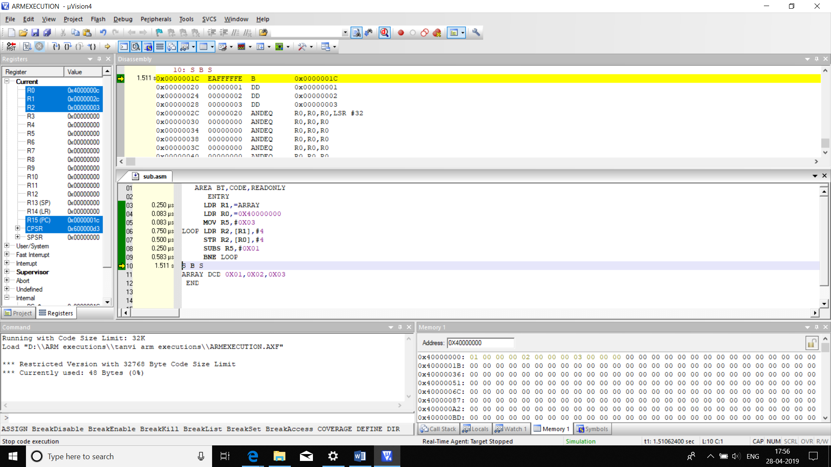

|  |  |  |
| --- | --- | --- |
|  | MEMORY | TIME |
| CODE | 48B | 2.499us |

**2.WITH LDM/STM**

AREA BT,CODE,READONLY

ENTRY

LDR R1,=ARRAY

LDR R0,=0X40000000

MOV R5,#0X03

LDMIA R1,{R2-R4}

STMIA R0,{R2-R4}

S B S

ARRAY DCD 0X01,0X02,0X03

END

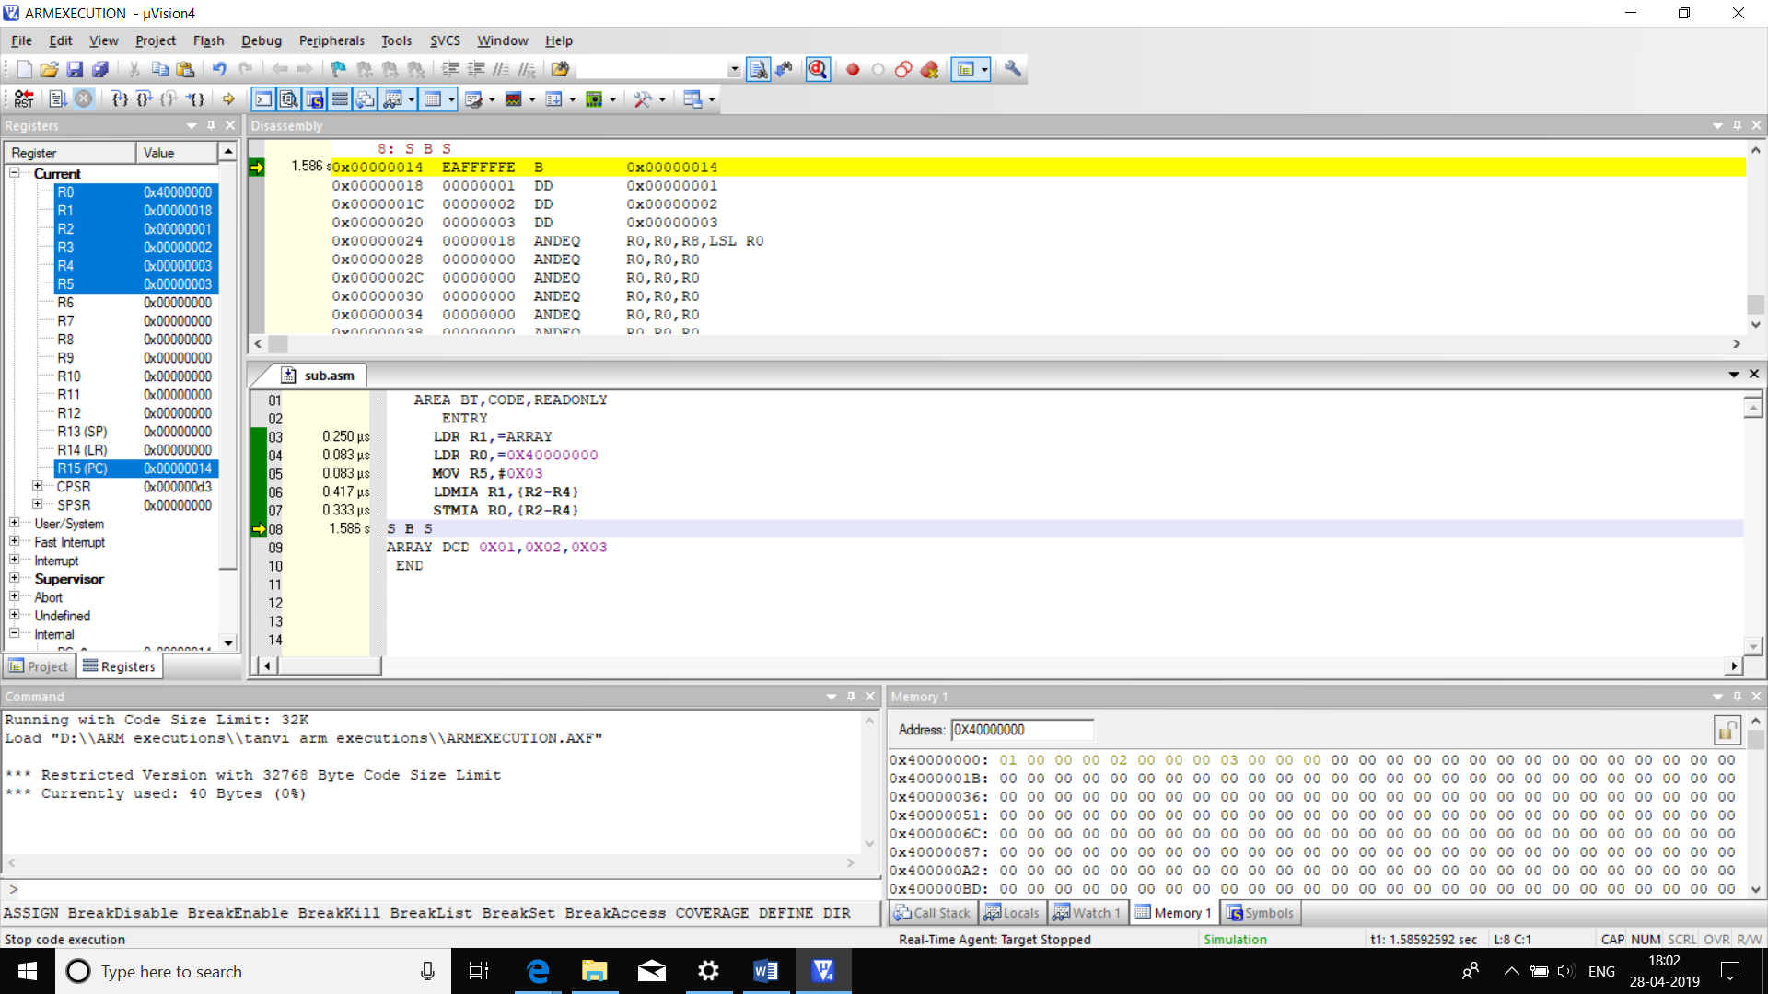

|  |  |  |
| --- | --- | --- |
|  | MEMORY | TIME |
| CODE | **40B** | **1.166us** |

**c)DATA TO STACK**

**1.USING LDM/STM**

AREA BT,CODE,READONLY

ENTRY

LDR R1,=0X40000010

LDR R0,=0X40000000

MOV R5,#0X03

LDMFD R1,{R2-R4}

STMIA R0,{R2-R4}

S B S

END

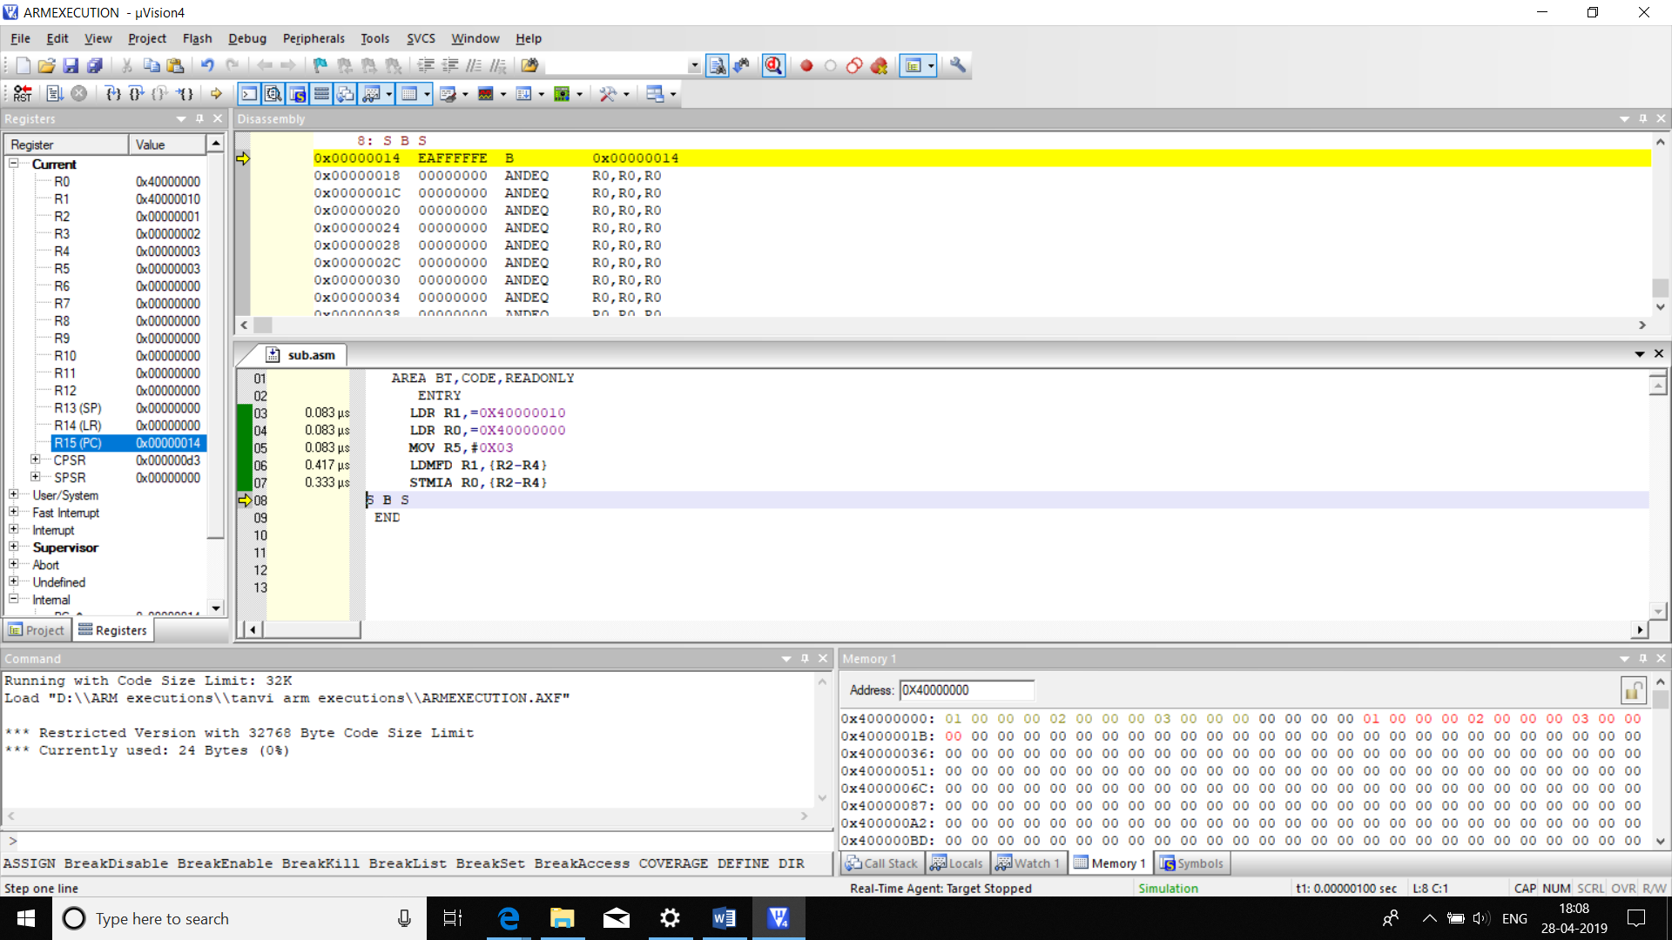

|  |  |  |
| --- | --- | --- |
|  | MEMORY | TIME |
| CODE | 24B | 0.999uS |

**2.WITHOUT USING LDM/STM**

AREA BT,CODE,READONLY

ENTRY

LDR R1,=0X40000020

LDR R0,=0X40000000

MOV R5,#0X03

LOOP LDR R2,[R0],#4

STR R2,[R1],#4

SUBS R5,#0X01

BNE LOOP

S B S

END

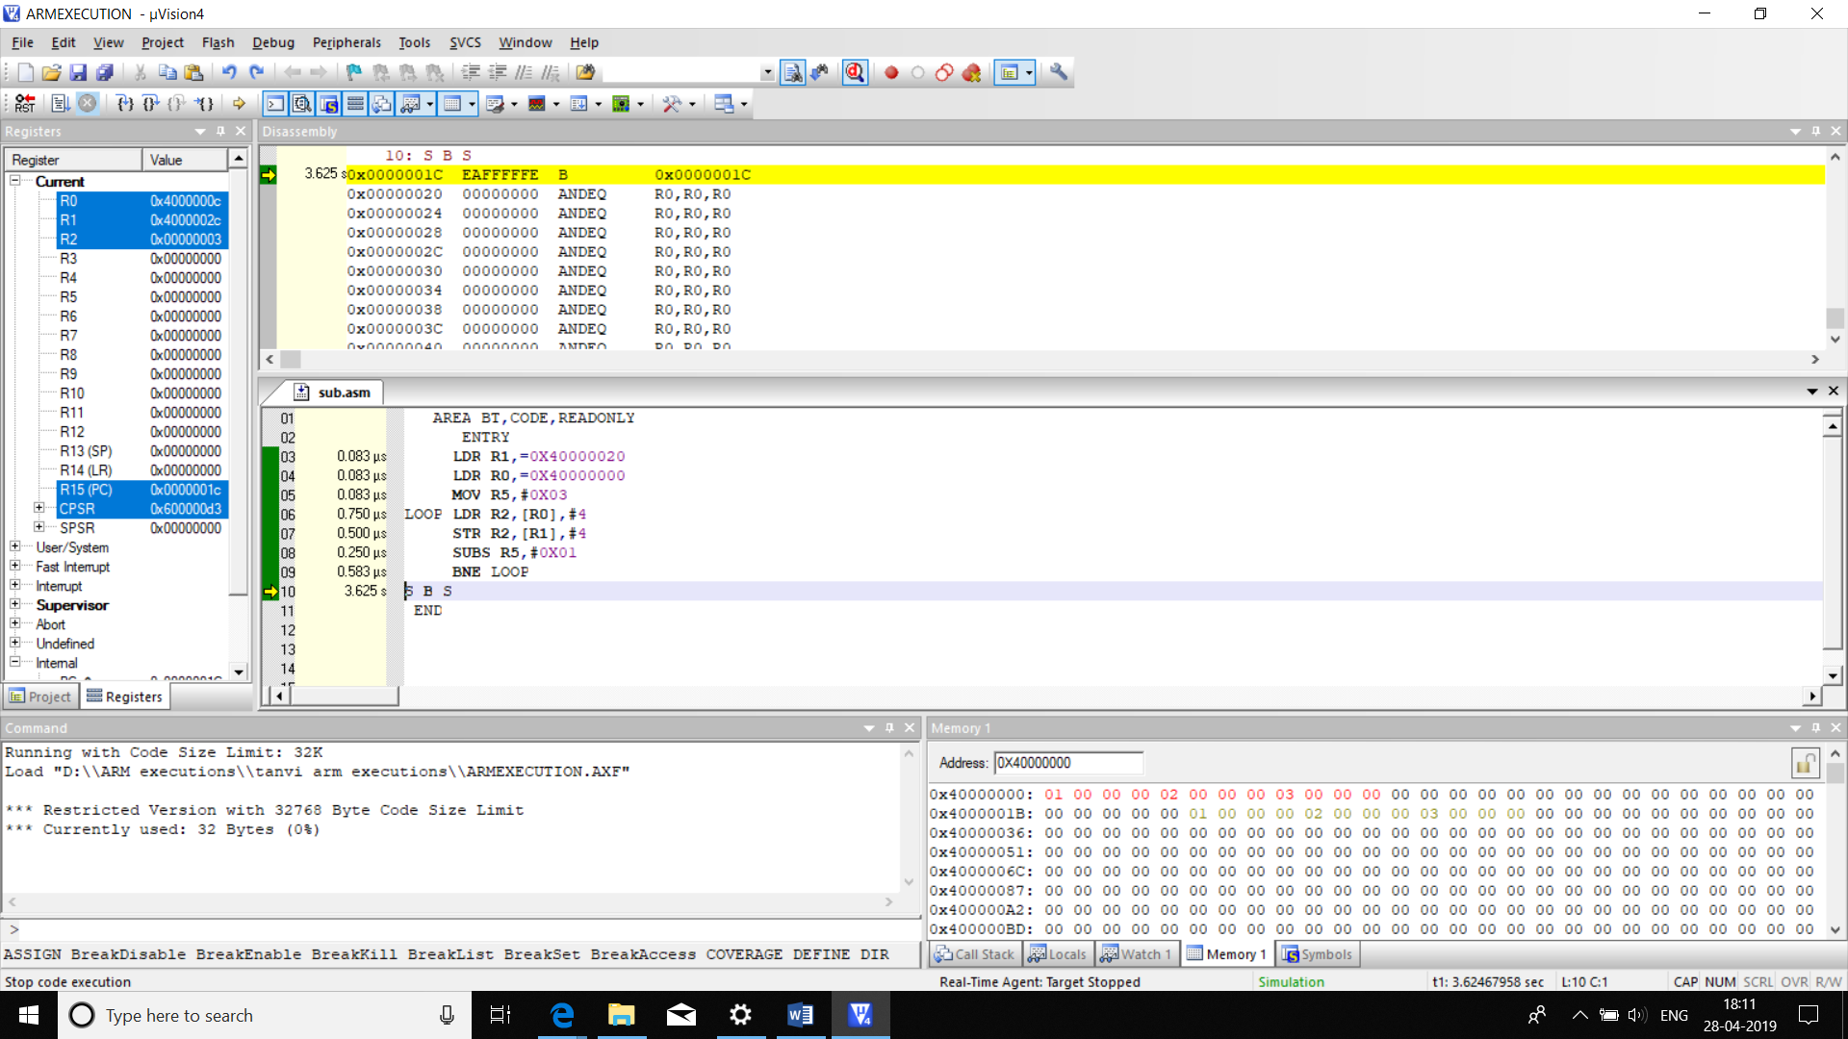

|  |  |  |
| --- | --- | --- |
|  | MEMORY | TIME |
| CODE | **32B** | **2.332uS** |

**THUMB PROGRAMS:**

**Q) ATTEMPT ALL THE QUESTIONS IN THUMB INSTRUCTION MODE**

**1**. **ADD TWO 32 BIT NUMBERS**

AREA T32ADD,CODE,READONLY

ENTRY

CODE32

LDR R0,=THUMB+1

BX R0

CODE16

THUMB LDR R1,=0X30000000

LDR R2,=0X20000000

ADD R1,R2

LDR R3,=ARM

BX R3

CODE32

ARM LDR R4,=0X40000000

STR R1,[R4]

STOP B STOP

END

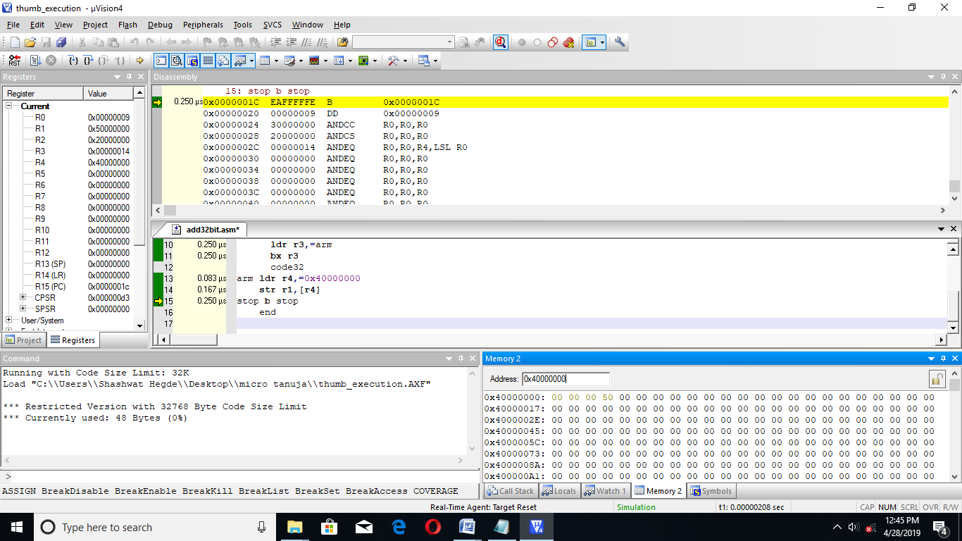

|  |  |  |
| --- | --- | --- |
|  | MEMORY | TIME |
| CODE | 48BYTES | 2.083 MICROSECOND |

**2. SUBTRACT TWO 32 BIT NUMBERS**

AREA T32SUB,CODE,READONLY

ENTRY

CODE32

LDR R0,=THUMB+1

BX R0

CODE16

THUMB LDR R1,=0X30000000

LDR R2,=0X20000000

SUB R1,R2

LDR R3,=ARM

BX R3

CODE32

ARM LDR R4,=0X40000000

STR R1,[R4]

STOP B STOP

END

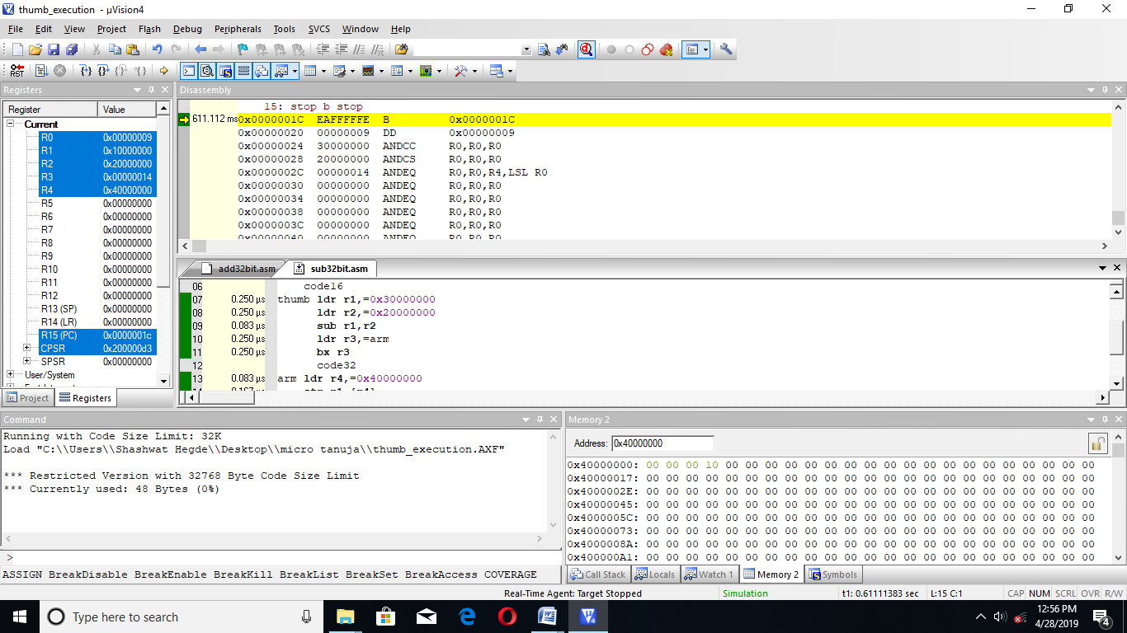

|  |  |  |
| --- | --- | --- |
|  | MEMORY | TIME |
| CODE | 48BYTES | 2.083 MICROSECOND |

**3. ADD TWO 64BIT NUMBERS**

AREA T64ADD,CODE,READONLY

ENTRY

CODE32

LDR R0,=THUMB+1

BX R0

CODE16

THUMB LDR R1,=0X30000000

LDR R2,=0X20000000

LDR R3,=0X40000001

LDR R4,=0X10000000

ADD R1,R2

ADC R3,R4

LDR R5,=ARM

BX R5

CODE32

ARM LDR R6,=0X40000000

STR R1,[R6]

ADD R6,#0X04

STR R3,[R6]

STOP B STOP

END

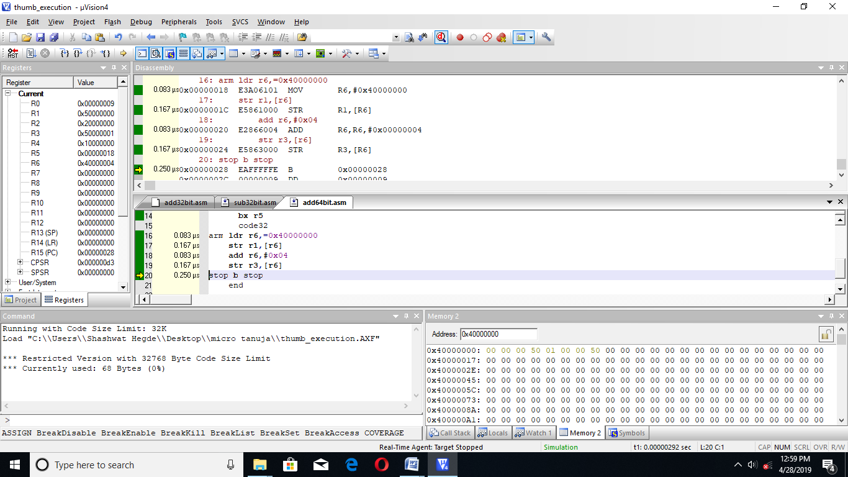

|  |  |  |
| --- | --- | --- |
|  | MEMORY | TIME |
| CODE | 68BYTES | 2.666 MICROSECOND |

**4. SUBTRACT TWO 64BIT NUMBERS**

AREA T64SUB,CODE,READONLY

ENTRY

CODE32

LDR R0,=THUMB+1

BX R0

CODE16

THUMB LDR R1,=0X30000000

LDR R2,=0X20000000

LDR R3,=0X40000001

LDR R4,=0X10000000

SUB R1,R2

SBC R3,R4

LDR R5,=ARM

BX R5

CODE32

ARM LDR R6,=0X40000000

STR R1,[R6]

ADD R6,#0X04

STR R3,[R6]

STOP B STOP

END

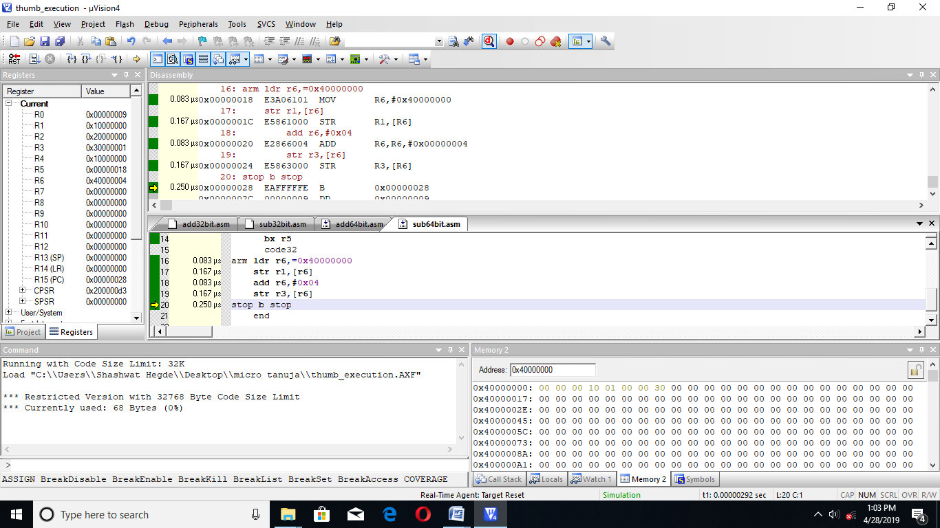

|  |  |  |
| --- | --- | --- |
|  | MEMORY | TIME |
| CODE | 68BYTES | 2.666 MICROSECOND |

**5. TO CHECK POSITIVE**

**CODE1: TO CHECK IF A NUMBER IS POSITIVE**

AREA TPOS,CODE,READONLY

ENTRY

CODE32

LDR R1,=0X40000000

LDR R0,=THUMB+1

BX R0

CODE16

THUMB LDR R2,[R1]

CMP R2,#0X00

BPL POS

BMI NEG

POS MOV R3,#0X01 ; THE NUMBER IS POSITIVE IS INDIATED WHEN R3=0X00000001

NEG B STOP

STOP B STOP

END

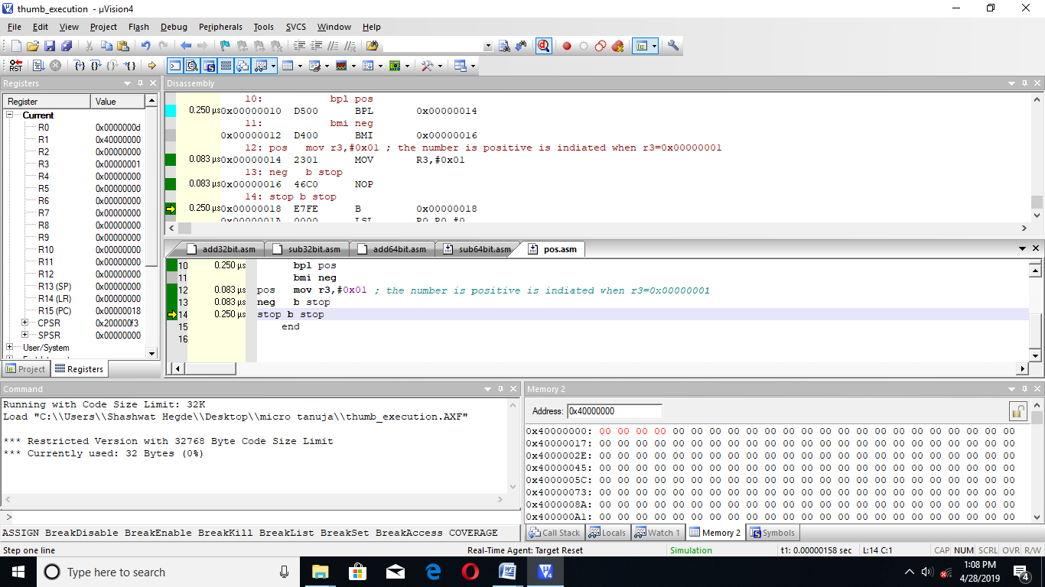

**CODE2:TO CHECK OF A GIVEN NUMBER IS POSITIVE OR NOT(CODE2)**

AREA TPS,CODE,READONLY

ENTRY

CODE32

LDR R3,=0XFFFFFFFF

LDR R1,=0X40000000

LDR R0,=THUMB+1

BX R0

CODE16

THUMB LDR R2,[R1]

AND R3,R2

LSL R3,#1

BCC POS

BCS NEG

POS MOV R4,#0X01 ; THE NUMBER IS POSITIVE IS INDIATED WHEN R3=0X00000001

NEG B STOP

STOP B STOP

END

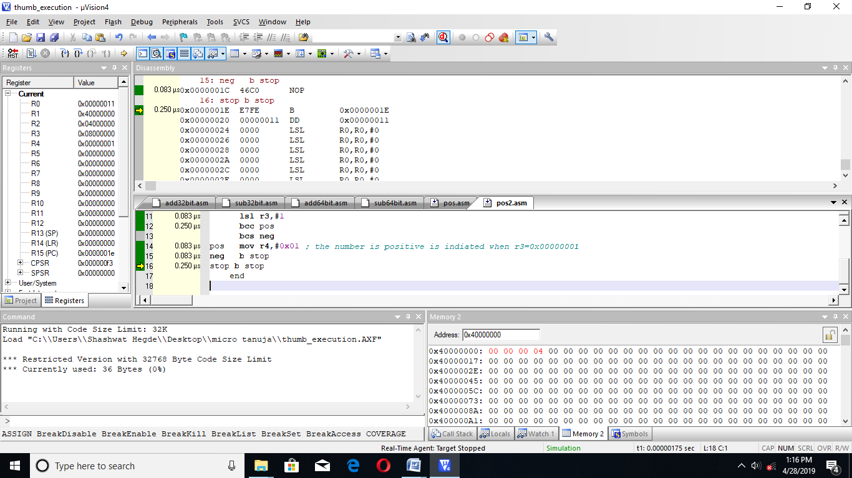

|  |  |  |
| --- | --- | --- |
|  | MEMORY | TIME |
| CODE 1 | 32BYTES | 1.583 MICROSECOND |
| CODE 2 | 36 BYTES | 1.748 MICROSECOND |

**CODE1:TO FIND NUMBER OF POSITIVE NUMBERS IN AN ARRAY OF 5 NUMBERS**

AREA TPS,CODE,READONLY

ENTRY

CODE32

MOV R5,#0X05

LDR R1,=0X40000000

LDR R0,=THUMB+1

BX R0

CODE16

THUMB LDR R2,[R1]

ADD R1,#0X04

CMP R2,#0X00

BPL POS

BMI N

POS ADD R4,#0X01

SUB R5,#0X01

BNE THUMB

BEQ STOP

N SUB R5,#0X01

BNE THUMB

BEQ STOP

STOP B STOP

END

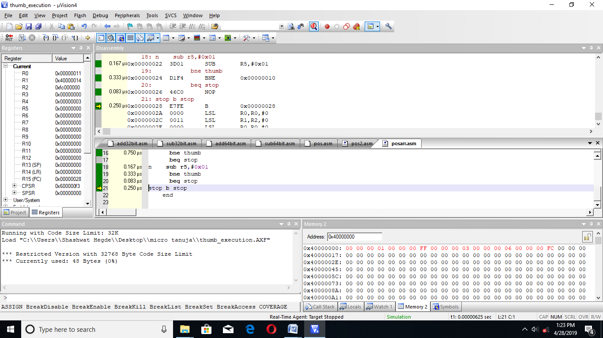

**CODE 2: TO FIND NUMBER OF POSITIVE NUMBERS IN AN ARRAY OF 5 NUMBERS**

AREA TPS,CODE,READONLY

ENTRY

CODE32

MOV R5,#0X05

LDR R3,=0XFFFFFFFF

LDR R1,=0X40000000

LDR R0,=THUMB+1

BX R0

CODE16

THUMB LDR R2,[R1]

ADD R1,#0X04

AND R3,R2

LSL R3,#1

BCC POS

BCS NE

POS ADD R4,#0X01

SUB R5,#0X01

BNE THUMB

BEQ STOP ;

NE SUB R5,#0X01

BNE THUMB

BEQ STOP

STOP B STOP

END

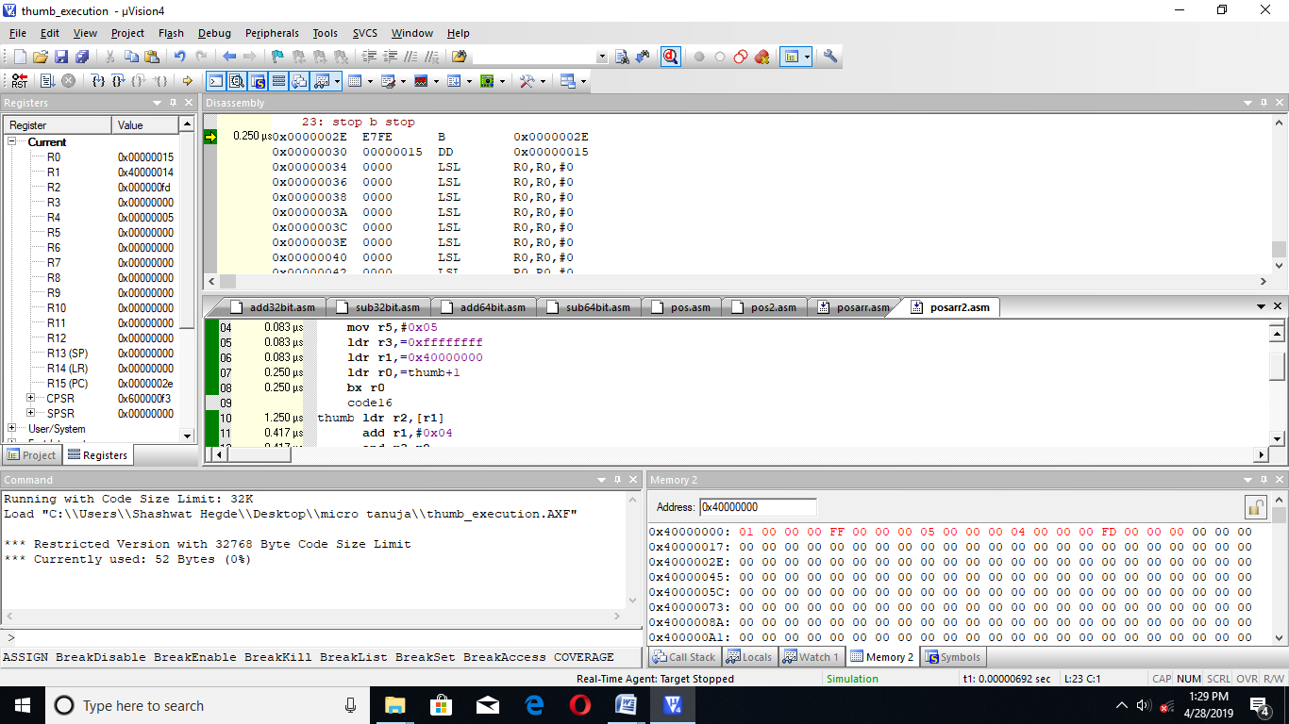

|  |  |  |
| --- | --- | --- |
|  | MEMORY | TIME |
| CODE 1 | 48BYTES | 5.583 MICROSECOND |
| CODE 2 | 52 BYTES | 4.583 MICROSECOND |

**6. TO CHECK NEGATIVE**

**CODE 1: TO CHECK IF A GIVEN NUMBER IS NEGATIVE OR NOT**

AREA TNEG,CODE,READONLY

ENTRY

CODE32

LDR R1,=0X40000000

LDR R0,=THUMB+1

BX R0

CODE16

THUMB LDR R2,[R1]

CMP R2,#0X00

BMI NEG

BPL POS

NEG MOV R3,#0X01 ;

POS B STOP

STOP B STOP END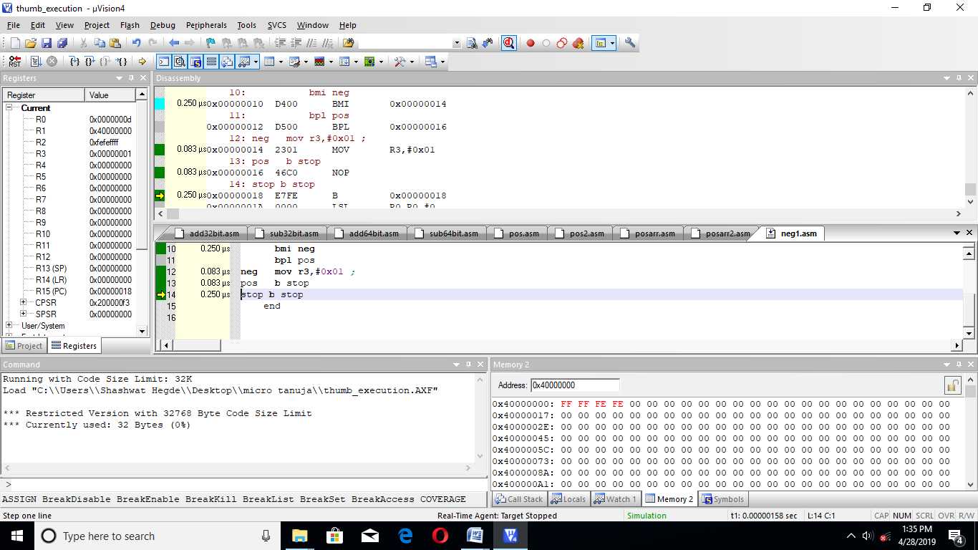

**CODE 2: TO CHECK OF A GIVEN NUMBER IS NEGATIVE OR NOT**

AREA TPS,CODE,READONLY

ENTRY

CODE32

LDR R3,=0XFFFFFFFF

LDR R1,=0X40000000

LDR R0,=THUMB+1

BX R0

CODE16

THUMB LDR R2,[R1]

AND R3,R2

LSL R3,#1

BCS NEG

BCC POS

NEG MOV R4,#0X01 ; THE NUMBER IS NEGATIVE IS INDIATED WHEN R3=0X00000001

POS B STOP

STOP B STOP

END

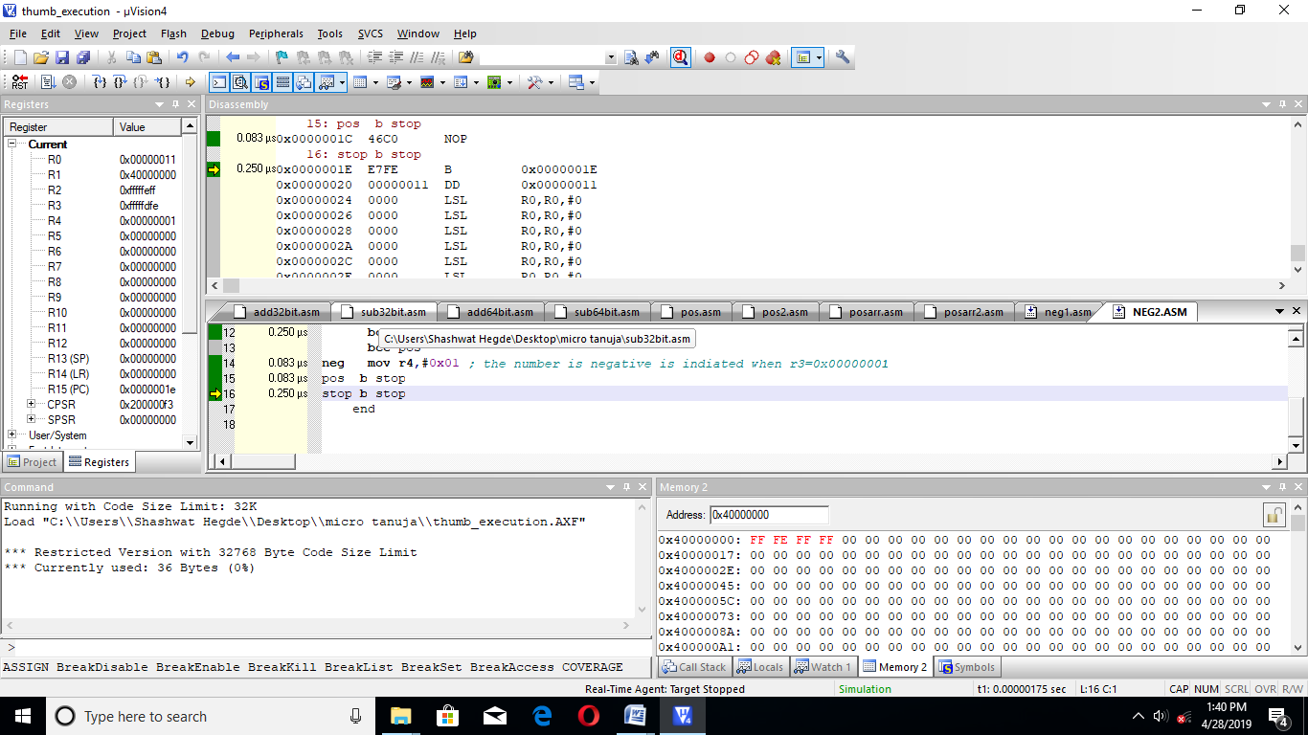

|  |  |  |
| --- | --- | --- |
|  | MEMORY | TIME |
| CODE 1 | 32BYTES | 1.582 MICROSECOND |
| CODE 2 | 36 BYTES | 1.748 MICROSECOND |

**CODE 1:TO FIND THE NUMBER OF NEGATIVE NUMBERS IN AN ARRAY**

AREA TPS,CODE,READONLY

ENTRY

CODE32

MOV R5,#0X05

LDR R3,=0XFFFFFFFF

LDR R1,=0X40000000

LDR R0,=THUMB+1

BX R0

CODE16

THUMB LDR R2,[R1]

ADD R1,#0X04

AND R3,R2

LSL R3,#1

BCC POS

BCS NE

POS SUB R5,#0X01

BNE THUMB

BEQ STOP

NE ADD R4,#0X01

SUB R5,#0X01

BNE THUMB

BEQ STOP

STOP B STOP

END

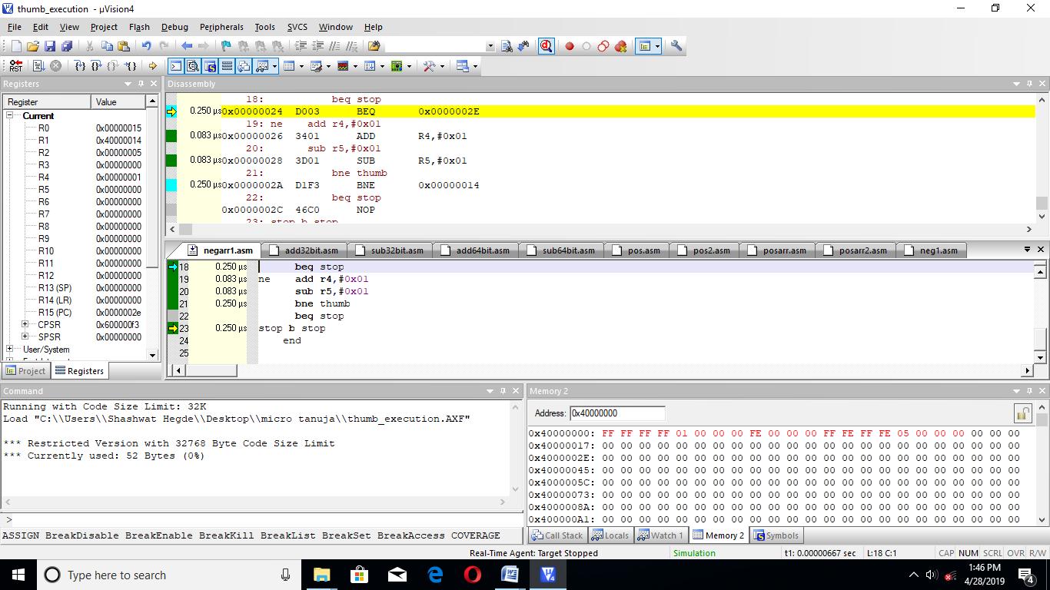

**CODE 2:TO FIND THE NUMBER OF NEGATIVE NUMBERS IN AN ARRAY**

AREA TPS,CODE,READONLY

ENTRY

CODE32

MOV R5,#0X05

LDR R1,=0X40000000

LDR R0,=THUMB+1

BX R0

CODE16

THUMB LDR R2,[R1]

ADD R1,#0X04

CMP R2,#0X00

BPL POS

BMI N

POS SUB R5,#0X01

BNE THUMB

BEQ STOP

N ADD R4,#0X01

SUB R5,#0X01

BNE THUMB

BEQ STOP

STOP B STOP

END

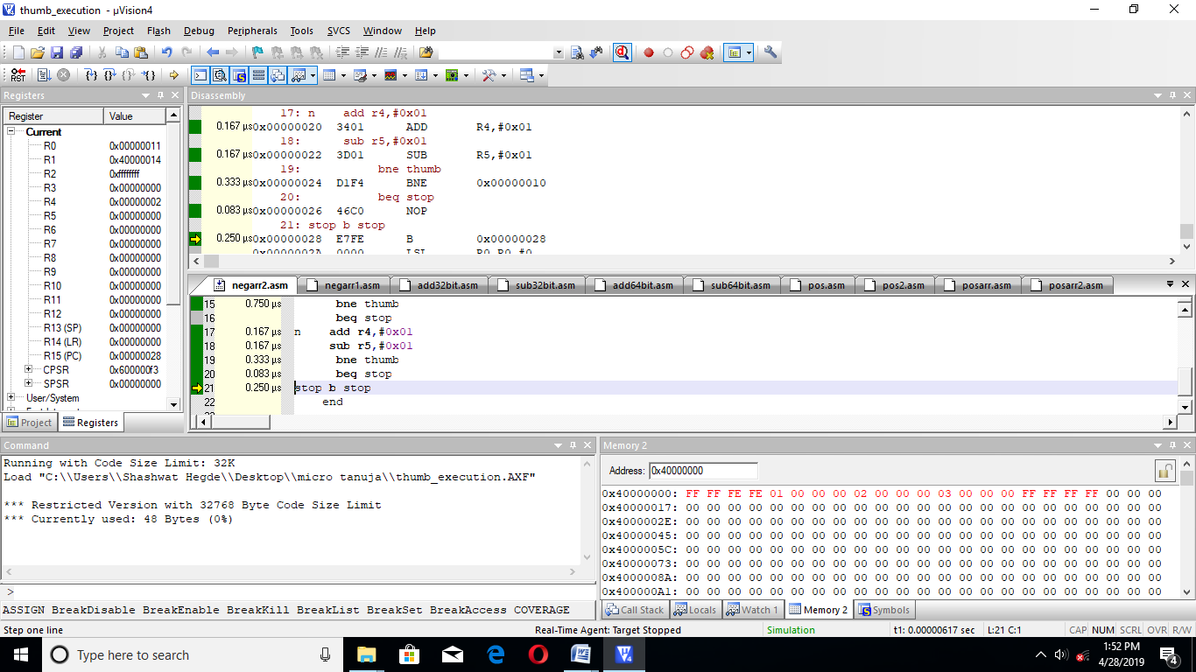

|  |  |  |
| --- | --- | --- |
|  | MEMORY | TIME |
| CODE 1 | 52BYTES | 6.415 MICROSECOND |
| CODE 2 | 48 BYTES | 5.917 MICROSECOND |

**7. TO CHECK EVEN OR ODD**

**CODE1: TO CHECK IF A NUMBER IS EVEN OR ODD**

AREA TPS,CODE,READONLY

ENTRY

CODE32

LDR R1,=0X40000000

LDR R0,=THUMB+1

BX R0

CODE16

THUMB LDR R2,[R1]

LSR R2,#1

BCC EVE

BCS ODD

EVE MOV R3,#0X01

B STOP ; THE NUMBER IS EVEN IS INDIATED WHEN R3=0X00000001

ODD MOV R4,#0X01

B STOP ; THE NUMBER IS ODD IS INDIATED WHEN R4=0X00000001

STOP B STOP

END

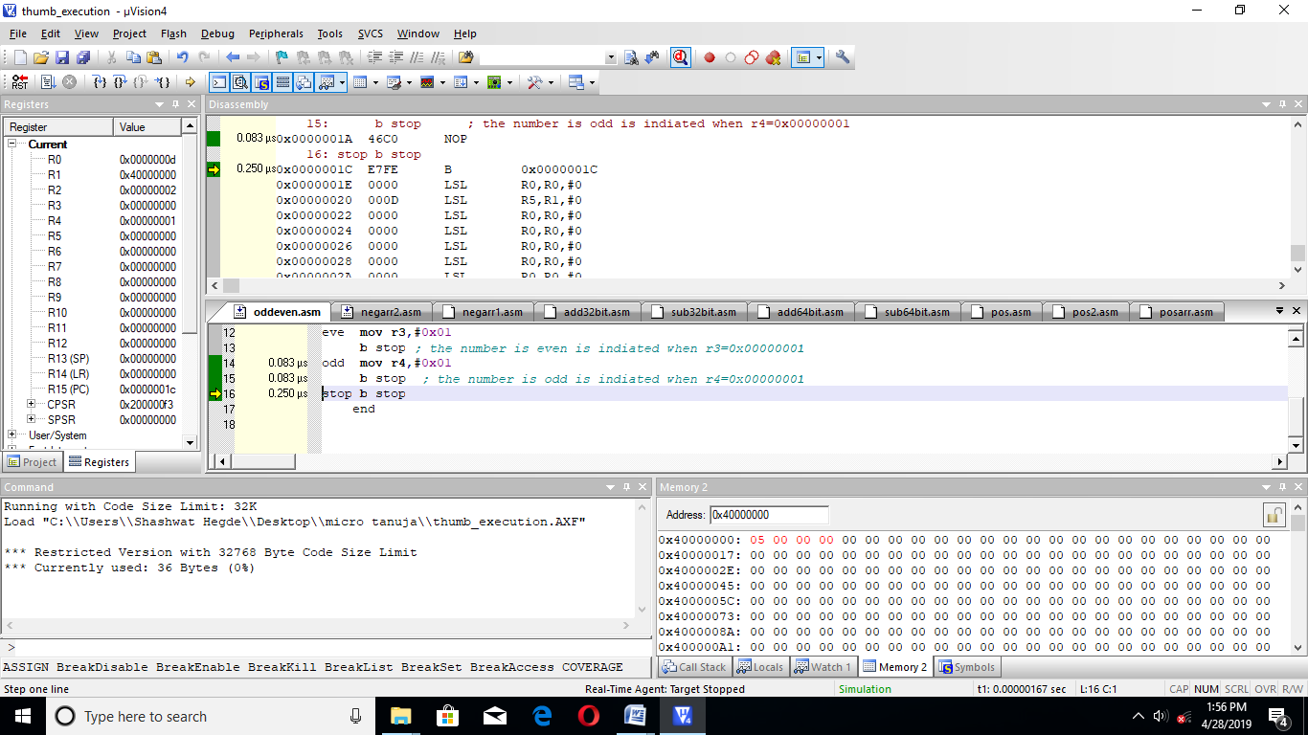

**CODE 2:**

AREA TPS,CODE,READONLY

ENTRY

CODE32

LDR R7,=0X11111111

LDR R1,=0X40000000

LDR R0,=THUMB+1

BX R0

CODE16

THUMB LDR R2,[R1]

AND R2,R7

LSR R2,#1

BCC EVE

BCS ODD

EVE MOV R3,#0X01

B STOP ; THE NUMBER IS EVEN IS INDIATED WHEN R3=0X00000001

ODD MOV R4,#0X01

B STOP ; THE NUMBER IS ODD IS INDIATED WHEN R4=0X00000001

STOP B STOP

END

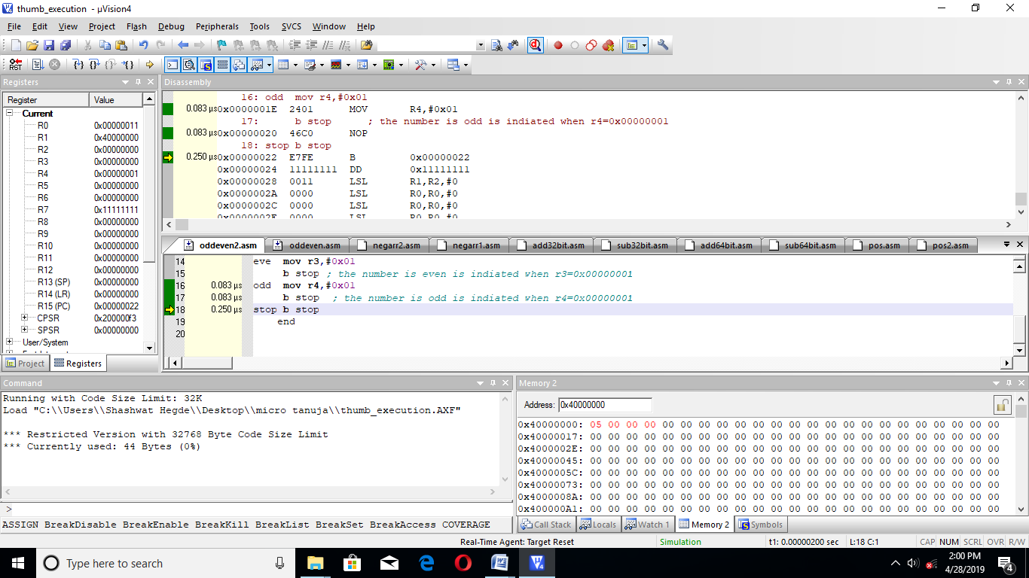

|  |  |  |
| --- | --- | --- |
|  | MEMORY | TIME |
| CODE 1 | 36BYTES | 1.415 MICROSECOND |
| CODE 2 | 44 BYTES | 1.748 MICROSECOND |

**CODE 1:TO FIND THE NUMBER OF EVEN AND ODD NUMBERS IN AN ARRAY**

AREA TPS,CODE,READONLY

ENTRY

CODE32

MOV R5,#0X05

LDR R3,=0X11111111

LDR R1,=0X40000000

LDR R0,=THUMB+1

BX R0

CODE16

THUMB LDR R2,[R1]

ADD R1,#0X04

AND R3,R2

LSR R3,#1

LDR R3,=0X11111111

BCC EVN

BCS NE

EVN ADD R4,#0X01 ; EVEN

SUB R5,#0X01

BNE THUMB

BEQ STOP

NE ADD R6,#0X01 ; ODD

SUB R5,#0X01

BNE THUMB

BEQ STOP

STOP B STOP

END

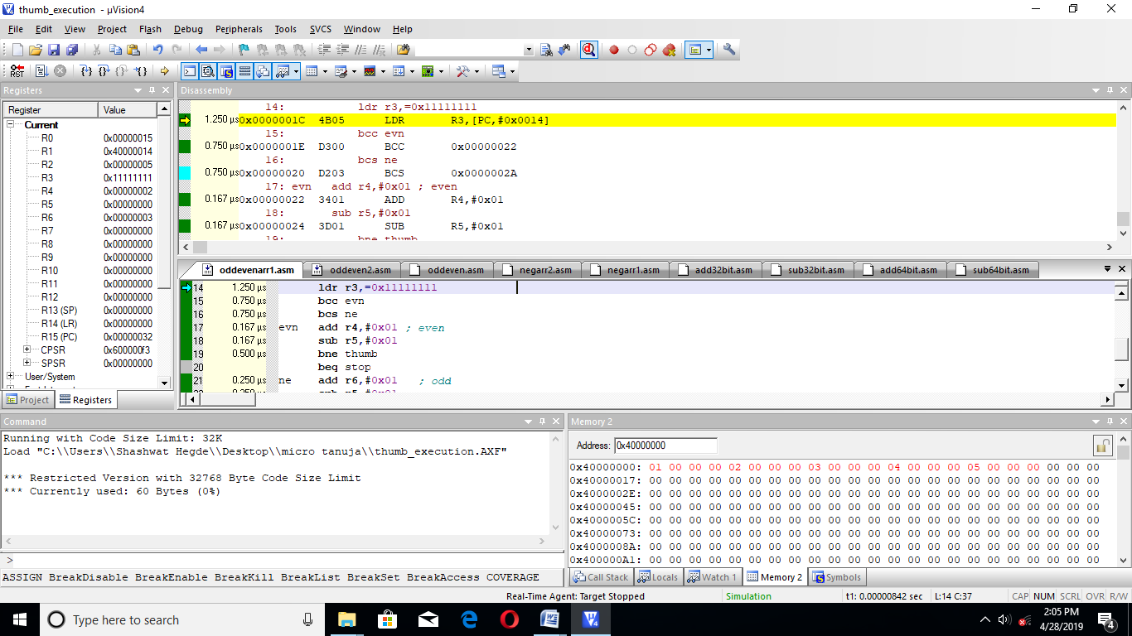

**CODE 2:**

AREA TPS,CODE,READONLY

ENTRY

CODE32

MOV R5,#0X05

LDR R1,=0X40000000

LDR R0,=THUMB+1

BX R0

CODE16

THUMB LDR R2,[R1]

ADD R1,#0X04

LSR R2,#1

BCS ODD

BCC EVN

EVN ADD R4,#0X01

SUB R5,#0X01

BNE THUMB

BEQ STOP

ODD ADD R6,#0X01

SUB R5,#0X01

BNE THUMB

BEQ STOP

STOP B STOP

END

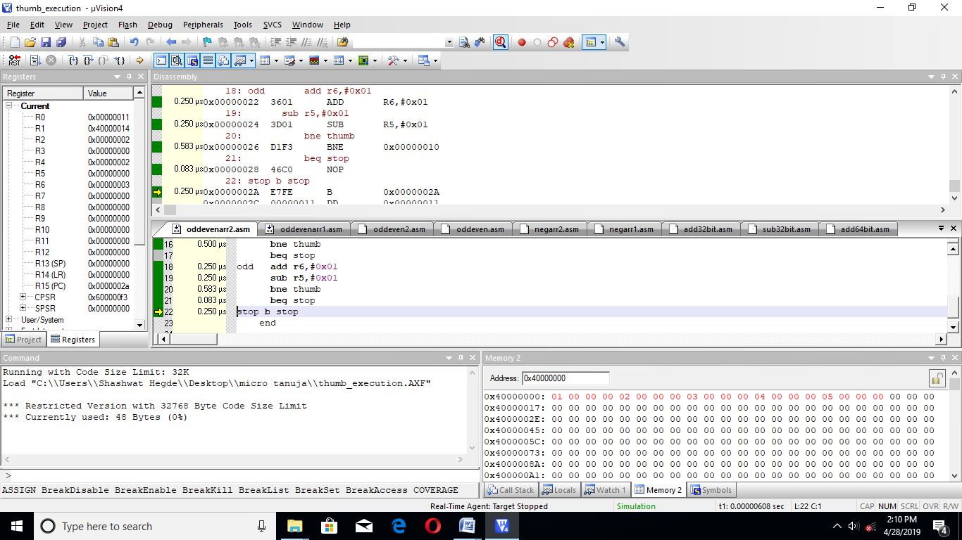

|  |  |  |
| --- | --- | --- |
|  | MEMORY | TIME |
| CODE 1 | 60BYTES | 8.167MICROSECOND |
| CODE 2 | 48 BYTES | 5.834 MICROSECOND |

**8. TO FIND MINIMUM AND MAXIMUM**

**CODE 1: TO FIND MAXIMUM OF TWO NUMBERS**

AREA MAX2,CODE,READONLY

ENTRY

CODE32

LDR R0,=0X40000000

LDR R1,=THUMB+1

BX R1

CODE16

THUMB LDR R1,[R0]

ADD R0,#0X04

LDR R2,[R0]

CMP R1,R2

BCC L2

BCS L1

L2 MOV R3,R2

B STOP

L1 MOV R3,R1

B STOP

STOP B STOP

END

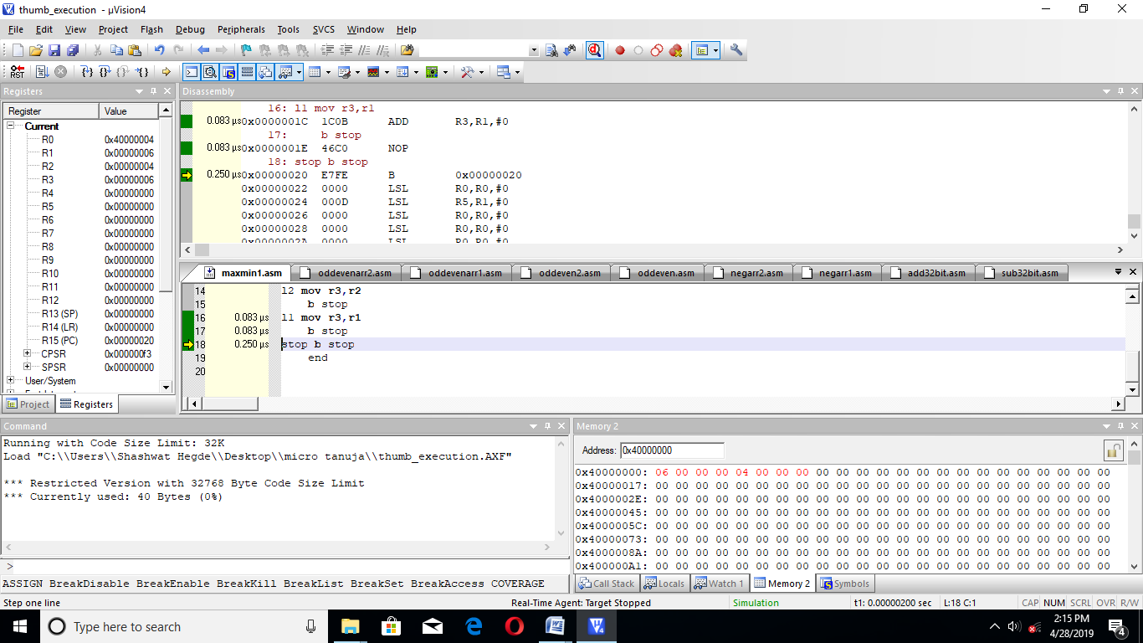

**CODE 2:**

AREA MAX2,CODE,READONLY

ENTRY

CODE32

LDR R0,=0X40000000

LDR R1,=THUMB+1

BX R1

CODE16

THUMB LDR R1,[R0]

MOV R4,R1

ADD R0,#0X04

LDR R2,[R0]

MOV R5,R2

SUB R4,R5

BCC L2

BCS L1

L2 MOV R3,R2

B STOP

L1 MOV R3,R1

B STOP

STOP B STOP

END

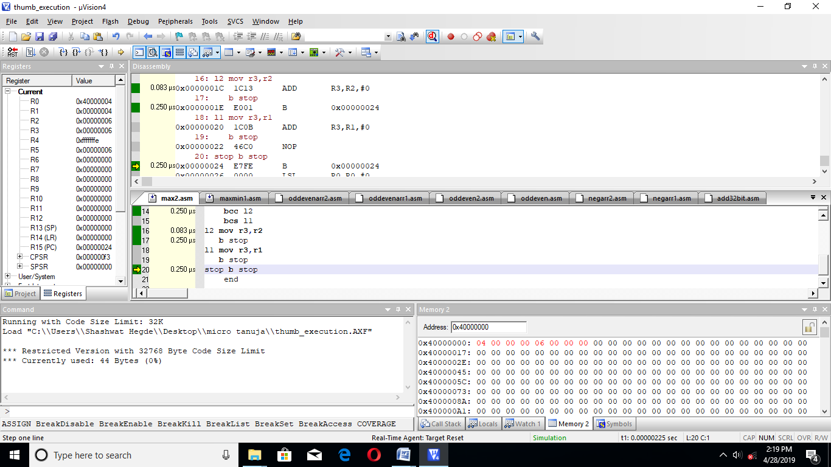

|  |  |  |
| --- | --- | --- |
|  | MEMORY | TIME |
| CODE 1 | 40BYTES | 1.748MICROSECOND |
| CODE 2 | 44 BYTES | 1.665MICROSECOND |

**B)FIND MAXIMUM IN AN ARRAY**

**CODE 1:**

AREA MAX2,CODE,READONLY

ENTRY

CODE32

MOV R7,#0X05

LDR R0,=0X40000000

LDR R3,[R0]

LDR R1,=THUMB+1

BX R1

CODE16

THUMB ADD R0,#0X04

LDR R2,[R0]

MOV R4,R3

SUB R4,R2

BMI L2

BPL L1

L2 MOV R3,R2

SUB R7,#0X01

BNE THUMB

BEQ STOP

L1 SUB R7,#0X01

BNE THUMB

BEQ STOP

STOP B STOP

END

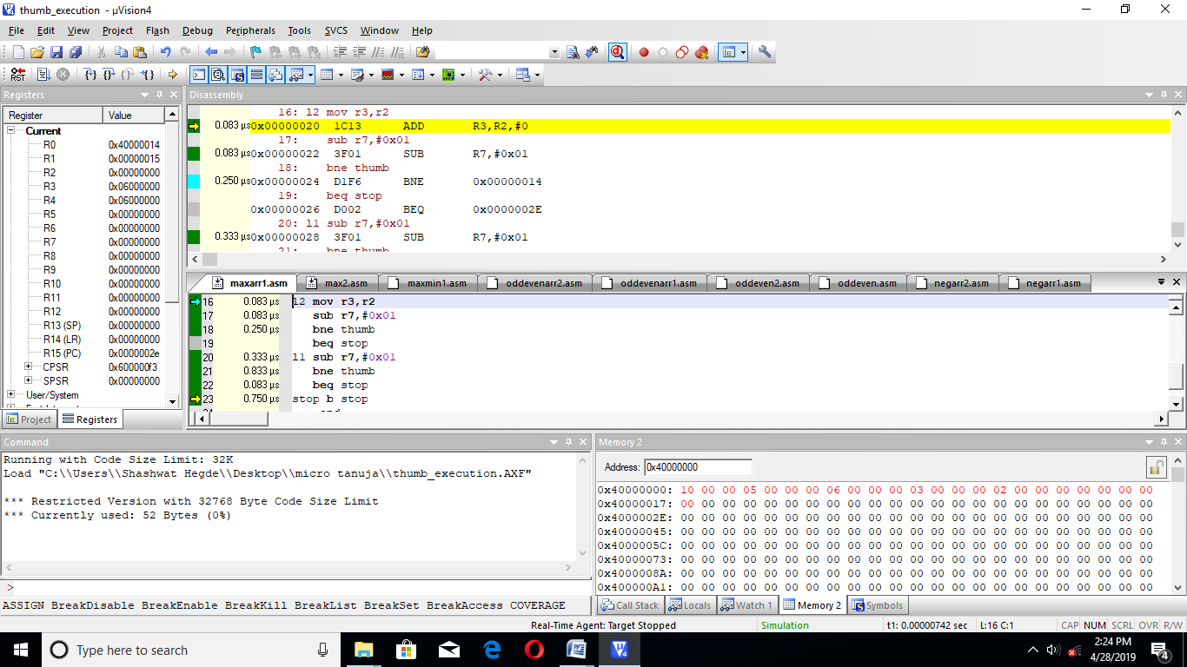

**CODE 2:**

AREA MAX2,CODE,READONLY

ENTRY

CODE32

MOV R7,#0X05

LDR R0,=0X40000000

LDR R3,[R0]

LDR R1,=THUMB+1

BX R1

CODE16

THUMB ADD R0,#0X04

LDR R2,[R0]

MOV R4,R3

CMP R4,R2

BMI L2

BPL L1

L2 MOV R3,R2

SUB R7,#0X01

BNE THUMB

BEQ STOP

L1 SUB R7,#0X01

BNE THUMB

BEQ STOP

STOP B STOP

END

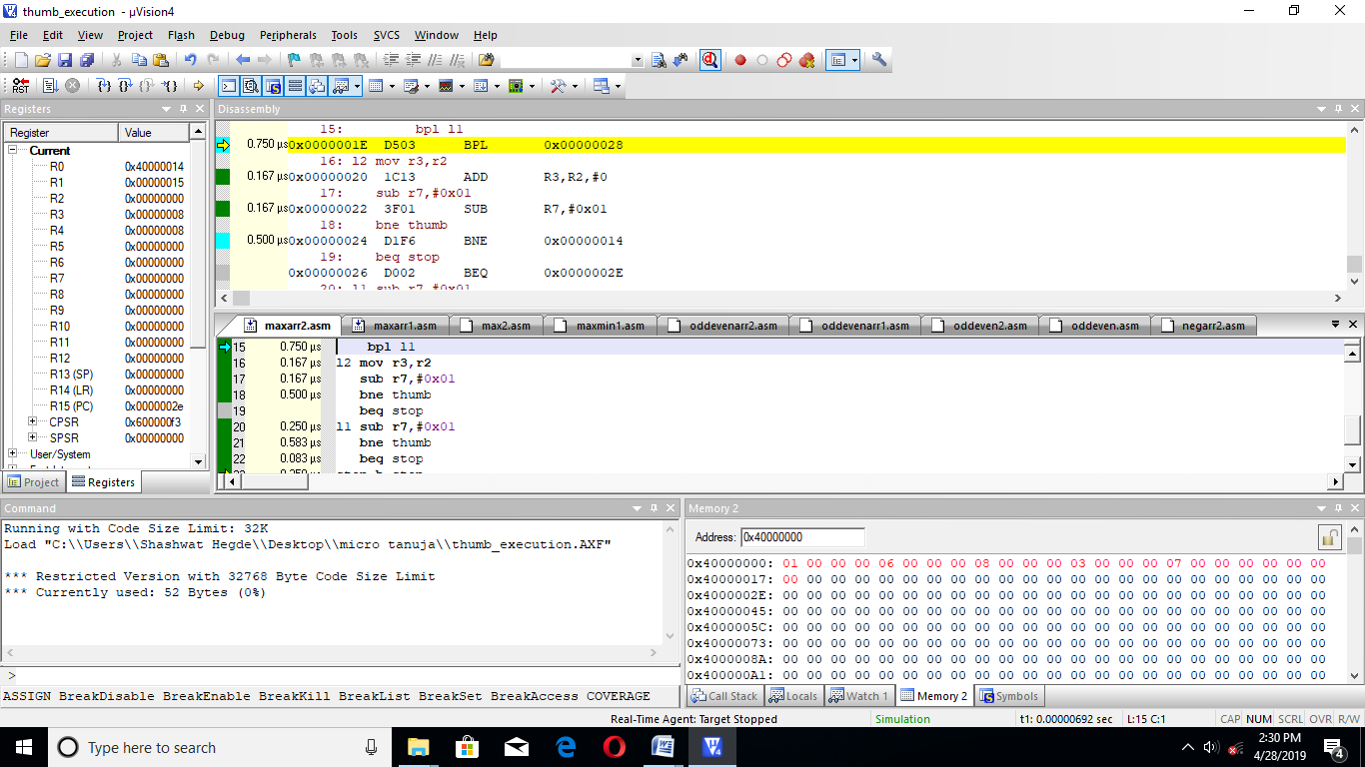

|  |  |  |
| --- | --- | --- |
|  | MEMORY | TIME |
| CODE 1 | 52BYTES | 6.665 MICROSECOND |
| CODE 2 | 52BYTES | 6.667 MICROSECOND |

**TO FIND MINUMIN OF TWO NUMBERS**

**CODE 1:**

AREA MAX2,CODE,READONLY

ENTRY

CODE32

LDR R0,=0X40000000

LDR R1,=THUMB+1

BX R1

CODE16

THUMB LDR R1,[R0]

ADD R0,#0X04

LDR R2,[R0]

CMP R1,R2

BCS L2

BCC L1

L2 MOV R3,R2

B STOP

L1 MOV R3,R1

B STOP

STOP B STOP

END

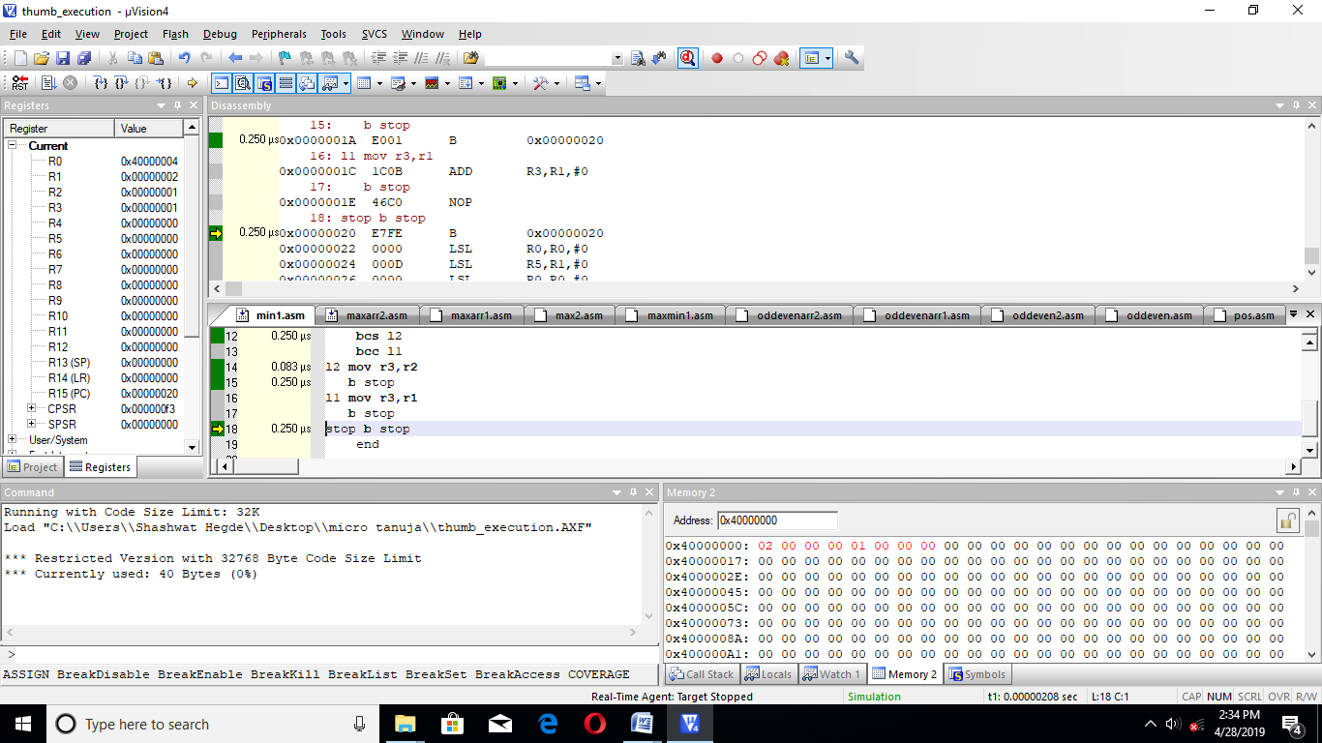

**CODE 2:**

AREA MAX2,CODE,READONLY

ENTRY

CODE32

LDR R0,=0X40000000

LDR R1,=THUMB+1

BX R1

CODE16

THUMB LDR R1,[R0]

MOV R4,R1

ADD R0,#0X04

LDR R2,[R0]

MOV R5,R2

SUB R4,R5

BCS L2

BCC L1

L2 MOV R3,R2

B STOP

L1 MOV R3,R1

B STOP

STOP B STOP

END

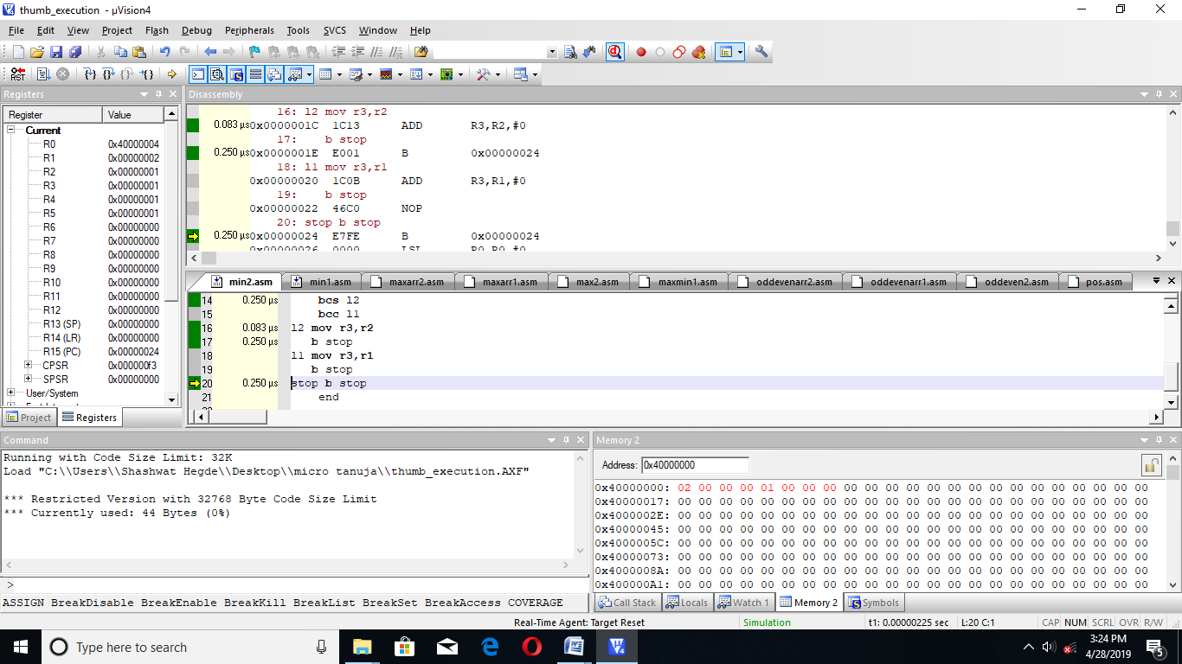

|  |  |  |
| --- | --- | --- |
|  | MEMORY | TIME |
| CODE 1 | 40BYTES | 1.499 MICROSECOND |
| CODE 2 | 44BYTES | 1.998 MICROSECOND |

**TO FIND MINIMUM OF 5 NUMBERS IN AN ARRAY**

**CODE 1:**

AREA MAX2,CODE,READONLY

ENTRY

CODE32

MOV R7,#0X05

LDR R0,=0X40000000

LDR R3,[R0]

LDR R1,=THUMB+1

BX R1

CODE16

THUMB ADD R0,#0X04

LDR R2,[R0]

MOV R4,R3

SUB R4,R2

BPL L2

BMI L1

L2 MOV R3,R2

SUB R7,#0X01

BNE THUMB

BEQ STOP

L1 SUB R7,#0X01

BNE THUMB

BEQ STOP

STOP B STOP

END

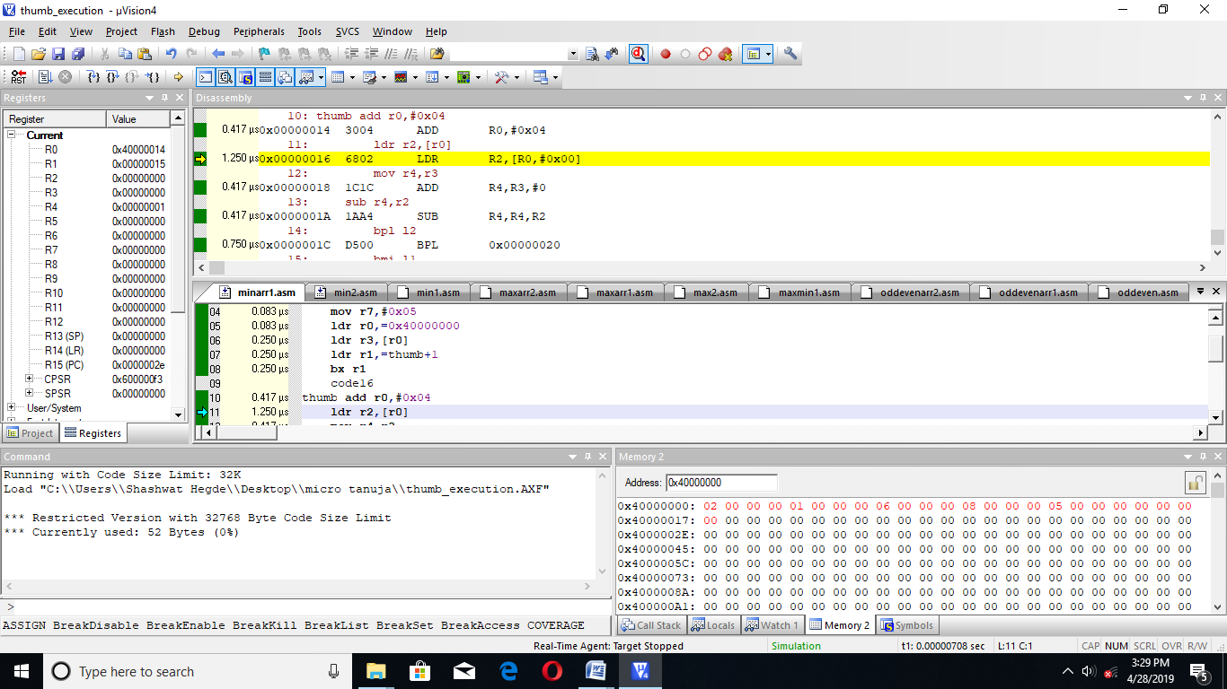

**CODE 2:**

AREA MAX2,CODE,READONLY

ENTRY

CODE32

MOV R7,#0X05

LDR R0,=0X40000000

LDR R3,[R0]

LDR R1,=THUMB+1

BX R1

CODE16

THUMB ADD R0,#0X04

LDR R2,[R0]

MOV R4,R3

CMP R4,R2

BMI L2

BPL L1

L2 MOV R3,R2

SUB R7,#0X01

BNE THUMB

BEQ STOP

L1 SUB R7,#0X01

BNE THUMB

BEQ STOP

STOP B STOP

END

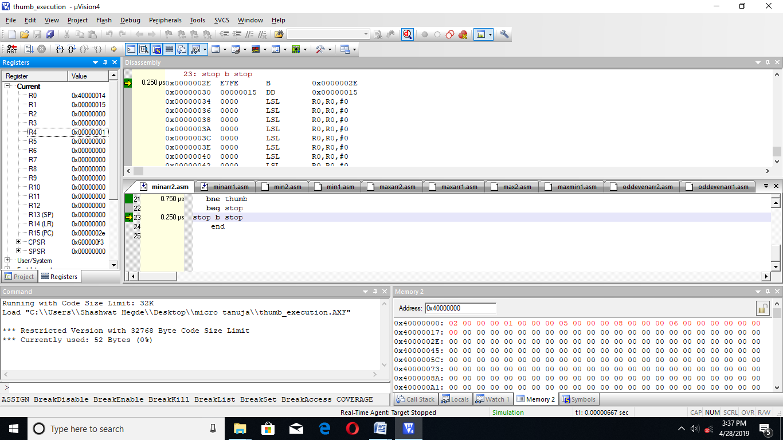

|  |  |  |
| --- | --- | --- |
|  | MEMORY | TIME |
| CODE 1 | 52BYTES | 6.834 MICROSECOND |
| CODE 2 | 52BYTES | 6.667 MICROSECOND |

**9. CODE FOR DIVISION**

AREA DIV,CODE,READONLY

ENTRY

CODE32

LDR R0,=THUMB+1

BX R0

CODE16

THUMB MOV R1,#0X06

MOV R2,#0X03

CMP R2,#0X00

BEQ STOP

BNE LQ

LQ CMP R1,R2

BEQ LOP

BNE DI

LOP MOV R3,#0X01

DI SUB R1,R2

CMP R1,#0X00

BPL AD

BMI STOP

AD ADD R3,#0X01

B DI

STOP B STOP

END

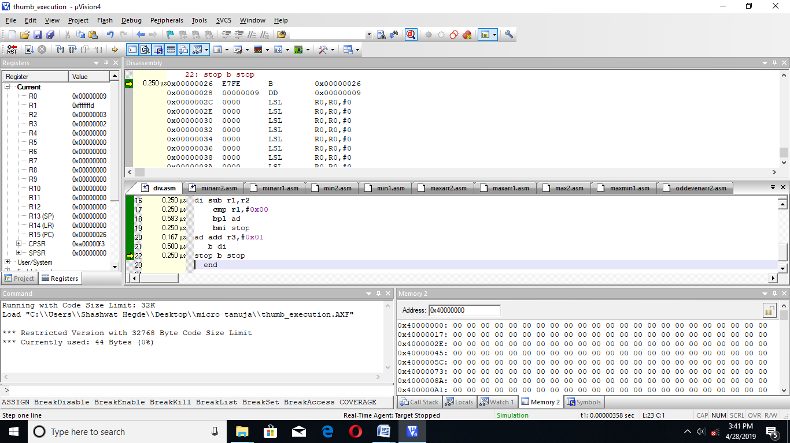

|  |  |  |
| --- | --- | --- |
|  | MEMORY | TIME |
| CODE | 44 BYTES | 3.248 MICROSECOND |

**10. CODE FOR MULTIPLICATION**

AREA MUL,CODE,READONLY

ENTRY

CODE32

LDR R0,=THUMB+1

BX R0

CODE16

THUMB MOV R1,#0X02

MOV R2,#0X03

CMP R2,#0X00

BEQ STOP

BNE LQ

LQ ADD R3,R1

SUB R2,#0X01

BNE LQ

BEQ STOP

STOP B STOP

END

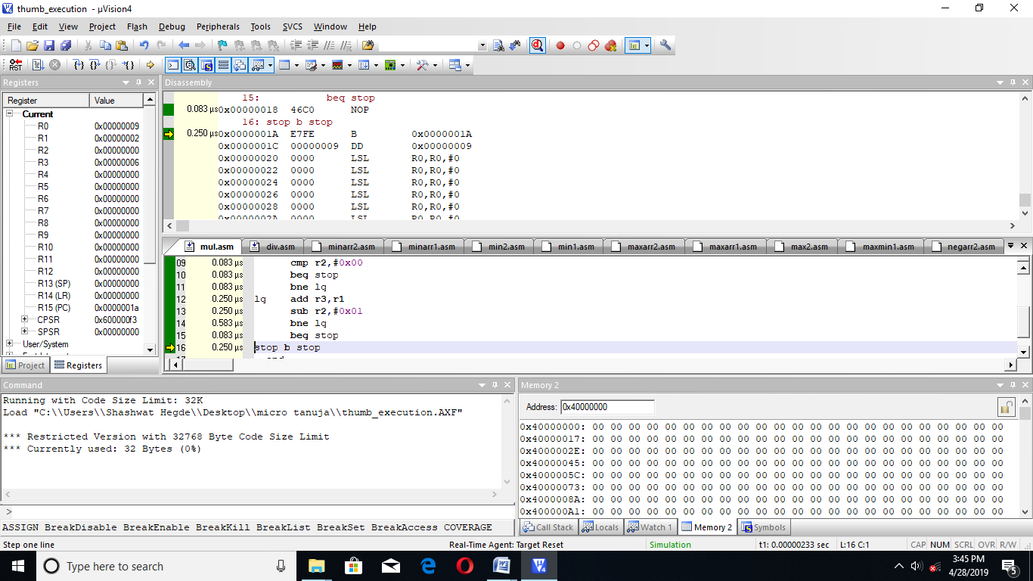

|  |  |  |
| --- | --- | --- |
|  | MEMORY | TIME |
| CODE | 32 BYTES | 2.081 MICROSECOND |

**11. PROGRAM TO ADD TWO ARRAYS AND SAVE THE RESULT IN THIRD ONE**

AREA AD,CODE,READONLY

ENTRY

CODE32

LDR R0,=0X40000000

LDR R1,=0X40000010

LDR R6,=0X40000020

MOV R2,#0X05

LDR R3,=THUMB+1

BX R3

CODE16

THUMB LDR R4,[R0]

ADD R0,#0X04

LDR R5,[R1]

ADD R1,#0X04

ADD R4,R5

STR R4,[R6]

ADD R6,#0X04

SUB R2,#0X01

BNE THUMB

BEQ STOP

STOP B STOP

END

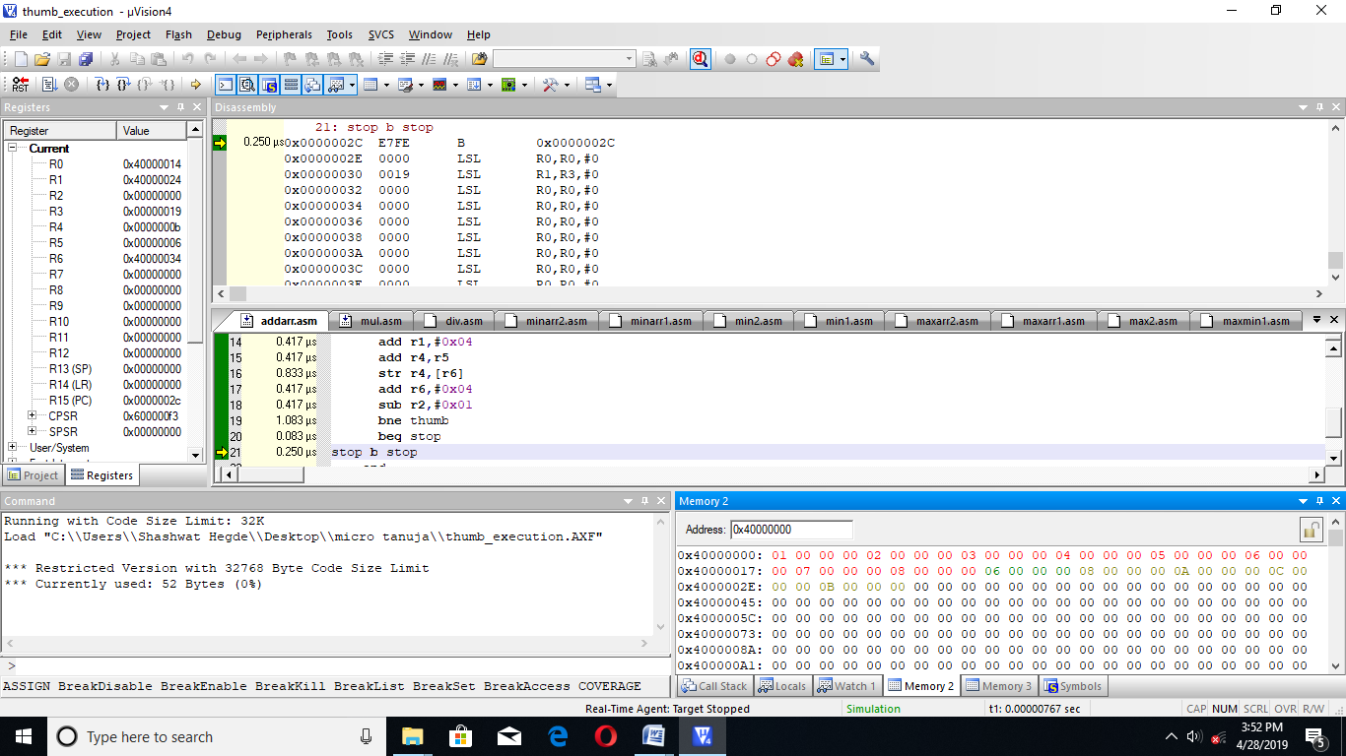

|  |  |  |
| --- | --- | --- |
|  | MEMORY | TIME |
| CODE | 52 BYTES | 7.416 MICROSECOND |

**12. PROGRAM TO COUNT THE NUMBER OF ONES AND ZEROES**

AREA ZO,CODE,READONLY

ENTRY

CODE32

MOV R1,#0X0E

MOV R4,#0X04

LDR R0,=THUMB+1

BX R0

CODE16

THUMB LSR R1,#1

BCC Z

BCS ONE

Z ADD R2,#0X01

SUB R4,#0X01

BNE THUMB

BEQ STOP

ONE ADD R3,#0X01

SUB R4,#0X01

BNE THUMB

BEQ STOP

STOP B STOP

END

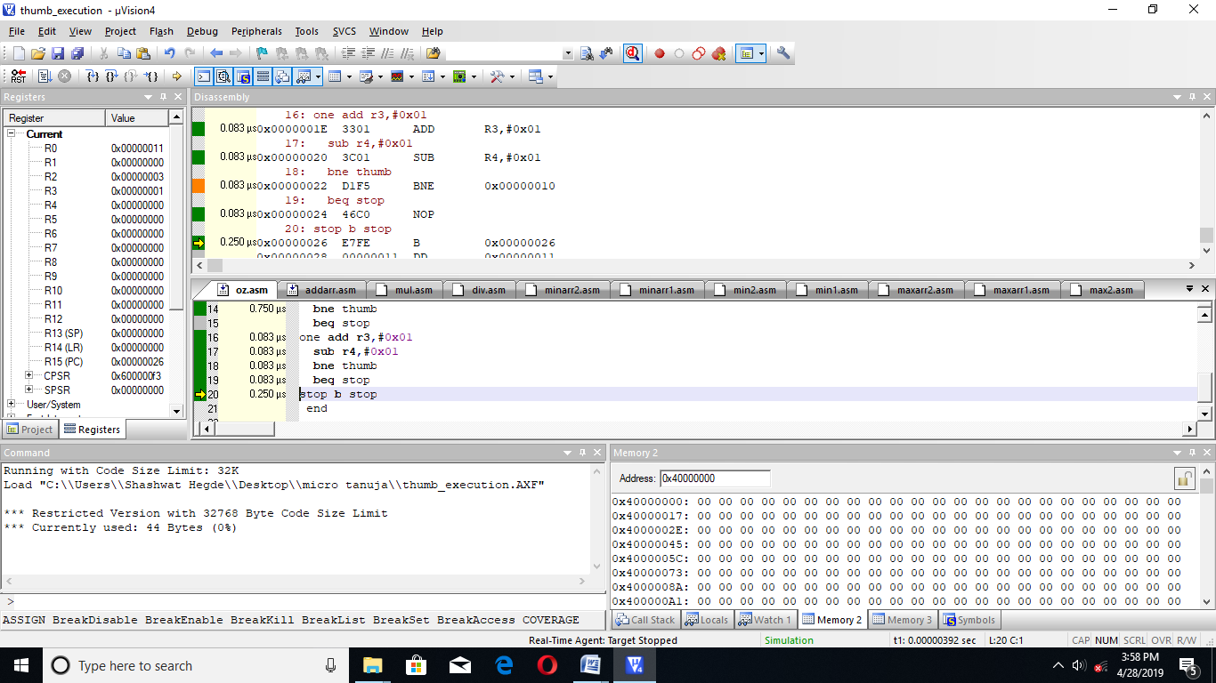

|  |  |  |
| --- | --- | --- |
|  | MEMORY | TIME |
| CODE | 44 BYTES | 3.664 MICROSECOND |

**13. CODE FOR THE SUM OF NEGATIVE NUMBERS IN AN ARRAY**

AREA ADODD,CODE,READONLY

ENTRY

CODE32

LDR R0,=0X40000000

MOV R2,#0X05

LDR R3,=THUMB+1

BX R3

CODE16

THUMB LDR R4,[R0]

ADD R0,#0X04

MOV R6,R4

LSL R4,#1

BCS ODD

BCC LOP

ODD ADD R5,R6

SUB R2,#0X01

BNE THUMB

BEQ STOP

LOP SUB R2,#0X01

BNE THUMB

BEQ STOP

STOP B STOP

END

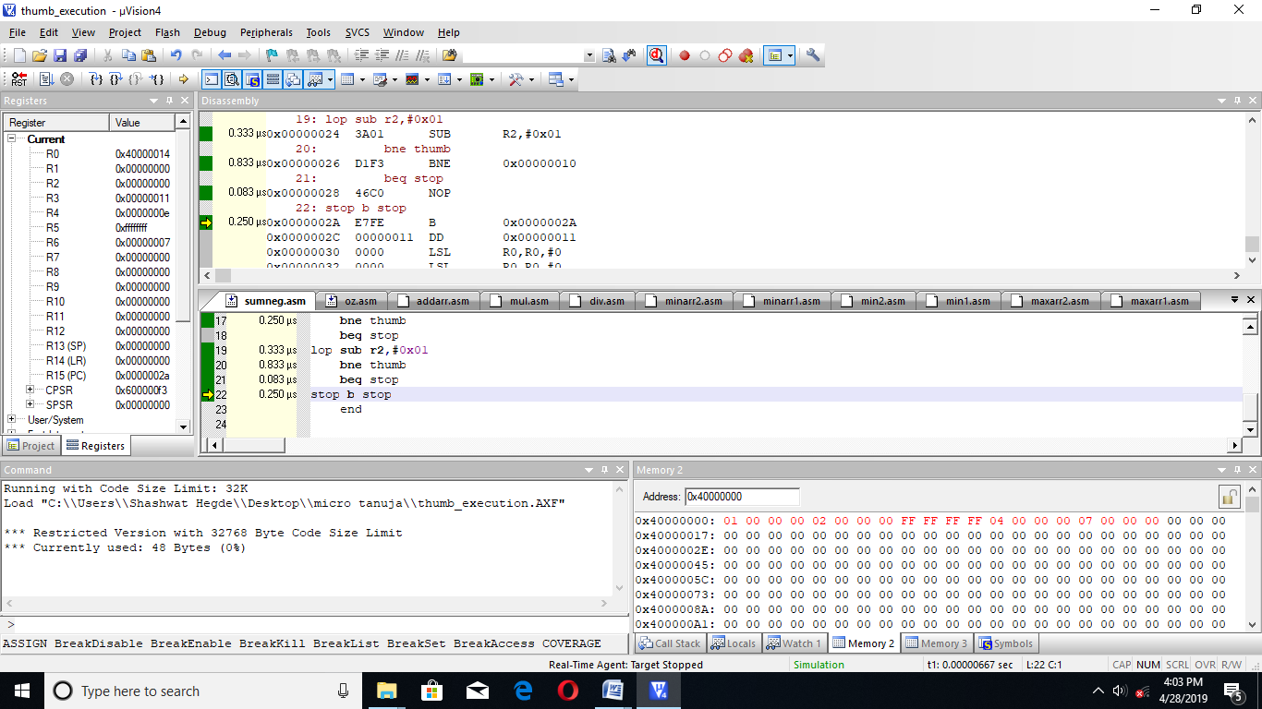

|  |  |  |
| --- | --- | --- |
|  | MEMORY | TIME |
| CODE | 48 BYTES | 6.415 MICROSECOND |

**14. CODE TO FIND THE SUM OF POSITIVE NUMBERS IN AN ARRAY**

AREA ADODD,CODE,READONLY

ENTRY

CODE32

LDR R0,=0X40000000

MOV R2,#0X05

LDR R3,=THUMB+1

BX R3

CODE16

THUMB LDR R4,[R0]

ADD R0,#0X04

MOV R6,R4

LSL R4,#1

BCC ODD

BCS LOP

ODD ADD R5,R6

SUB R2,#0X01

BNE THUMB

BEQ STOP

LOP SUB R2,#0X01

BNE THUMB

BEQ STOP

STOP B STOP

END

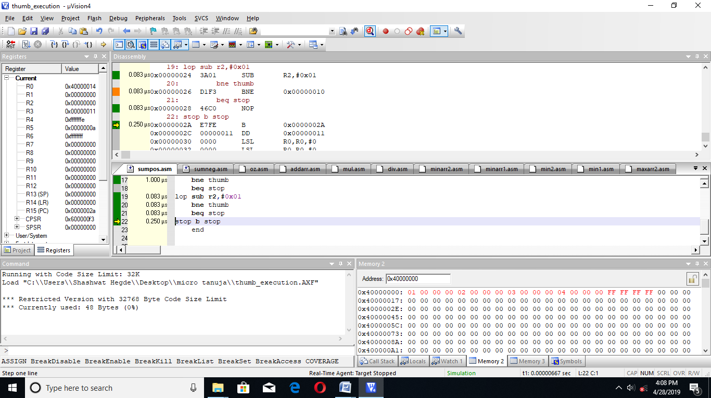

|  |  |  |
| --- | --- | --- |
|  | MEMORY | TIME |
| CODE | 48 BYTES | 6.415 MICROSECOND |

**15. CODE TO FIND THE SUM OF ODD NUMBERS**

AREA ADODD,CODE,READONLY

ENTRY

CODE32

LDR R0,=0X40000000

MOV R2,#0X05

LDR R3,=THUMB+1

BX R3

CODE16

THUMB LDR R4,[R0]

ADD R0,#0X04

MOV R6,R4

LSR R4,#1

BCS ODD

BCC LOP

ODD ADD R5,R6

SUB R2,#0X01

BNE THUMB

BEQ STOP

LOP SUB R2,#0X01

BNE THUMB

BEQ STOP

STOP B STOP

END

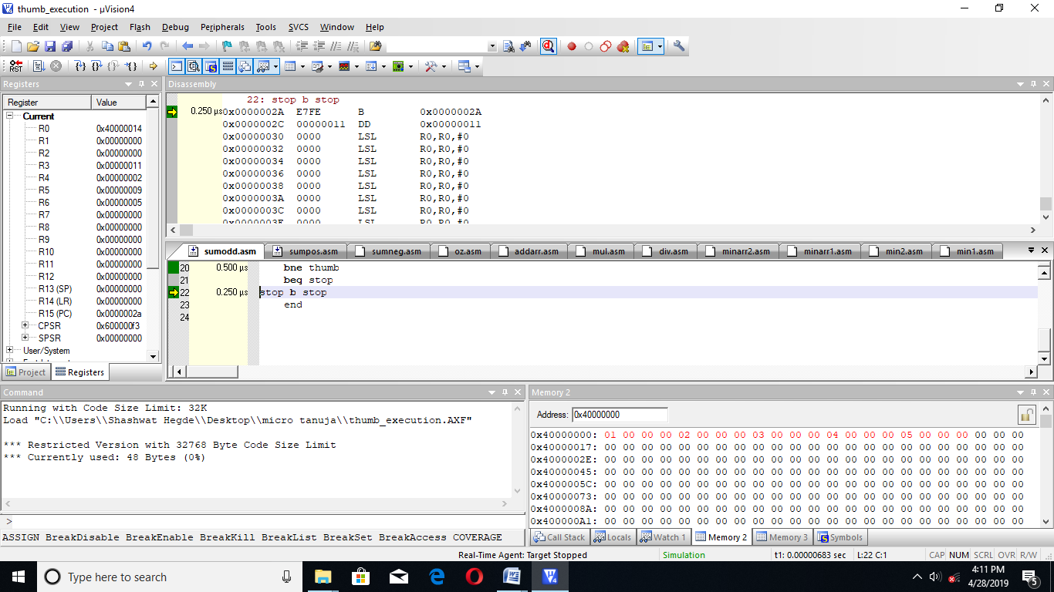

|  |  |  |
| --- | --- | --- |
|  | MEMORY | TIME |
| CODE | 48 BYTES | 6.584 MICROSECOND |

**16. CODE TO FIND THE SUM OF ALL EVEN NUMBERS IN AN ARRAY**

AREA ADODD,CODE,READONLY

ENTRY

CODE32

LDR R0,=0X40000000

MOV R2,#0X05

LDR R3,=THUMB+1

BX R3

CODE16

THUMB LDR R4,[R0]

ADD R0,#0X04

MOV R6,R4

LSR R4,#1

BCC EV

BCS LOP

EV ADD R5,R6

SUB R2,#0X01

BNE THUMB

BEQ STOP

LOP SUB R2,#0X01

BNE THUMB

BEQ STOP

STOP B STOP

END

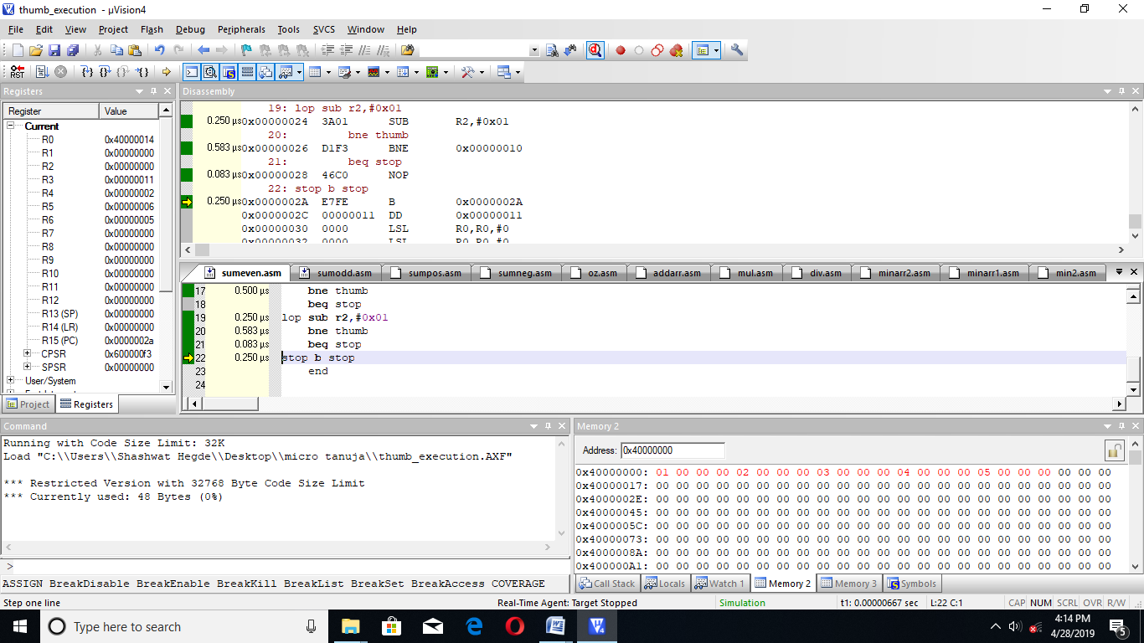

|  |  |  |
| --- | --- | --- |
|  | MEMORY | TIME |
| CODE | 48 BYTES | 6.584 MICROSECOND |

**17. CODE TO GENERATE FIRST 10 EVEN NUMBERS**

AREA GEN,CODE,READONLY

ENTRY

CODE32

LDR R0,=0X40000000

MOV R2,#0X0A

MOV R1,#0X00

LDR R3,=THUMB+1

BX R3

CODE16

THUMB STR R1,[R0]

ADD R0,#0X04

ADD R1,#0X02

SUB R2,#0X01

BNE THUMB

BEQ STOP

STOP B STOP

END

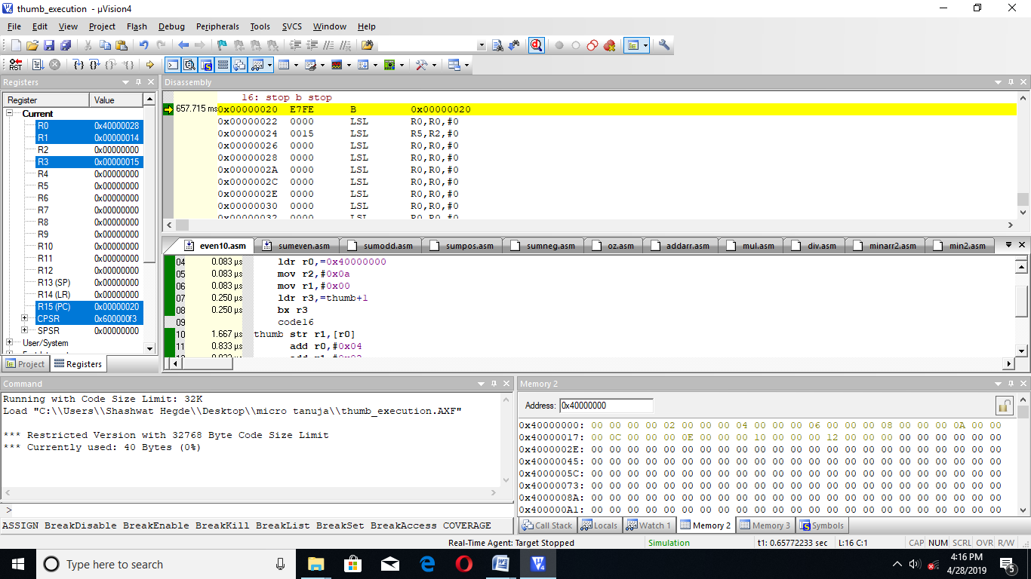

|  |  |  |
| --- | --- | --- |
|  | MEMORY | TIME |
| CODE | 40 BYTES | 5.828 MICROSECOND |

**18. CODE TO GEERATE FIRST 10 ODD NUMBERS**

AREA GEN,CODE,READONLY

ENTRY

CODE32

LDR R0,=0X40000000

MOV R2,#0X0A

MOV R1,#0X01

LDR R3,=THUMB+1

BX R3

CODE16

THUMB STR R1,[R0]

ADD R0,#0X04

ADD R1,#0X02

SUB R2,#0X01

BNE THUMB

BEQ STOP

STOP B STOP

END

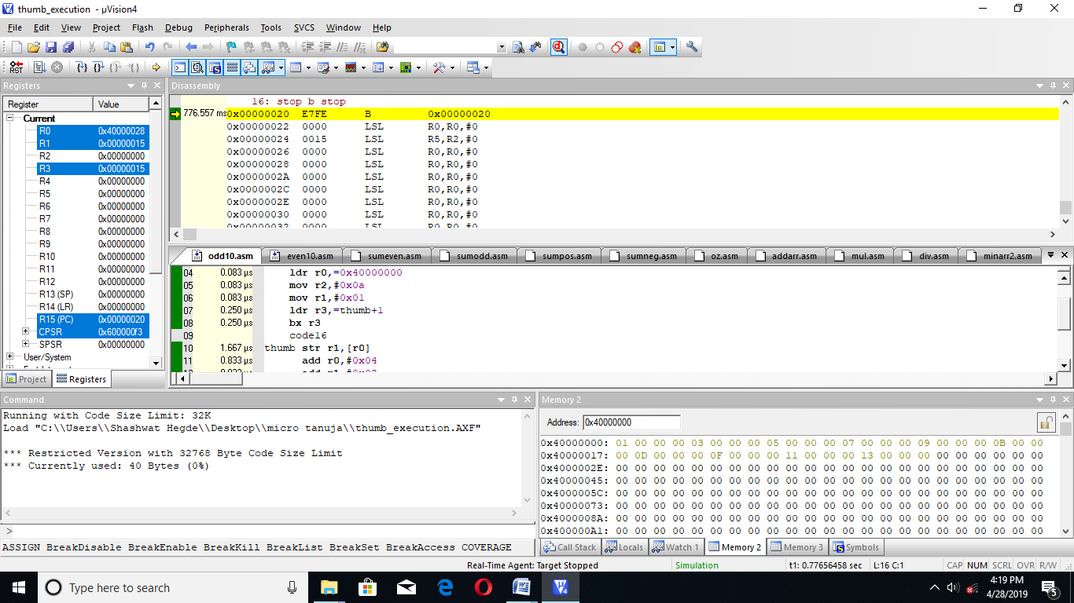

|  |  |  |
| --- | --- | --- |
|  | MEMORY | TIME |
| CODE | 40 BYTES | 5.828 MICROSECOND |

**19. CODE TO GENERATE FIBONACCI SERIES**

AREA GEN,CODE,READONLY

ENTRY

CODE32

LDR R0,=0X40000000

MOV R3,#0X01

ADD R0,#0X04

MOV R2,#0X00

STR R2,[R0]

ADD R0,#0X04

MOV R6,#0X08

LDR R5,=THUMB+1

BX R5

CODE16

THUMB STR R3,[R0]

ADD R0,#0X04

MOV R4,R3

ADD R3,R2

MOV R2,R4

SUB R6,#0X01

BNE THUMB

BEQ STOP

STOP B STOP

END

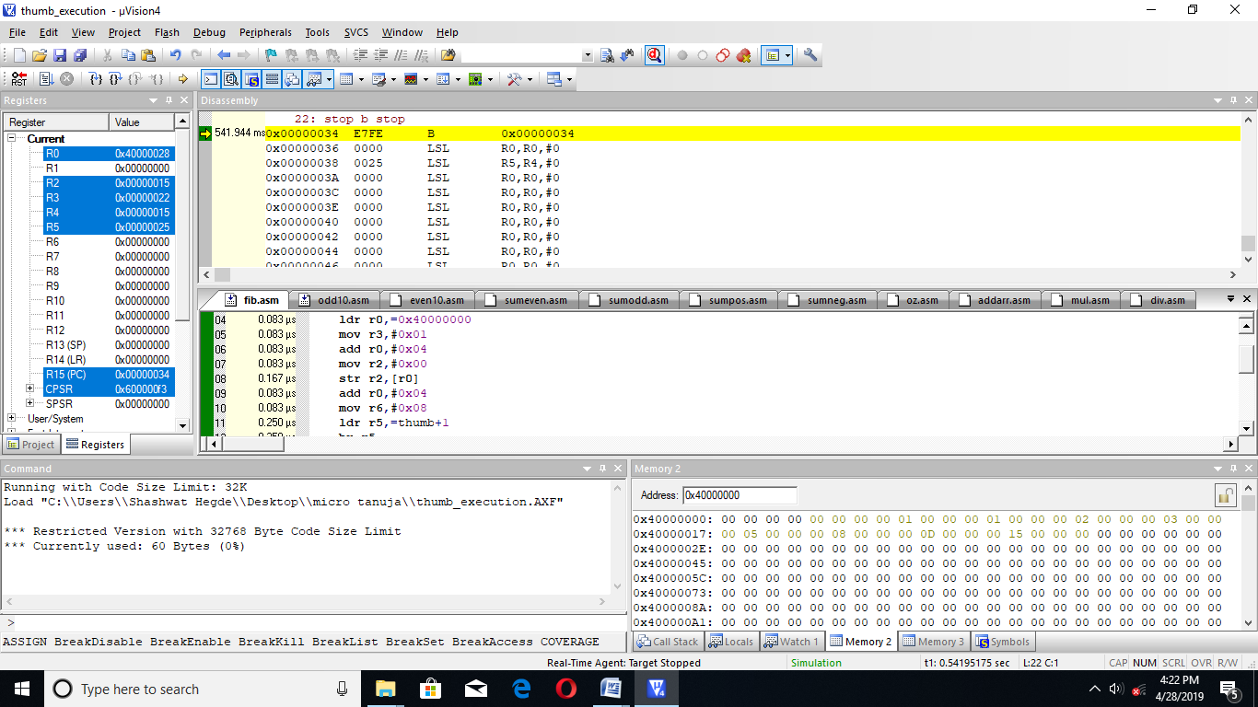

|  |  |  |
| --- | --- | --- |
|  | MEMORY | TIME |
| CODE | 60 BYTES | 7.749 MICROSECOND |

20. **ASCENDING ORDER**

AREA ASC,CODE,READONLY

ENTRY

CODE32

LDR R0,=TH+1

BX R0

CODE16

TH MOV R1,#5

UP LDR R2,=0X40000000

MOV R3,R2

ADD R3,#0X04

MOV R7,#0X03

LOP LDR R4,[R2]

LDR R5,[R3]

CMP R4,R5

BCC COR

BCS IN

IN MOV R6,R4

MOV R4,R5

MOV R5,R6

COR STR R4,[R2]

STR R5,[R3]

ADD R2,#0X04

ADD R3,#0X04

SUB R7,#0X01

BNE LOP

BEQ SUBB

SUBB SUB R1,#0X01

BNE UP

STOP B STOP

END

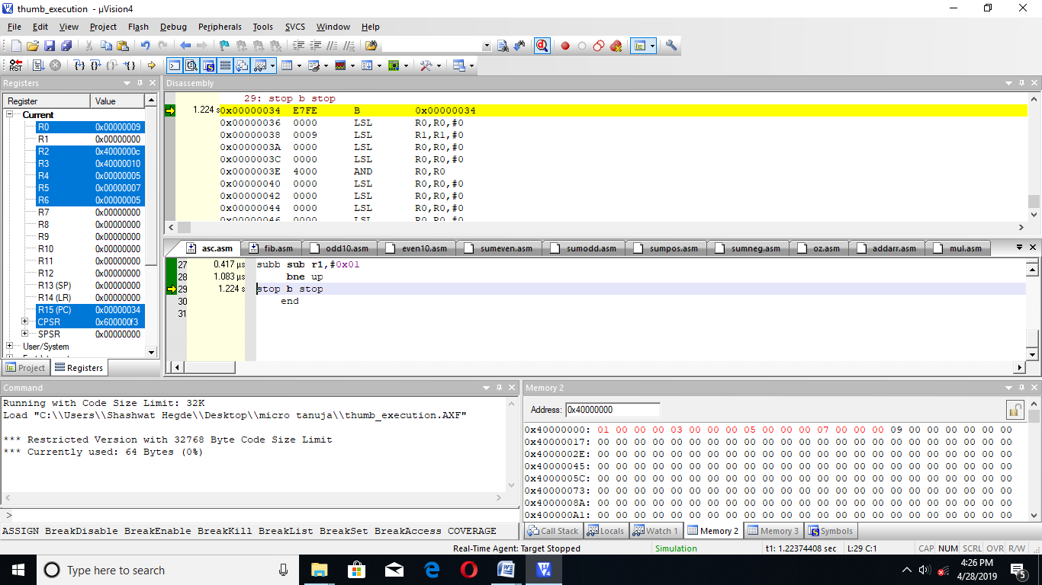

|  |  |  |
| --- | --- | --- |
|  | MEMORY | TIME |
| CODE | 64BYTES | 30.333 MICROSECOND |

**21. DESCENDING ORDER**

AREA ASC,CODE,READONLY

ENTRY

CODE32

LDR R0,=TH+1

BX R0

CODE16

TH MOV R1,#5

UP LDR R2,=0X40000000

MOV R3,R2

ADD R3,#0X04

MOV R7,#0X04

LOP LDR R4,[R2]

LDR R5,[R3]

CMP R4,R5

BCS COR

BCC IN

IN MOV R6,R4

MOV R4,R5

MOV R5,R6

COR STR R4,[R2]

STR R5,[R3]

ADD R2,#0X04

ADD R3,#0X04

SUB R7,#0X01

BNE LOP

BEQ SUBB

SUBB SUB R1,#0X01

BNE UP

STOP B STOP

END

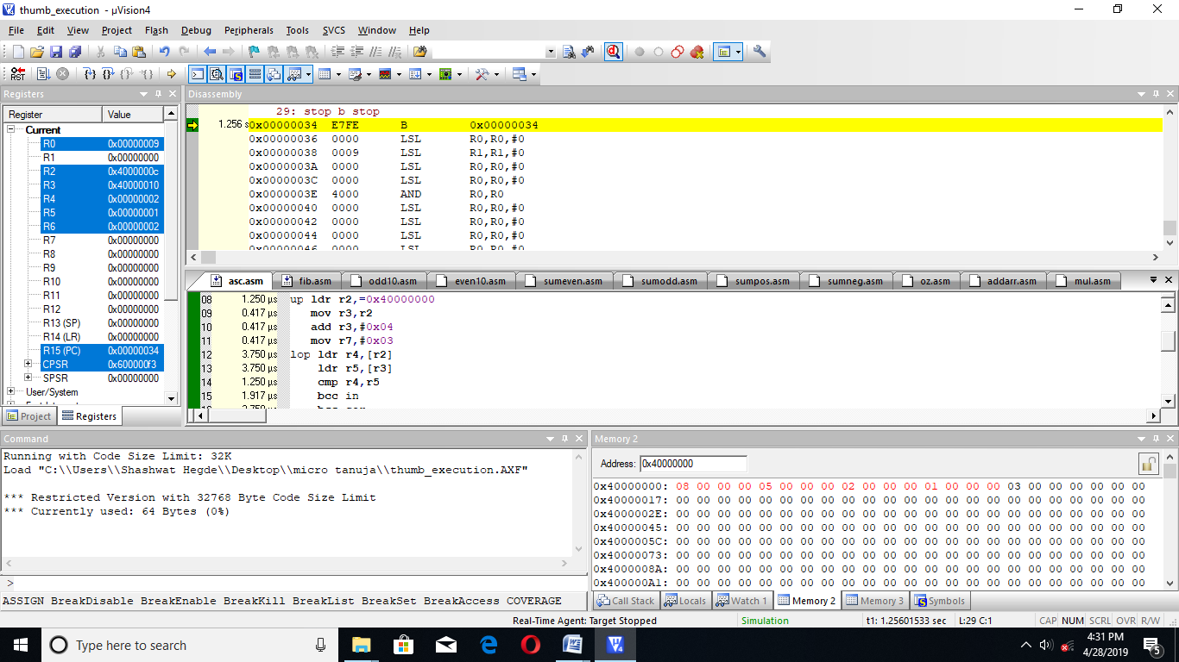

|  |  |  |
| --- | --- | --- |
|  | memory | Time |
| Code | 64bytes | 30.333 microsecond |

**21. HALF ASCENDING HALF DESCENDING**

area asc,code,readonly

entry

code32

ldr r0,=th+1

bx r0

code16

th mov r1,#3

up ldr r2,=0x40000000

mov r3,r2

add r3,#0x04

mov r7,#0x02

lop ldr r4,[r2]

ldr r5,[r3]

cmp r4,r5

bcc cor

bcs in

in mov r6,r4

mov r4,r5

mov r5,r6

cor str r4,[r2]

str r5,[r3]

add r2,#0x04

add r3,#0x04

sub r7,#0x01

bne lop

beq subb

subb sub r1,#0x01

bne up

dth mov r1,#2

dup ldr r2,=0x4000000d

mov r3,r2

add r3,#0x04

mov r7,#0x01

dlop ldr r4,[r2]

ldr r5,[r3]

cmp r4,r5

bcs dcor

bcc din

din mov r6,r4

mov r4,r5

mov r5,r6

dcor str r4,[r2]

str r5,[r3]

add r2,#0x04

add r3,#0x04

sub r7,#0x01

bne dlop

beq dsubb

dsubb sub r1,#0x01

bne dup

stop b stop

end

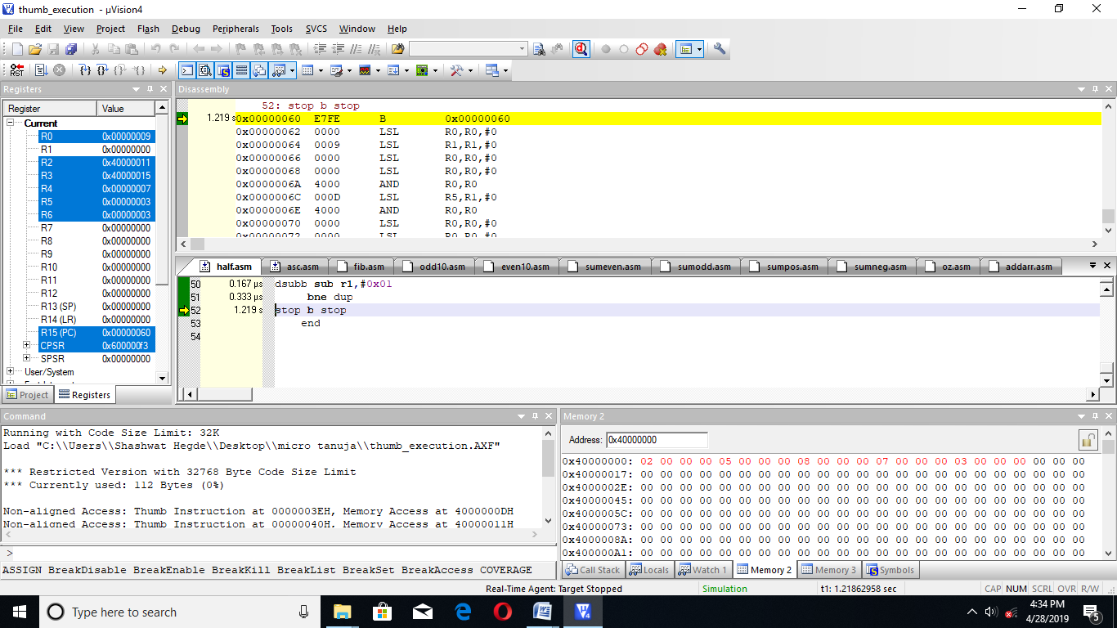

|  |  |  |
| --- | --- | --- |
|  | memory | Time |
| Code | 112bytes | 17.333 microsecond |

**22. STRING LENGTH**

area asc,code,readonly

entry

code32

dollar equ '$'

ldr r0,=string

ldr r1,=th+1

bx r1

code16

th ldrb r2,[r0]

add r0,#0x01

cmp r2,#dollar

bne ad

beq stop

ad add r3,#0x01

b th

stop b stop

string dcb "bcbcet",'$'

end

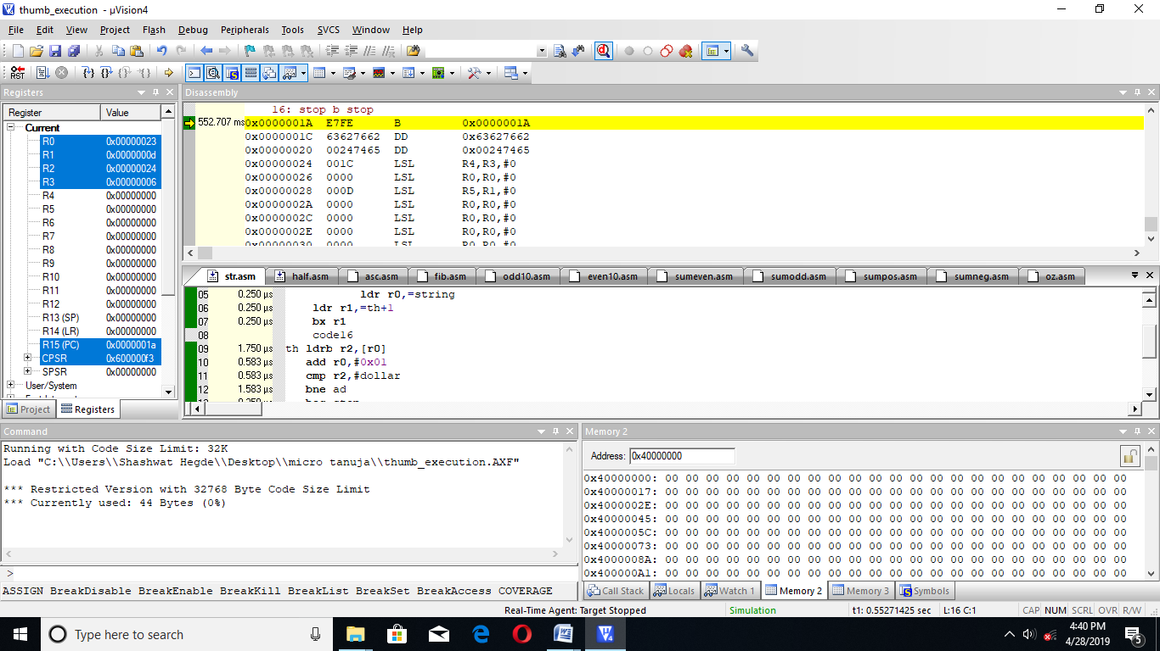

|  |  |  |
| --- | --- | --- |
|  | memory | Time |
| Code | 44 bytes | 7.499 microsecond |

**23. FIND THE NUMBER OF OCCURRENCE OF A CHARACTER**

area asc,code,readonly

entry

code32

dollar equ '$'

space equ ' '

ldr r0,=string

ldr r1,=th+1

bx r1

code16

th ldrb r2,[r0]

add r0,#0x01

cmp r2,#space

beq ad

bne rep

ad add r3,#0x01

b th

rep cmp r2,#dollar

bne th

beq stop

stop b stop

string dcb "tanvi shanbhag is good girl iii",'$'

end

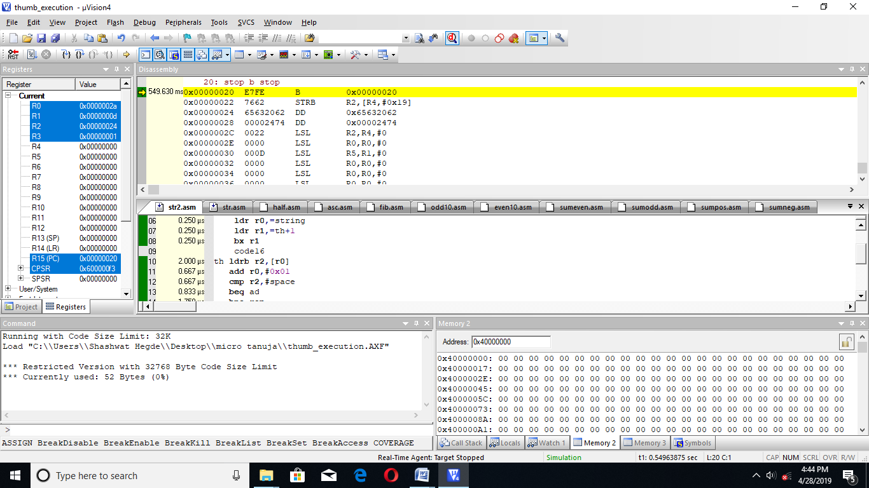

|  |  |  |
| --- | --- | --- |
|  | memory | Time |
| Code | 52 bytes | 9.249 microsecond |

**24. COMPARE STRING FOR LENGTH AND CONTENT**

area asc,code,readonly

entry

code32

dollar equ '$'

ldr r0,=string1

ldr r4,=string2

ldr r1,=th+1

bx r1

code16

th ldrb r2,[r0]

add r0,#0x01

cmp r2,#dollar

bne ad

beq dth

ad add r5,#0x01

bne th

dth ldrb r2,[r4]

add r4,#0x01

cmp r2,#dollar

beq lop

bne dad

dad add r6,#0x01

bne dth

lop cmp r5,r6

bne stop

content ldr r0,=string1

ldr r4,=string2

loop ldrb r2,[r0]

add r0,#0x01

ldrb r3,[r4]

add r4,#0x01

cmp r2,r3

beq hap

bne stop

hap add r7,#0x01

sub r5,#0x01

bne loop

beq comp

comp cmp r6,r7

beq addd

bne stop

addd mov r1,#0x01

stop b stop

string1 dcb "tanvi",'$'

string2 dcb "tanv ",'$'

end

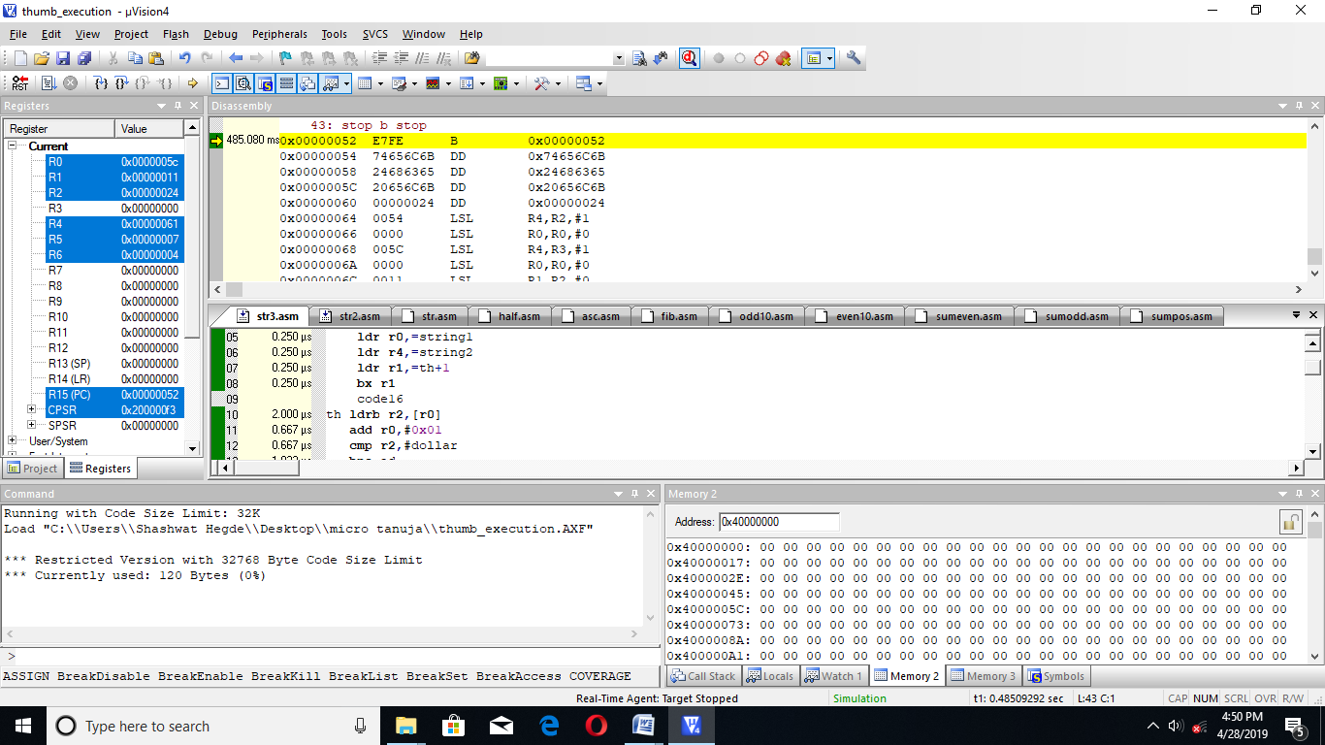

|  |  |  |
| --- | --- | --- |
|  | memory | Time |
| Code | 120 bytes | 13.416microsecond |

**25**. **REVERSE A STRING**

area strrev,code,readonly

entry

code32

ldr r1,=th+1

bx r1

code16

th ldr r0,=string

ldr r2,=0x40000000

l ldrb r3,[r0]

add r0,#0x01

cmp r3,#0

bne ad

beq reverse

ad add r4,#0x01

b l

reverse ldr r0,=string

add r0,r4

b loop

loop sub r0,#0x01

ldrb r5,[r0]

strb r5,[r2]

add r2,#0x01

sub r4,#0x01

bne loop

stop b stop

string dcb "bvb",'0'

end

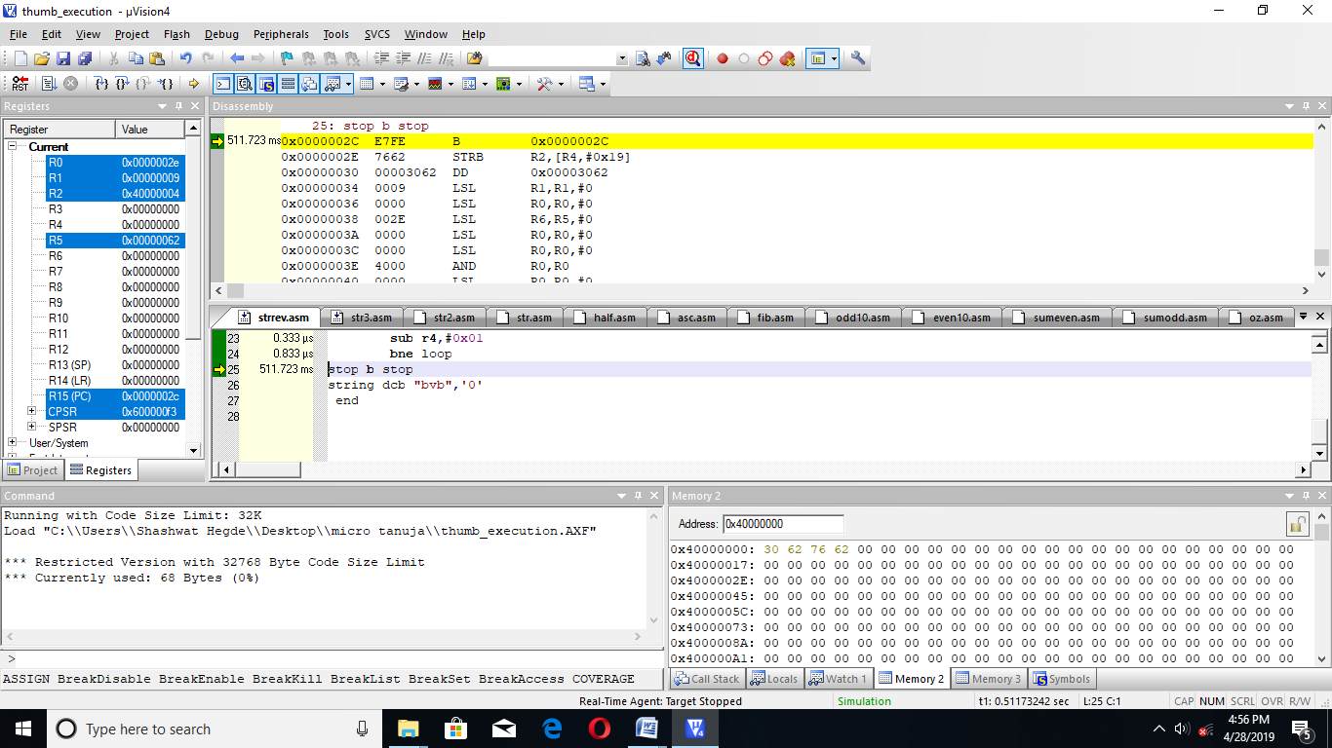

|  |  |  |
| --- | --- | --- |
|  | memory | Time |
| Code | 68 bytes | 10.665microsecond |

**26. CHECK IF A STRING IS A PALINDROME**

area strrev,code,readonly

entry

code32

ldr r0,=s+1

bx r0

code16

s mov r0,#0

ldr r1,=string

ldr r2,=string

loop1 ldrb r3,[r1]

add r1,#1

cmp r3,#0

bne loop2

beq loop3

loop2 add r5,#1

bne loop1

loop3 mov r4,r5

sub r4,#0x01

add r2,r4

ldr r1,=string

loop5 ldrb r4,[r1]

ldrb r7,[r2]

add r1,#0x01

sub r2,#0x01

cmp r4,r7

beq loop4

bne loop6

loop4 add r6,#0x01

bne loop5

loop6 cmp r5,r6

beq yes

bne stop

yes add r0,#0x01

stop b stop

string dcb "madam",0

end

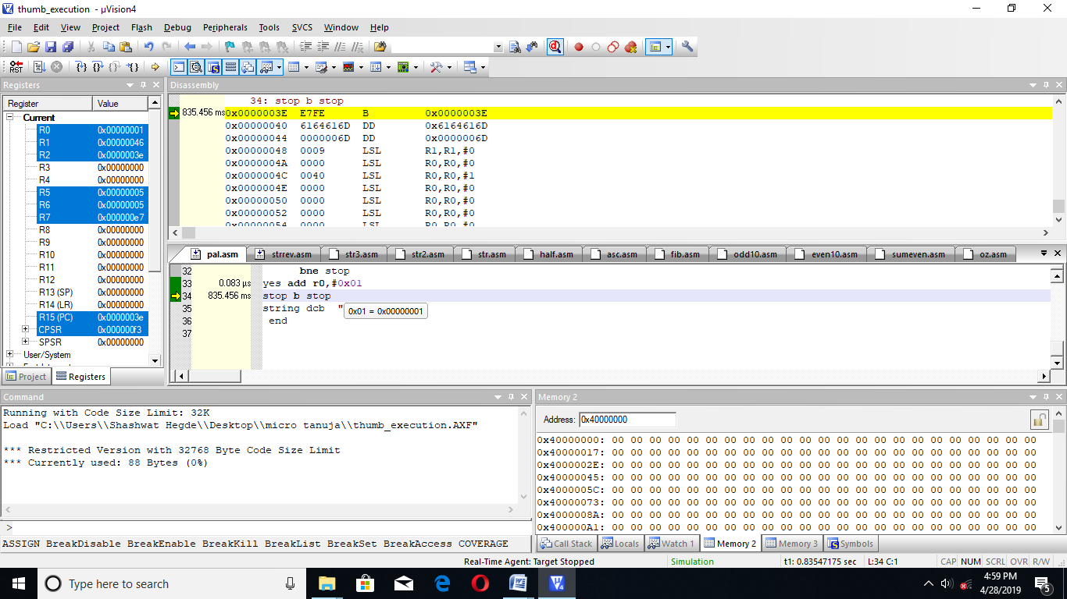

|  |  |  |
| --- | --- | --- |
|  | memory | Time |
| Code | 88 bytes | 15.498 microsecond |

**27. TO ARRANGE A STRING IN ALPHABETICAL ORDER**

area d,code,readonly entry

code32

ldr r0,=thu+1

bx r0

code16

thu mov r0,#0

ldr r0,=string

ldr r2,=0x40000000

tu ldrb r3,[r0]

add r0,#1

cmp r3,#0

bne loops

beq asc

loops strb r3,[r2]

add r2,#1

add r4,#1

b tu

asc mov r0,#0

mov r0,r4

up ldr r2,=0x40000000

sub r0,#0x01

mov r3,r2

add r3,#1

mov r4,r0

loop1 ldrb r5,[r2]

ldrb r6,[r3]

cmp r5,r6

bcc cor

bcs inc

inc mov r7,r5

mov r5,r6

mov r6,r7

cor strb r5,[r2]

strb r6,[r3]

add r2,#1

add r3,#1

sub r4,#0x01

bne loop1

sub r0,#0x01

bne up

beq stop

stop b stop

string dcb "bvbcet",0

end

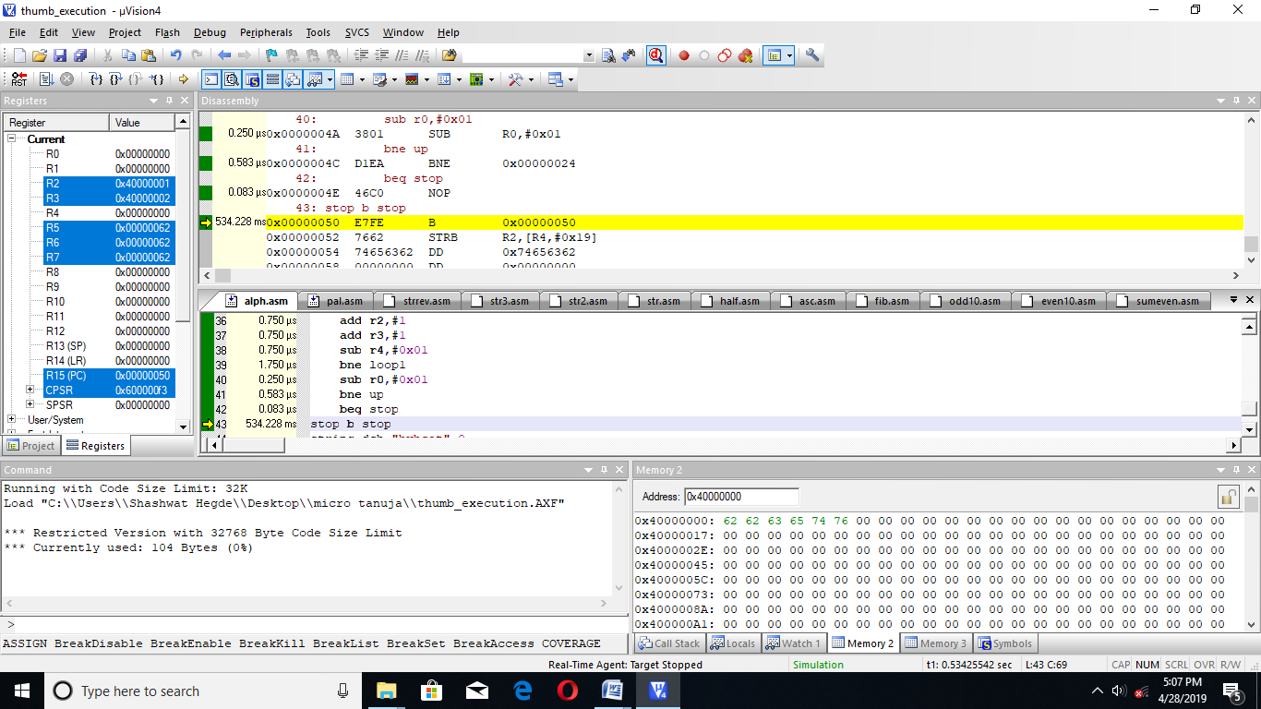

|  |  |  |
| --- | --- | --- |
|  | memory | Time |
| Code | 104 bytes | 25.081 microsecond |

**28. DEVELOP CODE IN THUMB MODE FOR FOLLOWING CONTEXT**

**1. Main function should take care of block transfer of 6 words from data memory to register bank**

**2. SUBROUTINE CALLED IN MAIN DOING ADDITION OF 5 WORDS**

**3.ON RETURN MAIN FUNCTION SHOULD STORE ADDED RESULT ON TO MEMORY**

AREA CODE1,CODE,READONLY

ENTRY

CODE32

LDR R0,=MAIN+1

BX R0

CODE16

MAIN LDR R1,=0X40000000

LDMIA R1!,{R2-R6}

AD BL ADDITION

LDR R0,=0X40000020

STR R2,[R0]

STOP B STOP

ADDITION ADD R2,R3

ADD R2,R4

ADD R2,R5

ADD R2,R6

MOV PC,LR

END

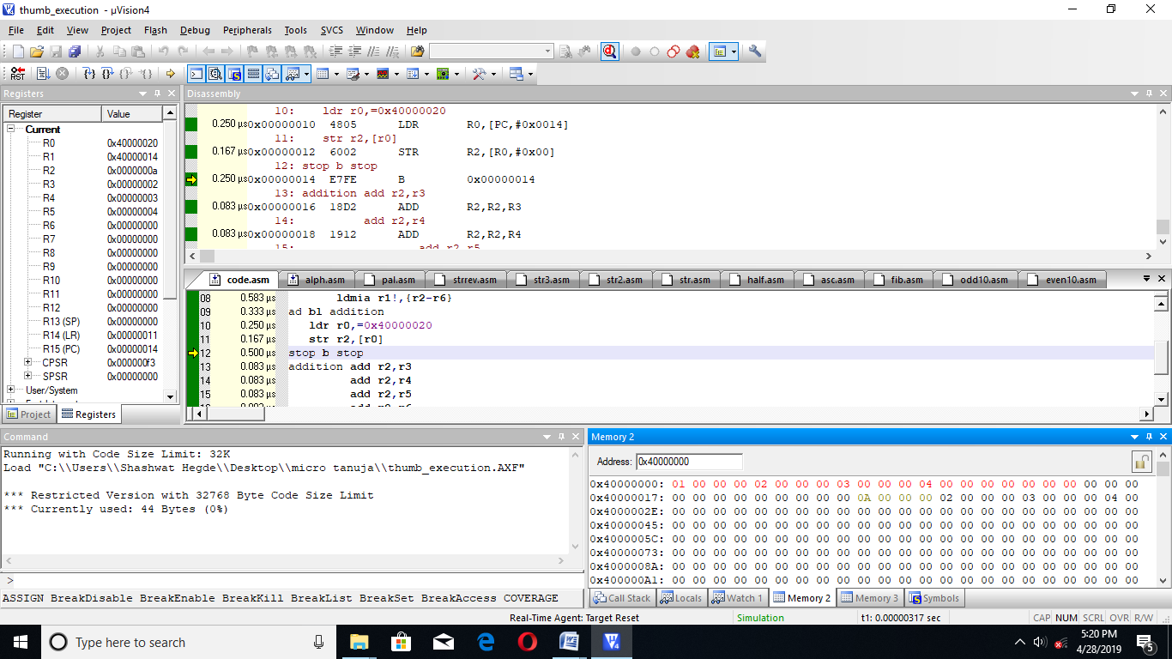

|  |  |  |
| --- | --- | --- |
|  | MEMORY | TIME |
| CODE | 44 BYTES | 2.915 MICROSECOND |

**29. CODE TO CHECK IF A GIVEN NUMBER IS PRIME OR NOT**

AREA ASC,CODE,READONLY

ENTRY

CODE32

LDR R0,=THU+1

BX R0

CODE16

THU MOV R0,#0X00

MOV R0,#0X09

MOV R1,R0

MOV R2,#0X02

CMP R0,#0X02

BEQ PRIME

BNE CONT

PRIME MOV R6,#0X01

B STOP

NOTPRIME ADD R2,#0X01

CMP R2,R0

BPL CONT

BMI STOP

CONT MOV R3,R0

MOV R4,R2

BL DIV

CMP R3,#0X00

BNE GO

BEQ NOTPRIME

GO ADD R2,#0X01

CMP R0,R2

BNE CONT

BEQ PRIME

STOP B STOP

DIV SUB R3,R4

ADD R5,#0X01

CMP R3,R4

BPL DIV

MOV PC,LR

END

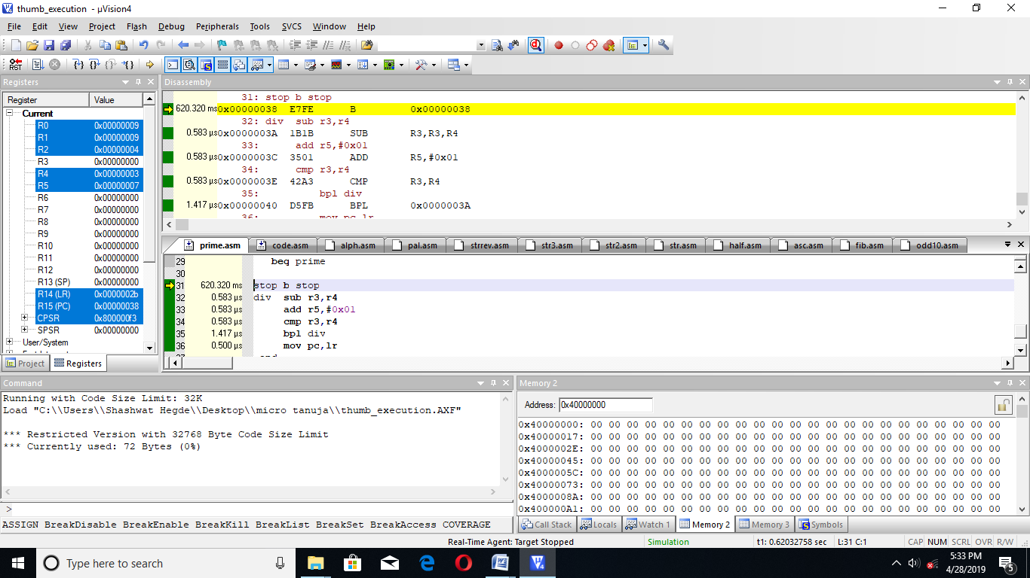

|  |  |  |
| --- | --- | --- |
|  | MEMORY | TIME |
| CODE | 72 BYTES | 7.58 MICROSECOND |

**30. BLOCK TRANSFER WITH LDM/STM INSTRUCTION**

**1. CODE MEMORY TO DATA MEMORY**

AREA MOVE,CODE,READONLY

ENTRY

CODE32

LDR R0,=DATA

LDR R1,=0X40000000

LDR R2,=THUMB+1

BX R2

CODE16

THUMB LDMIA R0!,{R2-R4}

STMIA R1!,{R2-R4}

STOP B STOP

DATA DCD 0X11,0X12,0X13

END

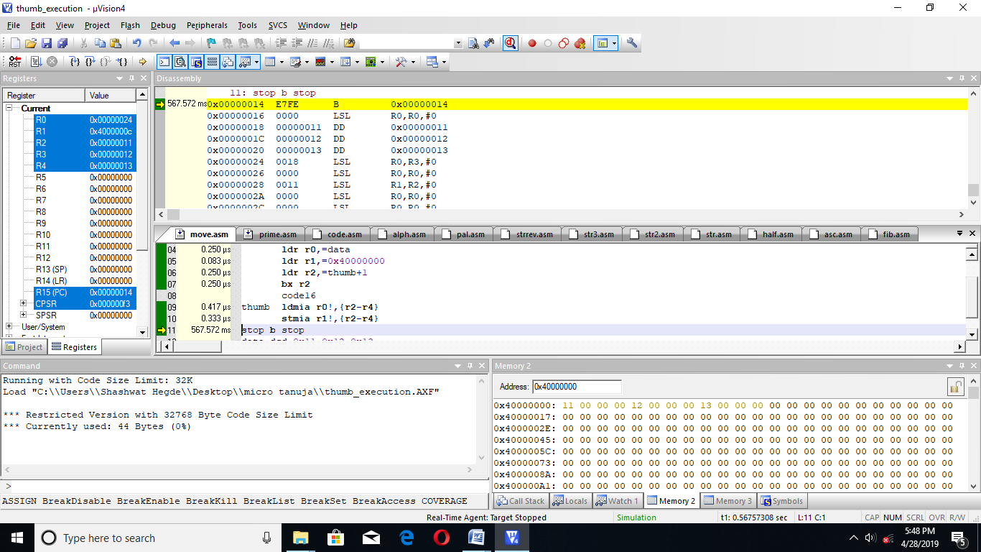

|  |  |  |
| --- | --- | --- |
|  | MEMORY | TIME |
| CODE | 44 BYTES | 1.583 MICROSECOND |

**2. DATA MEMORY TO DATA MEMORY**

AREA MOVE,CODE,READONLY

ENTRY

CODE32

LDR R0,=0X40000000

LDR R1,=0X40000010

LDR R2,=THUMB+1

BX R2

CODE16

THUMB LDMIA R0!,{R2-R4}

STMIA R1!,{R2-R4}

STOP B STOP

END

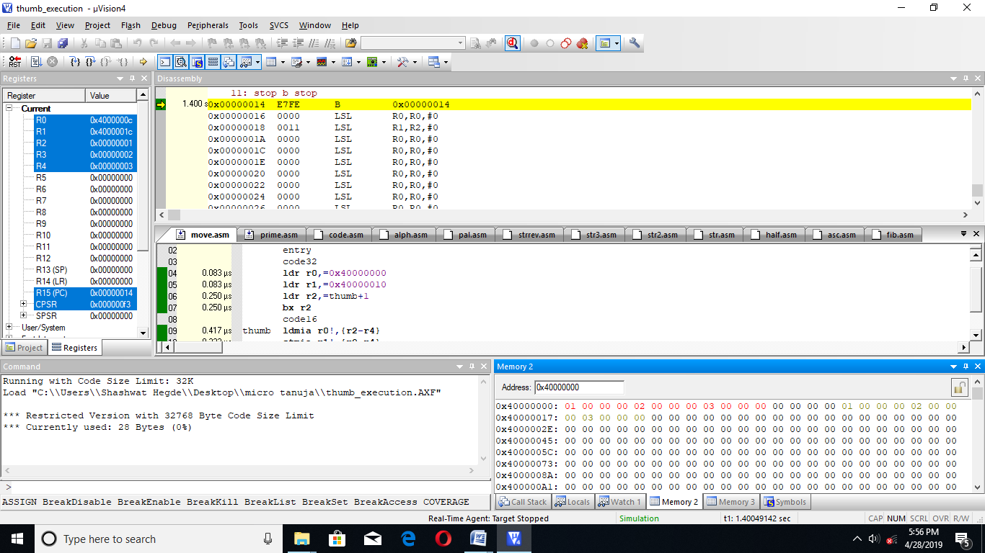

|  |  |  |
| --- | --- | --- |
|  | MEMORY | TIME |
| CODE | 28 BYTES | 1.416 MICROSECOND |

**31. DEVELOP CODE TO FIND**

**1. R0=5R1**

AREA MULT,CODE,READONLY

ENTRY

CODE32

LDR R3,=THUMB+1

BX R3

CODE16

THUMB MOV R1,#0X02

MOV R0,#0X00

MOV R2,#0X05

LQ ADD R0,R1

SUB R2,#0X01

BNE LQ

BEQ STOP

STOP B STOP

END

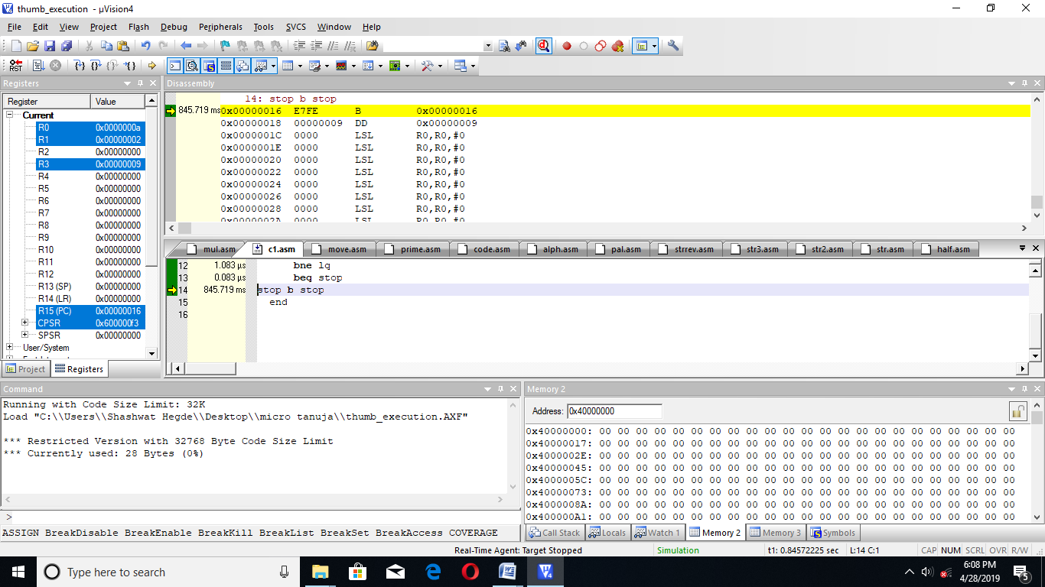

|  |  |  |
| --- | --- | --- |
|  | MEMORY | TIME |
| CODE | 28 BYTES | 2.749 MICROSECOND |

**2. R3=10R4**

AREA MULT,CODE,READONLY

ENTRY

CODE32

LDR R0,=THUMB+1

BX R0

CODE16

THUMB MOV R4,#0X02

MOV R3,#0X00

MOV R2,#0X0A

LQ ADD R3,R4

SUB R2,#0X01

BNE LQ

BEQ STOP

STOP B STOP

END

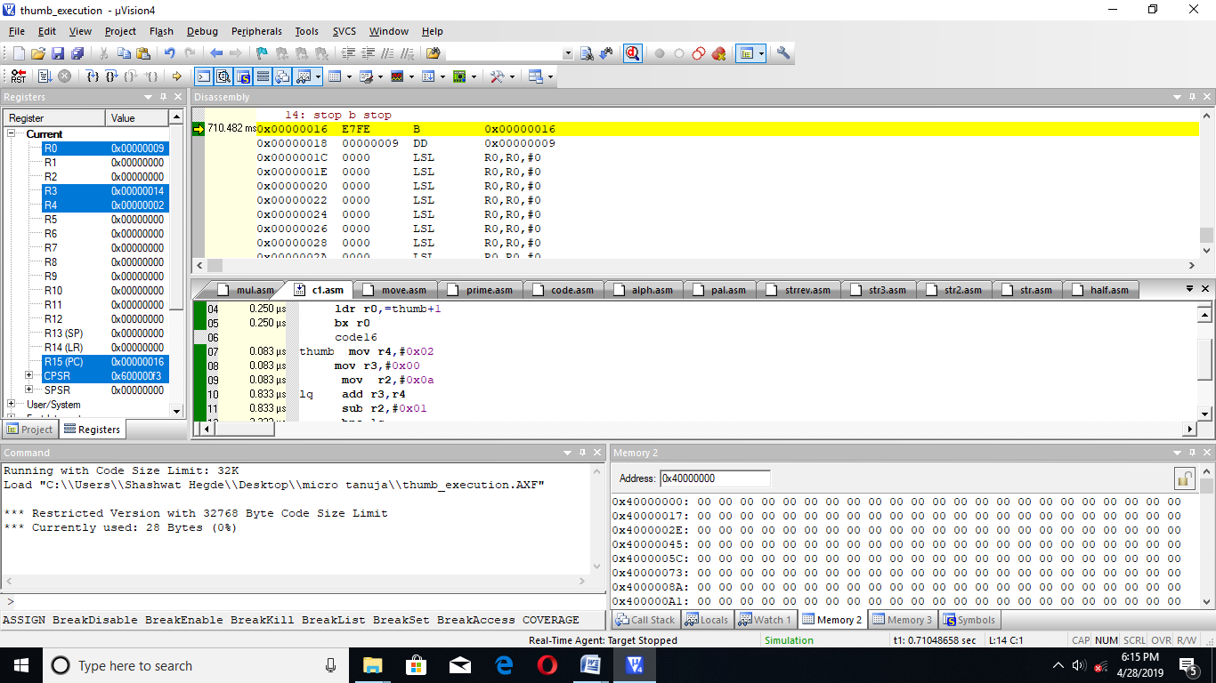

|  |  |  |
| --- | --- | --- |
|  | MEMORY | TIME |
| CODE | 28 BYTES | 2.749 MICROSECOND |

**3. R7=10R3**

AREA MULT,CODE,READONLY

ENTRY

CODE32

LDR R0,=THUMB+1

BX R0

CODE16

THUMB MOV R3,#0X02

MOV R7,#0X00

MOV R2,#0X0A

LQ ADD R7,R3

SUB R2,#0X01

BNE LQ

BEQ STOP

STOP B STOP

END

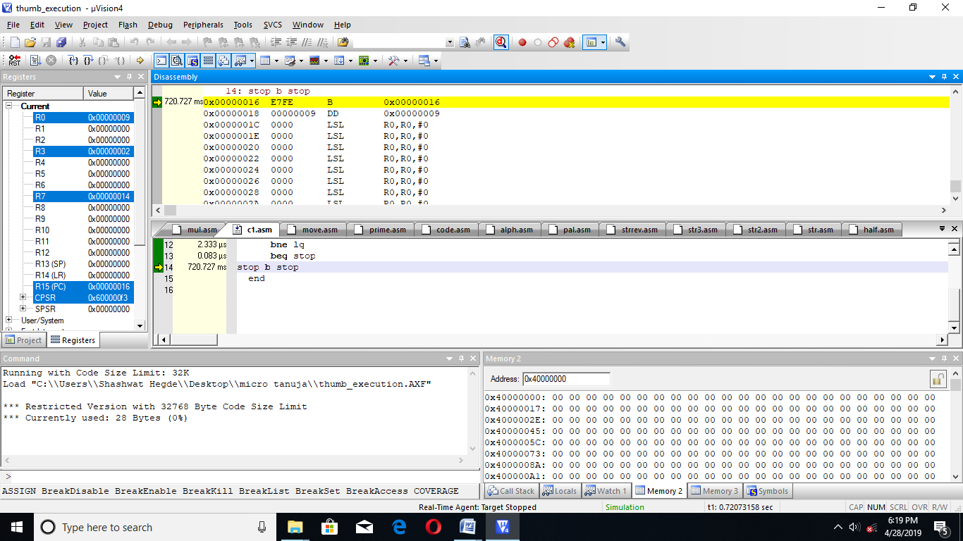

|  |  |  |
| --- | --- | --- |
|  | MEMORY | TIME |
| CODE | 28 BYTES | 2.749 MICROSECOND |

**4. IF (R0>R1)**

**{**

**R2=R0+4R1**

**}**

**ELSE**

**R2=R0+7R1**

AREA MULT,CODE,READONLY

ENTRY

CODE32

LDR R4,=THUMB+1

BX R4

CODE16

THUMB MOV R0,#0X01

MOV R1,#0X02

CMP R0,R1

BPL L1

BMI L2

L2 MOV R1,#0X02

MOV R2,#0X00

MOV R3,#0X07

LQ1 ADD R2,R1

SUB R3,#0X01

BNE LQ1

ADD R0,R2

MOV R2,R0

B STOP

L1 MOV R1,#0X02

MOV R2,#0X00

MOV R3,#0X04

LQ ADD R2,R1

SUB R3,#0X01

BNE LQ

ADD R0,R2

MOV R2,R0

STOP B STOP

END

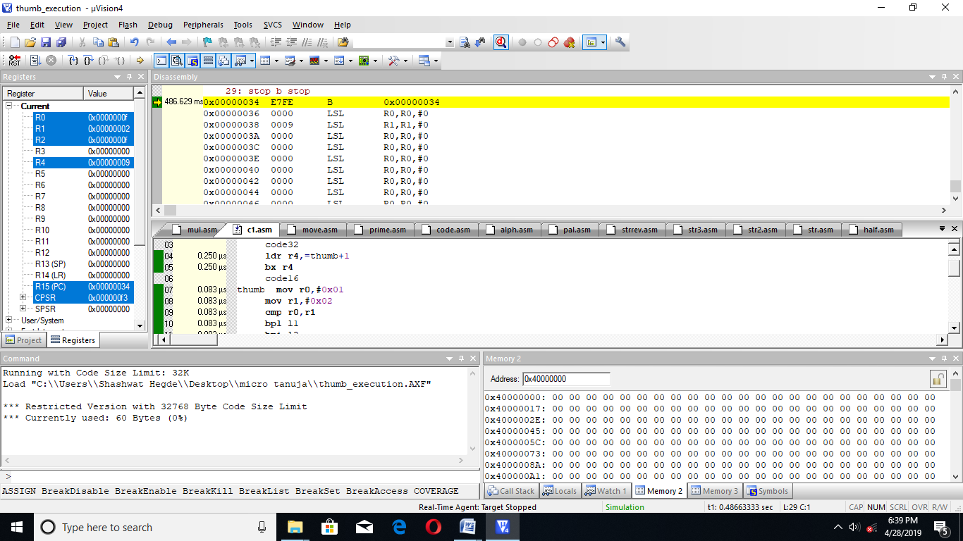

|  |  |  |
| --- | --- | --- |
|  | MEMORY | TIME |
| CODE | 60 BYTES | 4.246 MICROSECOND |